**CSIT 314**

# **PROJECT REPORT**



**UNIVERSITY OF WOLLONGONG**

**SCHOOL OF COMPUTING AND INFORMATION TECHNOLOGY**

**Group Name: TeamCG**

**Prepared for:**

**Mr. Hoa Dam**

**Mr. Terence Chew**

# **Members Contribution**

The team has mutually agreed to this description and is satisfied with the contribution of each team member’s efforts.

| **Name** | **UOW ID** | **Contribution** | **Description** | **Signature** |
| --- | --- | --- | --- | --- |
| Huang Junde | 6347046 | 100% | User Stories  Use Case Diagram  BCE Class Diagram  BCE Sequence Diagram  Feature of Software Application (Data Driven Development) |  |
| Dany Irfan | 7083105 | 100% | User Stories  Use Case Diagram  BCE Class Diagram  BCE Sequence Diagram  Ethical Considerations |  |
| Priscilla Kai Ting Loo | 6278632 | 100% | User Stories  Frontend programming  Backend programming  Database |  |
| Eng Yong Tee | 6347186 | 100% | Did use case diagram, class diagram, sequence diagram. Helped with use case description and helped to fit the java code into b-c-e framework. |  |
| Hai Tian Jonathan Khoo | 5922033 | 100% | Feature of software development  User Stories  Use case description  Ethical consideration |  |
| Yap Yuan Xin | 6278905 | 100% | User Stories  Wireframing  Test cases  Ethical considerations |  |
| Hwang Qi Hsin, Jasmine | 6276672 | 100% | User stories  Use case descriptions  Test cases  TDD  CI/CD  Ethical considerations |  |

# 

# **Content Page**

**PROJECT REPORT** **1**

**Members Contribution** **2**

**Content Page** **4**

**1. User Stories** **8**

Bug Reporter 8

Triager 9

Developer 11

Reviewer 12

**2. List of complete tasks** **13**

**3. Gantt chart** **14**

**4. Use case Diagrams** **15**

**5. Use case Descriptions** **20**

**6. BCE Class Diagram** **33**

**7. BCE Sequence Diagram** **52**

**8. Sprints** **70**

a. Sprint 1 70

Wireframe 70

Bug Reporter 70

Triager 72

Developer 73

Reviewer 74

Screenshot of interface 75

Bug Reporter 75

Triager 77

Developer 78

Reviewer 79

Screenshot of taiga 80

Test cases 82

Bug Reporter 82

Triager 83

Developer 84

Reviewer 85

Test Driven Development 86

b. Sprint 2 106

Wireframe 106

Bug Reporter 106

Triager 107

Developer 108

Reviewer 109

Screenshot of interface 110

Bug Reporter 110

Triager 111

Developer 112

Reviewer 113

Screenshot of taiga 114

Test cases 116

Bug Reporter 116

Triager 118

Developer 119

Reviewer 120

c. Sprint 3 121

Screenshot of interface 121

Bug Reporter 121

Triager 122

Developer 123

Reviewer 124

Screenshot of taiga 125

Test cases 126

Bug Reporter 126

Triager 128

Developer 130

Reviewer 131

d. Sprint 4 134

Wireframe 134

Triager 134

Developer 137

Reviewer 138

Screenshot of interface 139

Triager 139

Developer 140

Reviewer 143

Screenshot of taiga 144

Test cases 148

Triager 148

Developer 153

Reviewer 154

e. Sprint 5 155

Wireframe 155

Bug Reporter 155

Triager 156

Developer 156

Reviewer 158

Screenshot of interface 159

Bug Reporter 159

Triager 160

Developer 160

Reviewer 162

Screenshot of taiga 163

Test cases 166

Bug Reporter 166

Triager 167

Developer 168

Reviewer 169

**9. CI/CD screenshots for one feature/functionality** **170**

**10. Ethical considerations** **177**

Accountability 177

Colleagues 177

Dependability 177

Integrity 177

Judgment 177

Management 178

Self 178

**11. Feature of software application that can be developed using data-driven software development** **179**

Data Collection 180

Data Cleaning 180

Feature Engineering 180

Model Training 181

Model Evaluation 181

Model Deployment 181

Model Monitoring 181

**12. Meeting minutes** **182**

Meeting Minutes 1 182

Meeting Minutes 2 184

Meeting Minutes 3 186

Meeting Minutes 4 188

Meeting Minutes 5 190

Meeting Minutes 6 192

# 

# **1. User Stories**

## **Bug Reporter**

As a Bug Reporter, I want to be able to log into the bug reporting system so that I can use the functionalities of the website.

As a Bug Reporter, I want to be able to log out of the bug reporting system so that I can terminate my session

As a Bug Reporter, I want to be able to view all the bug reports so that I can view the bug type, description, status, who reported it, who it is assigned to, who it is allocated to, when it is reported and when it is resolved for each bug report.

As a Bug Reporter, I want to be able to search for bug reports through the use of keywords, so that I can see what information or update has been performed or added by the various actors.

As a Bug Reporter, I want to be able to view past comments on a bug in a forum so that I can view inputs and updates by all users.

As a Bug Reporter, I want to be able to insert comments on a bug in a forum so that I can add my inputs to the thread.

As a Bug Reporter, I want to have a form so that I am able to submit a report.

## 

## **Triager**

As a triager, I want to be able to log into the bug reporting system so that I can use the functionalities of the website.

As a triager, I want to be able to log out of the bug reporting system so that I can terminate my session

As a triager, I want to be able to view all the bug reports so that I can view the bug type, description, status, who reported it, who it is assigned to, who it is allocated to, when it is reported and when it is resolved for each bug report.

As a triager, I want to be able to search for bug reports through the use of keywords, so that I can see what information or update has been performed.

As a triager, I want to be able to view past comments on a bug in a forum so that I can view inputs and updates by all users.

As a triager, I want to be able to insert comments on a bug in a forum so that I can add my inputs to the thread.

As a triager, I want to be able to view unresolved bugs so that I can check if they are duplicate or invalid.

As a triager, I want to mark bug reports as duplicate so there would not be duplicative work done.

As a triager, i want to mark bug reports as invalid so that no time would be wasted on trying to fix an invalid bug.

As a triager, I want to have a report on the best performed developer so that I can view the best performed developer.

As a triager, I want to have a report on the best performed reporter so that I can view the best performed reporter.

As a triager, I want to have a report on numbers of bugs reported in a month so that I can view numbers of bugs reported in a month.

As a triager, I want to have a report on the number of bugs resolved in a week so that I can view the number of bugs resolved in a week.

As a triager, I want to be able to assign a bug report to a developer so that the bugs are able to be resolved in a more efficient manner.

As a triager, I want to be able to view unassigned bugs so that I know which bugs I have to assign.

As a triager, I want to be able to view developers so that I can know which developers are available to assign bugs to.

As a triager, I want to be able to view reviewed bugs so that I know which bugs I can close.

As a triager, I want to be able to close the bug report so that every user of the system can know that the bug is closed.

## **Developer**

As a developer, I want to be able to log into the bug reporting system so that I can use the functionalities of the website.

As a developer, I want to be able to log out of the bug reporting system so that I can terminate my session

As a developer, I want to be able to view all the bug reports so that I can view the bug type, description, status, who reported it, who it is assigned to, who it is allocated to, when it is reported and when it is resolved for each bug report.

As a developer, I want to be able to search for bug reports through the use of keywords, so that I can see what information or update has been performed.

As a developer, I want to be able to view bug reports that have been assigned to me by Triagers so that I know what task has been assigned to me.

As a developer, I want to be able to mark the bug report as ‘“pending review” when the bug is solved so that I can notify the Reviewer to review.

As a developer, I want to be able to view past comments on a bug in a forum so that I can view inputs and updates by all users.

As a developer, I want to be able to insert comments on a bug in a forum so that I can add my inputs to the thread.

## **Reviewer**

As a reviewer, I want to be able to log into the bug reporting system so that I can use the functionalities of the website.

As a reviewer, I want to be able to log out of the bug reporting system so that I can terminate my session

As a reviewer,I want to be able to view all the bug reports so that I can view the bug type, description, status, who reported it, who it is assigned to, who it is allocated to, when it is reported and when it is resolved for each bug report.

As a reviewer, I want to be able to search for bug reports through the use of keywords, so that I can see what information or update has been performed.

As a reviewer, I want to be able to view past comments on a bug in a forum so that I can view inputs and updates by all users.

As a reviewer, I want to be able to insert comments on a bug in a forum so that I can add my inputs to the thread.

As a reviewer, I want to be able to mark the bug report from “pending review” to “reviewed” when the bug has been reviewed by the reviewer so that I can notify the Triager to close the bug.

As a reviewer, I want to be able to view bugs marked as “pending review” so that I can know which bug I have to review.

# **2. List of complete tasks**

For every user story we have the following tasks:

1. Develop use case diagram
2. Develop use case description
3. Develop class diagram for bce framework
4. Develop sequence diagram for bce framework
5. Develop front end
6. Develop back end
7. Testing

# **3. Gantt chart**

# 

# **4. Use case Diagrams**

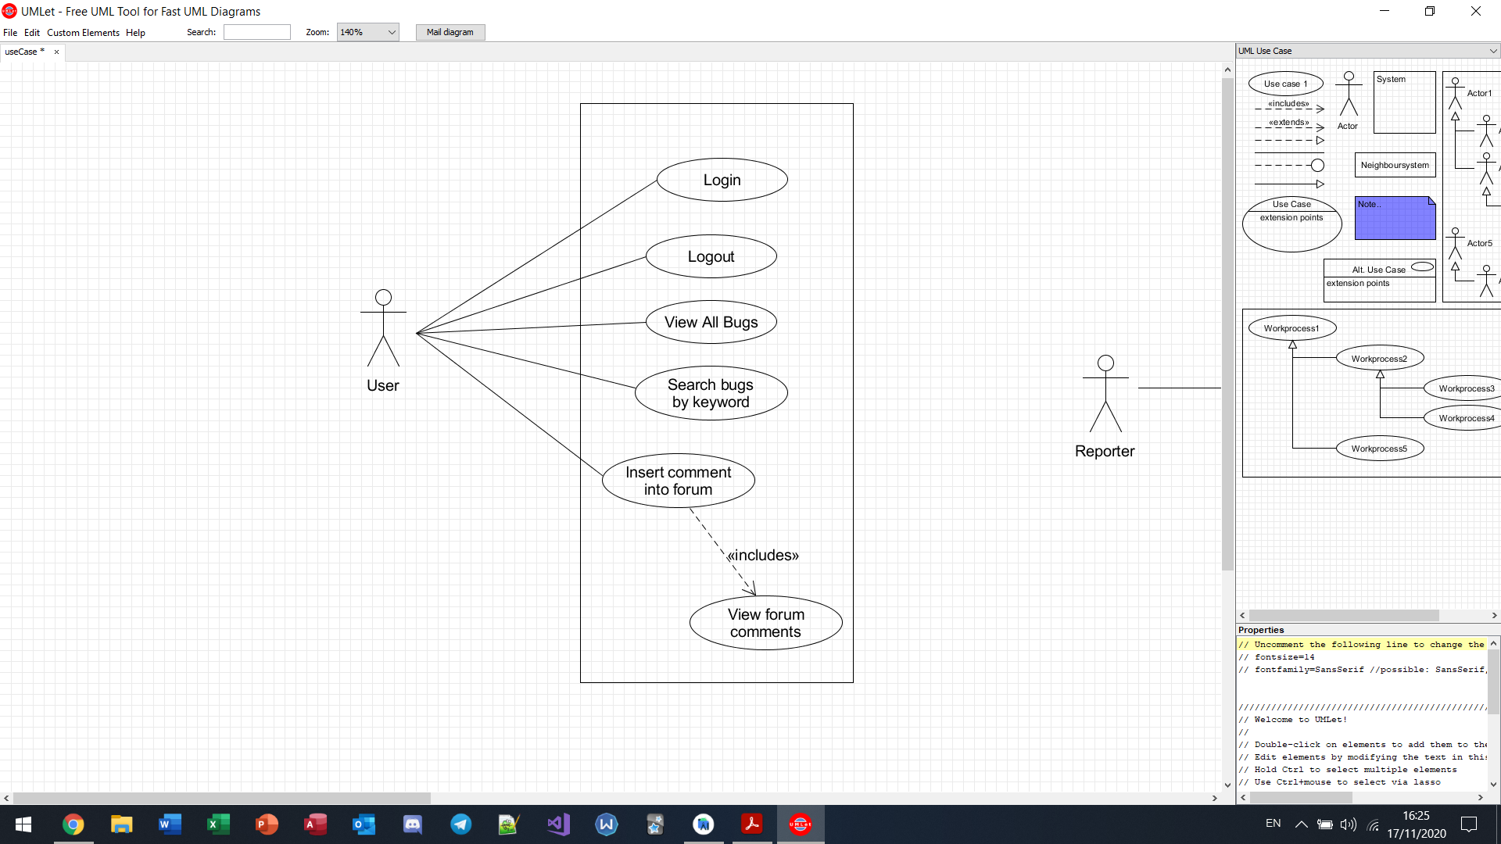

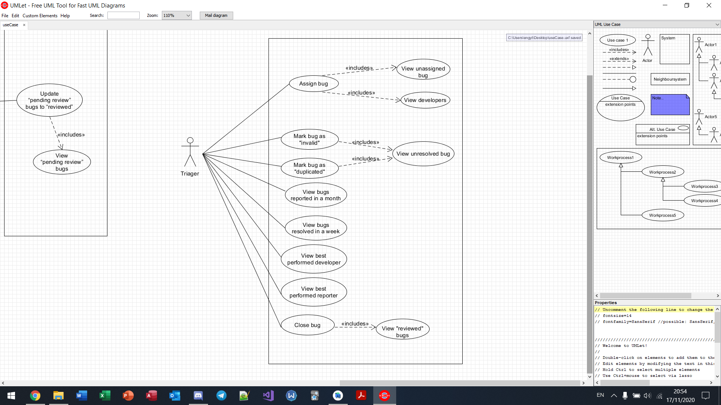

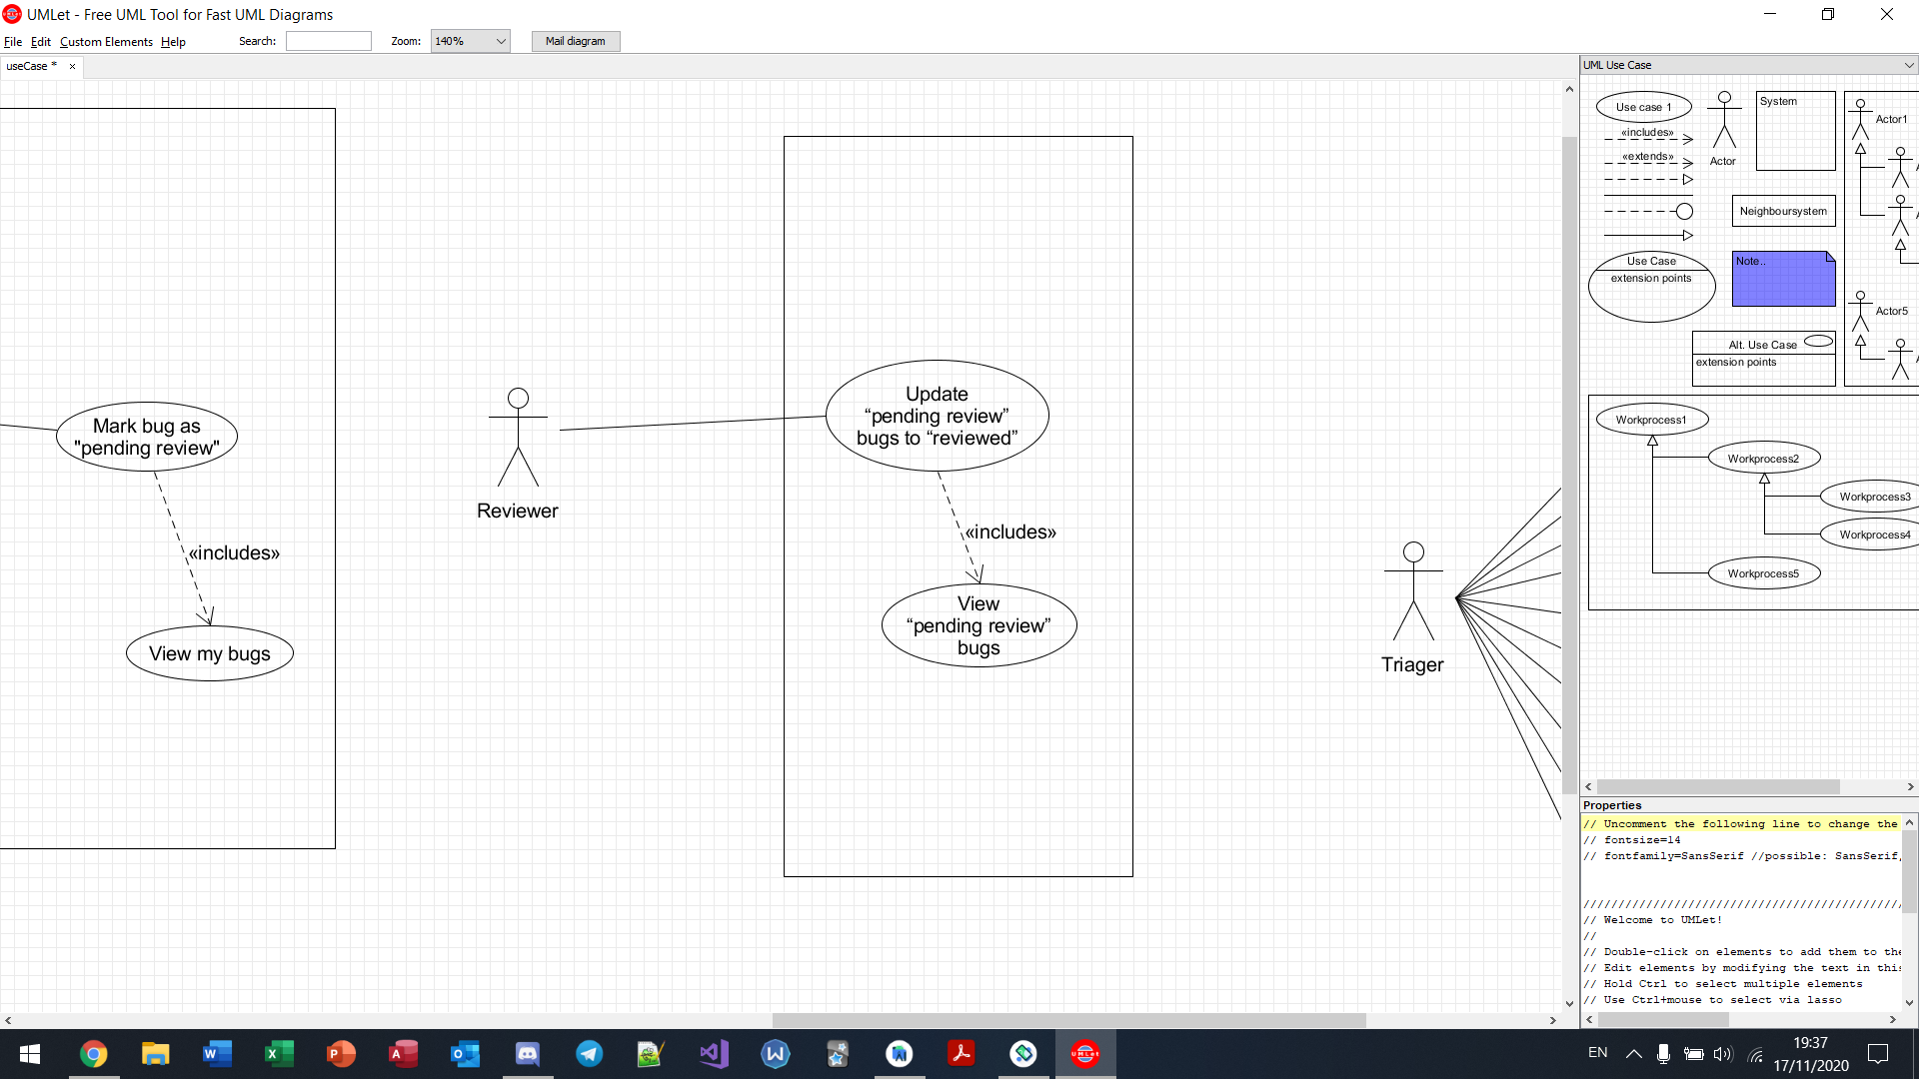

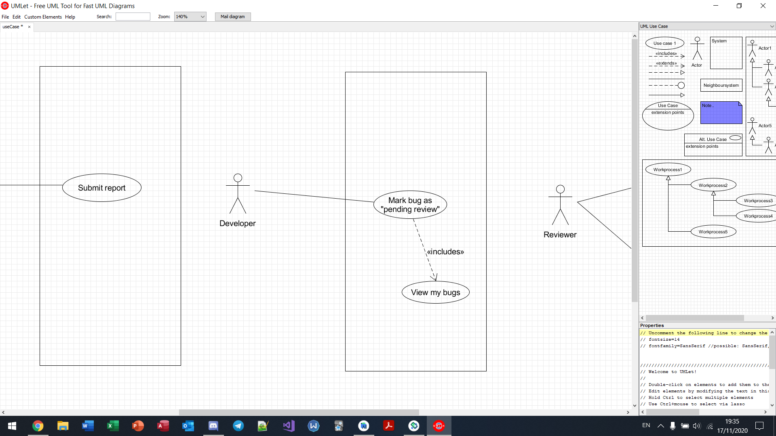

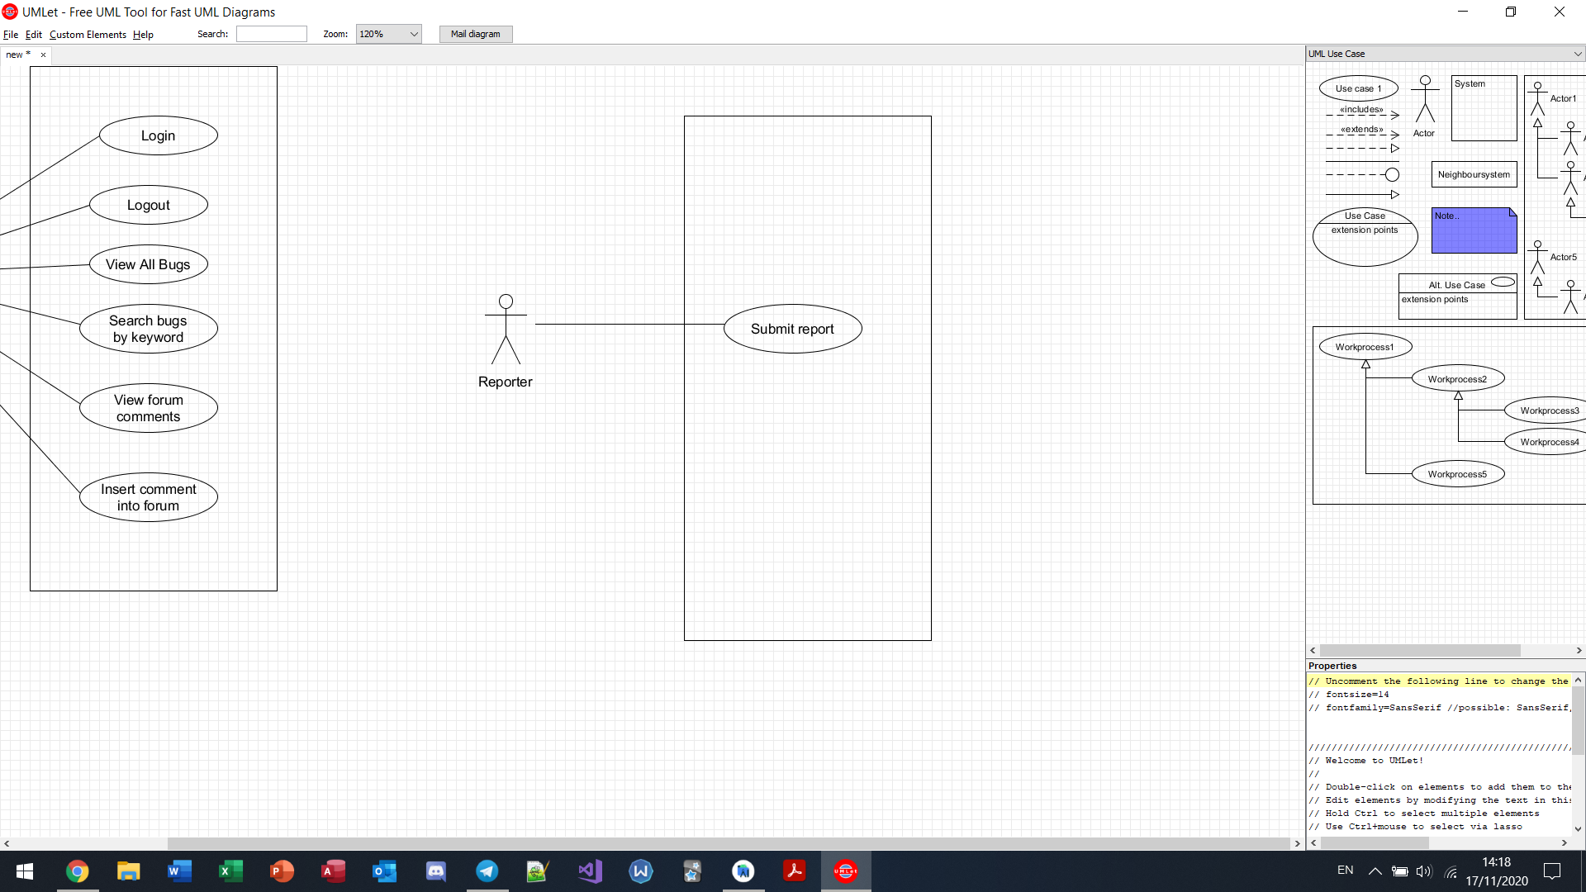

# 

# **5. Use case Descriptions**

| **Name:** **Login to System** | **ID: #43, #52, #78, #88** |
| --- | --- |
| **Stakeholders and Goals:** Users of bug reporting system - to log into the bug reporting system and utilize other functions | |
|
|
|
|
| **Description:** Users of bug reporting system wants to log into the bug reporting system | |
| **Actors:** Bug Reporter, Developer, Triager, Reviewer | |
| **Trigger:** User initiates login process | |
| **Normal Flow:**   1. The user runs the bug reporting system 2. The system displays login interface 3. The user enters credentials (username and password) 4. The system checks validity of credentials 5. End | |
| **Sub-Flows:** None | |
| **Alternative/Exceptional Flows:**  3a. User credentials not recognized, login fails. | |

| **Name:** **Logout of System** | **ID: #44, #53, #79, #89** |
| --- | --- |
| **Stakeholders and Goals:** Users of bug reporting system - to exit from the bug reporting system | |
|
|
|
|
| **Description:** Users of bug reporting system wants to logout of their account from the bug reporting system | |
| **Actors:** Bug Reporter, Developer, Triager, Reviewer | |
| **Trigger:** User chooses to logout of account from the system | |
| **Normal Flow:**   1. The user clicks on menu and clicks on “Logout” button 2. The system displays a prompt to confirm that the user wants to logout 3. The user confirms the logout by clicking “YES” 4. The system logs out of user account and displays the login interface 5. End | |
| **Sub-Flows:** None | |
| **Alternative/Exceptional Flows:** User clicks “NO” | |

| **Name: Search for Bug Reports using Keyword** | **ID: #46, #55, #81, #91** |
| --- | --- |
| **Stakeholder and Goals:** Users of bug reporting system – want to search for bug report using keywords | |
| **Description:** Users of bug reporting system search for a bug report by using keyword found in the content of the bug report. Keyword includes, but not limited to the name of the reporter, name of developer assigned, name of reviewer who reviewed the bug report, title of the bug report. | |
| **Actors:** Bug Reporter, Developer, Triager, Reviewer | |
| **Trigger:** User initiates search function by keyword | |
| **Normal Flow:** | |
| 1. The user inputs keyword into textbox 2. The system shortlist and displays bug reports which have matching values in any of its attributes, even partially. 3. End | |
| **Sub-Flows:** None | |
| **Alternative/Exceptional flows:** None | |

| **Name:** **View All Bug Reports** | **ID: #48, #57, #83, #93** |
| --- | --- |
| **Stakeholders and Goals:** Users of bug reporting system - allows for all actors to view all the bug reports that were reported. | |
|
|
|
|
| **Description :** Users of bug reporting system are able to view the list of bug reports that were reported, along with all the relevant information relating to it. | |
| **Actors:** Bug Reporter, Developer, Triager, Reviewer | |
| **Trigger:** User initiates View Bug Reports button | |
| **Normal Flow:**   1. The user clicks on “View Bug Reports” button 2. The system displays a list of bug reports 3. End | |
| **Sub-Flows:** None | |
| **Alternative/Exceptional Flows:** None | |

| **Name: View forum comments** | **ID: #49, #58, #84, #94** |
| --- | --- |
| **Stakeholder and Goals:** Users of bug reporting system – allows users to view comments on how to solve a type of bug | |
| **Description:** Users of bug reporting system are able to open up the forum page to view past comments on a bug. | |
| **Actors:** Bug Reporter, Developer, Triager, Reviewer | |
| **Trigger:** User wants to view the forum | |
| **Normal Flow:** | |
| 1. The user clicks on discuss 2. The system displays a textbox and a view button 3. The user enter bug report id and clicks on view 4. The system displays all past comments 5. End | |
| **Sub-Flows:** None | |
| **Alternative/Exceptional flows:** None | |

| **Name: Insert comment in Forum** | **ID: #477, #478, #484, #485** |
| --- | --- |
| **Stakeholder and Goals:** Users of bug reporting system – allows users to leave comments on how to solve a type of bug | |
| **Description:** Users of bug reporting system are able to open up the forum page to leave comments on how to solve a bug via comments | |
| **Actors:** Bug Reporter, Developer, Triager, Reviewer | |
| **Trigger:** User wants to insert a comment for a bug | |
| **Normal Flow:** | |
| 1. The user has entered the bug report id and is viewing past comments for the bug 2. The user can add in additional comments by typing in the textbox at the bottom of the screen and click the “SUBMIT” button 3. End | |
| **Sub-Flows:** None | |
| **Alternative/Exceptional flows:** None | |

| **Name: Submit Report** | **ID: #51** |
| --- | --- |
| **Stakeholder and Goals:** Bug Reporter – want to report a bug | |
| **Description:** A Bug Reporter wants to report a bug and must login to the system | |
| **Actors:** Bug Reporter | |
| **Trigger:** The reporter initiates the bug reporting function | |
| **Normal Flow:**   1. The bug reporter clicks on “Report Bug” 2. The system displays bug reporting form 3. The bug reporter enters bug title and bug description submits form 4. The system will redirect the user to “All Bugs” page 5. End | |
| **Sub-Flows:** None | |
| **Alternative/Exceptional flows:** None | |

| **Name:** **View Bug Reports Assigned to Developer** | **ID: #87** |
| --- | --- |
| **Stakeholders and Goals:** Developer - to view the bug reports assigned to the developer so he/she knows which bugs he/she has to work on | |
|
|
|
|
| **Description :** A Developer wants to view bug reports assigned to him/her that are not yet resolved and requires work done | |
| **Actors:** Developer | |
| **Trigger:** The Developer chooses to view bug reports assigned to him/her | |
| **Normal Flow:**   1. The developer click “My Bugs” button 2. The system displays a list of bug reports which the triager has assigned to the developer to resolve 3. End | |
| **Sub-Flows:** None | |
| **Alternative/Exceptional Flows:** None | |

| **Name:** **Mark Bug Report as “Pending Review”** | **ID: #86** |
| --- | --- |
| **Stakeholders and Goals:** Developer - mark bug report as “pending review” once done | |
|
|
|
|
| **Description :** A Developer wants to mark bug report as “pending review” once done | |
| **Actors:** Developer | |
| **Trigger:** The Developer clicks on the function to mark bug report as “pending review” | |
| **Normal Flow:**   1. The developer views all bugs assigned to him / her 2. The developer enter the bug report id and clicks on submit button 3. The system updates the status to “pending review” 4. End | |
| **Sub-Flows:** None | |
| **Alternative/Exceptional Flows:** None | |

| **Name: View “pending review” bug reports** | **ID: #486** |
| --- | --- |
| **Stakeholder and Goals:** Reviewer - review resolved bug reports | |
| **Description:** A reviewer want to view bug reports that are pending review | |
| **Actors:** Reviewer | |
| **Trigger:** The reviewer initiates the review resolved bug reports function | |
| **Normal Flow:**   1. The reviewer clicks on “Review Bugs” 2. The system displays review bugs page and list of resolved bugs report 3. End | |
| **Sub-Flows:** None | |
| **Alternative/Exceptional flows:** None | |

| **Name: Update bug reports from “pending review” to “reviewed”** | **ID: #96** |
| --- | --- |
| **Stakeholder and Goals:** Reviewer - review resolved bug reports | |
| **Description:** A reviewer has reviewed a bug report and wants to mark it as “reviewed” | |
| **Actors:** Reviewer | |
| **Trigger:** The reviewer wants to mark a bug report from “pending review” to “review” | |
| **Normal Flow:**   1. The reviewer views bugs with the “pending review” status 2. The reviewer enter bug id and clicks submit 3. The system updates the case of the bug from “pending review” to “reviewed”. 4. End | |
| **Sub-Flows:** None | |
| **Alternative/Exceptional flows:** None | |

| **Name:** **View unassigned bug** | **ID: #480** |
| --- | --- |
| **Stakeholders and Goals:** Triager - to bugs which are not yet assigned to a developer | |
|
|
|
|
| **Description:** Triager views all bugs which are not yet assigned to a developer | |
| **Actors:** Triager | |
| **Trigger:** Triager chooses to view bugs which are not yet assigned to a developer | |
| **Normal Flow:**   1. The triager clicks on “Assign Bugs” 2. The system display list of unresolved bug reports that have yet to be assigned to a developer 3. End | |
| **Sub-Flows:** None | |
| **Alternative/Exceptional Flows:**  None | |

| **Name:** **View developers** | **ID: #481** |
| --- | --- |
| **Stakeholders and Goals:** Triager - to view all developers | |
|
|
|
|
| **Description:** Triager views all developers | |
| **Actors:** Triager | |
| **Trigger:** Triager chooses to view all developers | |
| **Normal Flow:**   1. The triager clicks on “Assign Bugs” 2. The system display list of all developers 3. End | |
| **Sub-Flows:** None | |
| **Alternative/Exceptional Flows:**  None | |

| **Name:** **Assign Bug Reports to Developer** | **ID: #67** |
| --- | --- |
| **Stakeholders and Goals:** Triager - to assign bug reports to respective developer | |
|
|
|
|
| **Description:** Triager is able to assign a bug report to its respective developer for solving the bug more efficiently | |
| **Actors:** Triager | |
| **Trigger:** Triager chooses to view a bug report that has yet to be assigned | |
| **Normal Flow:**   1. The triager clicks on “Assign Bugs” 2. The triager input bug report id and developer’s username and click submit 3. The system updates “assigned to” and “allocated by” to developer’s username and triager’s username 4. End | |
| **Sub-Flows:** None | |
| **Alternative/Exceptional Flows:**  Invalid bug report id or developer username, system will return an error an stay on the current screen | |

| **Name:** **View unresolved bug** | **ID: #479** |
| --- | --- |
| **Stakeholders and Goals:** Triager - to view which bugs are not yet resolved | |
|
|
|
|
| **Description:** Triager is able to to view which bugs are not yet resolved | |
| **Actors:** Triager | |
| **Trigger:** Triager chooses to view a bugs that are yet to be resolved | |
| **Normal Flow:**   1. Triager clicks on “Invalid Bugs” 2. System will display a list of bugs with “unresolved” as its status 3. End | |
| **Sub-Flows:** None | |
| **Alternative/Exceptional Flows:**  None | |

| **Name:** **Mark Bug Report as Duplicated** | **ID: #61** |
| --- | --- |
| **Stakeholders and Goals:** Triager - to mark a bug report as duplicate to prevent redundant work done to resolve the same bug. | |
|
|
|
|
| **Description :** Triagers can mark a bug report as duplicate and the case will be closed | |
| **Actors:** Triager | |
| **Trigger:** The Triager sees a duplicate bug report | |
| **Normal Flow:**   1. The triager clicks on “Invalid Bugs” button 2. The system displays list of unresolved bugs 3. The triager to input the bug report id and select “duplicated” from the drop down list and clicks submit 4. The system changes the status of the bug report to “Duplicated” and close the case 5. End | |
| **Sub-Flows:** None | |
| **Alternative/Exceptional Flows:** None | |

| **Name:** **Mark Bug Report as Invalid** | **ID: #62** |
| --- | --- |
| **Stakeholders and Goals:** Triager - to mark a bug report as invalid to prevent redundant work done to resolve an invalid bug. | |
|
|
|
|
| **Description :** Triagers can mark a bug report as invalid and the case will be closed | |
| **Actors:** Triager | |
| **Trigger:** The Triager sees an invalid bug report | |
| **Normal Flow:**   1. The triager clicks on “Invalid Bugs” button 2. The system displays list of unresolved bugs 3. The triager to input the bug report id and select “invalid” from the drop down list and clicks submit 4. The system changes the status of the bug report to “Invalid” and close the case 5. End | |
| **Sub-Flows:** None | |
| **Alternative/Exceptional Flows:** None | |

| **Name:** **View Report of Bugs Reported in a Month** | **ID: #65** |
| --- | --- |
| **Stakeholders and Goals:** Triager - wants to know how many bugs were reported in a month | |
|
|
|
|
| **Description:** Triager is able to view the bugs that were reported in a month | |
| **Actors:** Triager | |
| **Trigger:** Triager chooses to view a list of reports | |
| **Normal Flow:**   1. The triager clicks on “Reports” button 2. The system shows list of reports 3. The triager clicks on “Number of reports from ___ to ___” 4. The system displays a page for user to input dates 5. The triager input from date to date and clicks on view. 6. The system displays the number of bugs that were reported and resolved in that range (triager has to manually enter the dates for the month) 7. End | |
| **Sub-Flows:** None | |
| **Alternative/Exceptional Flows:**  4a. No bugs were resolved in that month, display “0 bugs reported this month” message | |

| **Name:** **View Report of Bugs Resolved in a Week** | **ID: #66** |
| --- | --- |
| **Stakeholders and Goals:** Triager - wants to know how many bugs were resolved in a week | |
|
|
|
|
| **Description:** Triager is able to view the bugs that were resolved in a week | |
| **Actors:** Triager | |
| **Trigger:** Triager chooses to view a list of reports | |
| **Normal Flow:**   1. The triager clicks on “Reports” button 2. The system shows list of reports 3. The triager clicks on “Number of reports from ___ to ___” 4. The system displays a page for user to input dates 5. The triager input from date to date and clicks on view. 6. The system displays the number of bugs that were reported and resolved in that range (triager has to manually enter the dates for the week) 7. End | |
| **Sub-Flows:** None | |
| **Alternative/Exceptional Flows:**  4a. No bugs were resolved in that week, display “0 bugs resolved this week” message | |

| **Name:** **View Report on Best Performed Developer** | **ID: #63** |
| --- | --- |
| **Stakeholders and Goals:** Triager - wants to know who is the best performed developer | |
|
|
|
|
| **Description:** Triager is able to view which developer has solved the most bugs | |
| **Actors:** Triager | |
| **Trigger:** Triager chooses to view a list of reports | |
| **Normal Flow:**   1. The triager clicks on “Reports” button 2. The system shows list of reports 3. The triager clicks on “Best Performed Developer” 4. The system displays the name of all Developers and number of bugs resolved by them. The list will be displayed in descending order of the number of bugs resolved by each developer, hence showing the best performed developer at the top. 5. End | |
| **Sub-Flows:** None | |
| **Alternative/Exceptional Flows:** None | |

| **Name:** **View Report on Best Performed Reporter** | **ID: #64** |
| --- | --- |
| **Stakeholders and Goals:** Triager - wants to know who is the best performed reporter | |
|
|
|
|
| **Description:** Triager is able to view which reporter has reported the most bugs | |
| **Actors:** Triager | |
| **Trigger:** Triager chooses to view a list of reports | |
| **Normal Flow:**   1. The triager clicks on “Reports” button 2. The system shows list of reports 3. The triager clicks on “Best Performed Reporter” 4. The system displays the name of all Reporters and number of bugs reported by them. The list will be displayed in descending order of the number of bugs reported by each reporter, hence showing the best performed reporter at the top. 5. End | |
| **Sub-Flows:** None | |
| **Alternative/Exceptional Flows:** None | |

| **Name:** **View “reviewed” bugs** | **ID: #482** |
| --- | --- |
| **Stakeholders and Goals:** Triager - to view which bugs are already “reviewed” | |
|
|
|
|
| **Description:** Triager can view which bugs have already been reviewed by a reviewer. | |
| **Actors:** Triager | |
| **Trigger:** Triager view “reviewed” bugs | |
| **Normal Flow:**   1. The triager clicks on “Close reports” 2. System will display a list of bugs which status is “reviewed” 3. End | |
| **Sub-Flows:** None | |
| **Alternative/Exceptional Flows:** None | |

| **Name:** **Close Bug Report** | **ID: #483** |
| --- | --- |
| **Stakeholders and Goals:** Triager - to close the bug report after it has been reviewed | |
|
|
|
|
| **Description:** After the bug report has been marked as “reviewed”, a triager will close it to mark the end of the bug report. | |
| **Actors:** Triager | |
| **Trigger:** Triager wants to close a bug report that has been reviewed | |
| **Normal Flow:**   1. The triager views “reviewed” bugs 2. Triager enters bug id and clicks submit 3. The system updates the status of the bug from “reviewed” to “closed”. 4. End | |
| **Sub-Flows:** None | |
| **Alternative/Exceptional Flows:** None | |

# **6. BCE Class Diagram**

Login

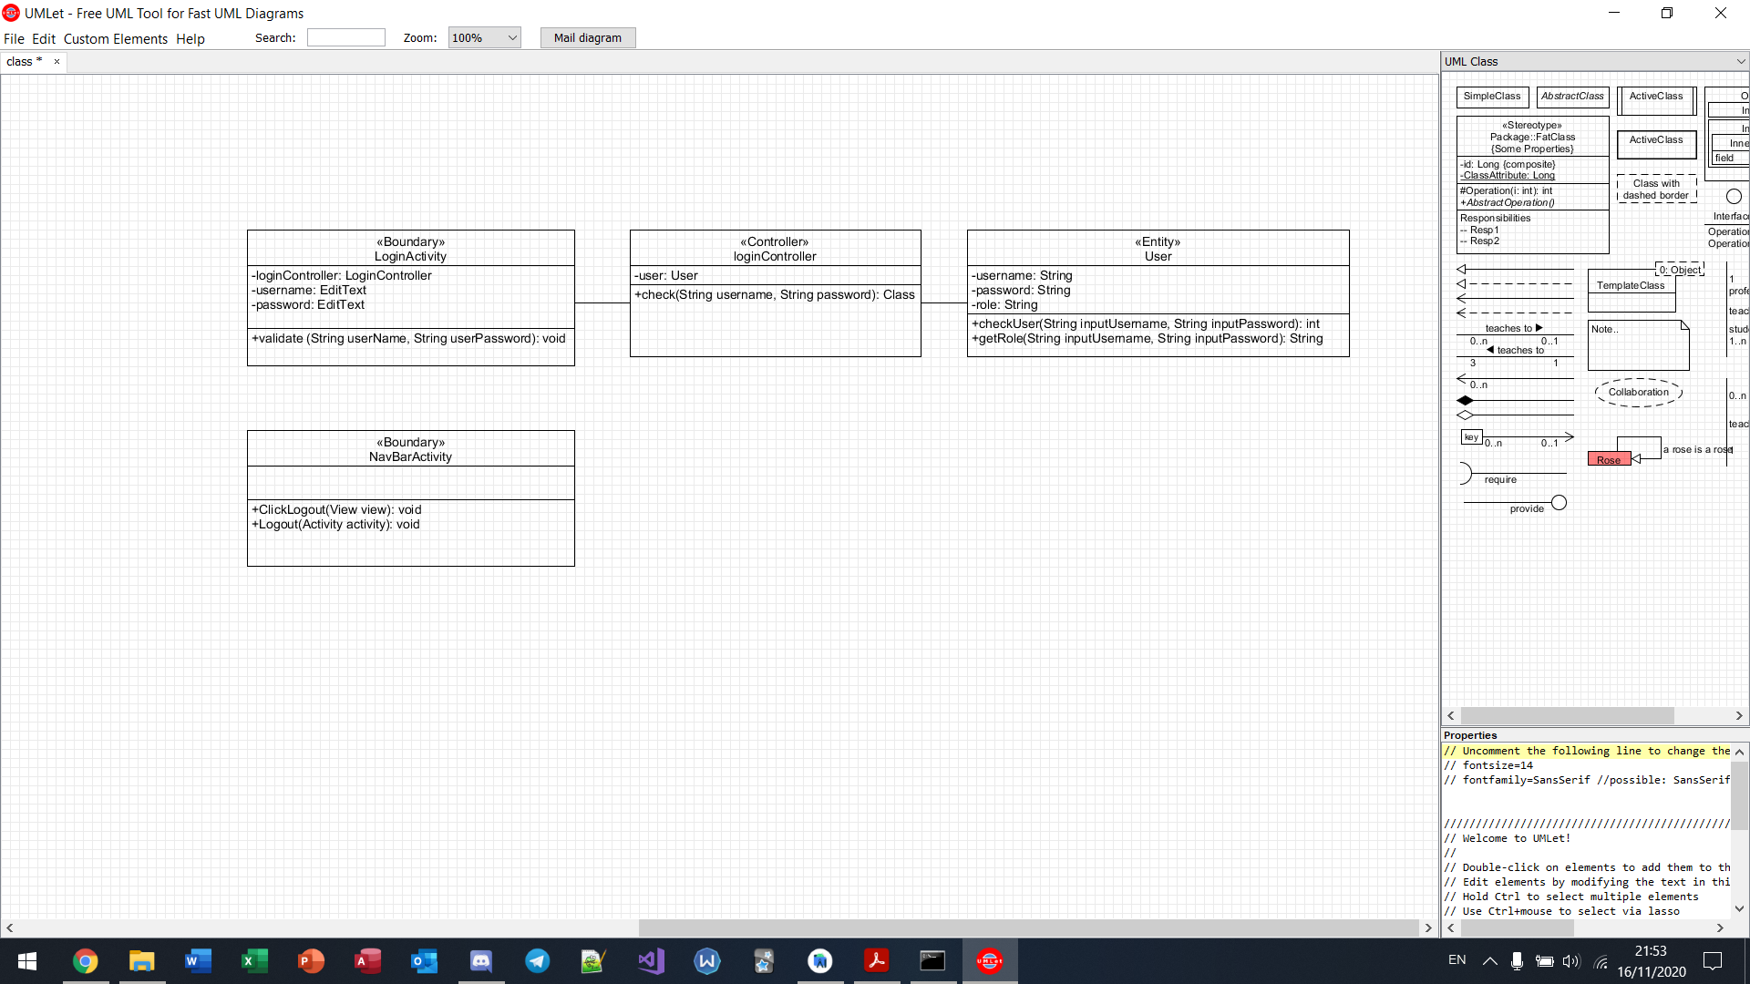

Logout

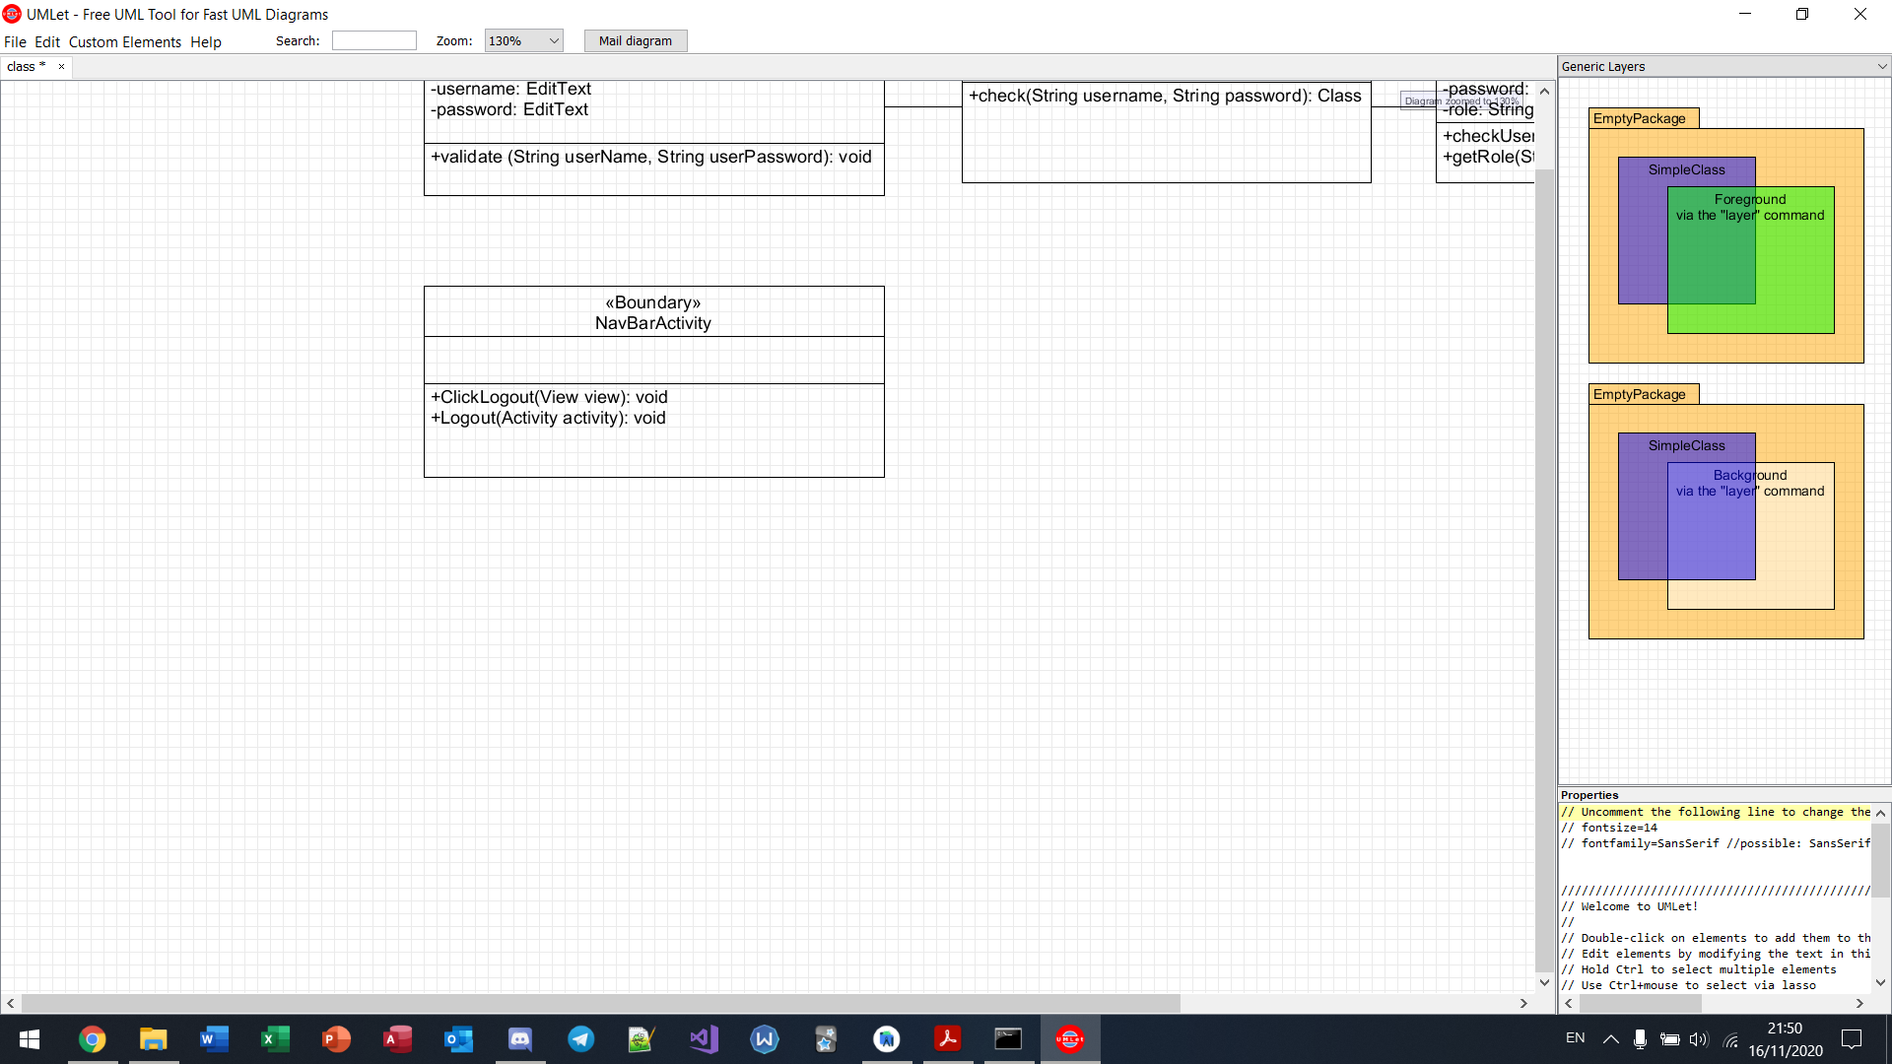

View all bugs

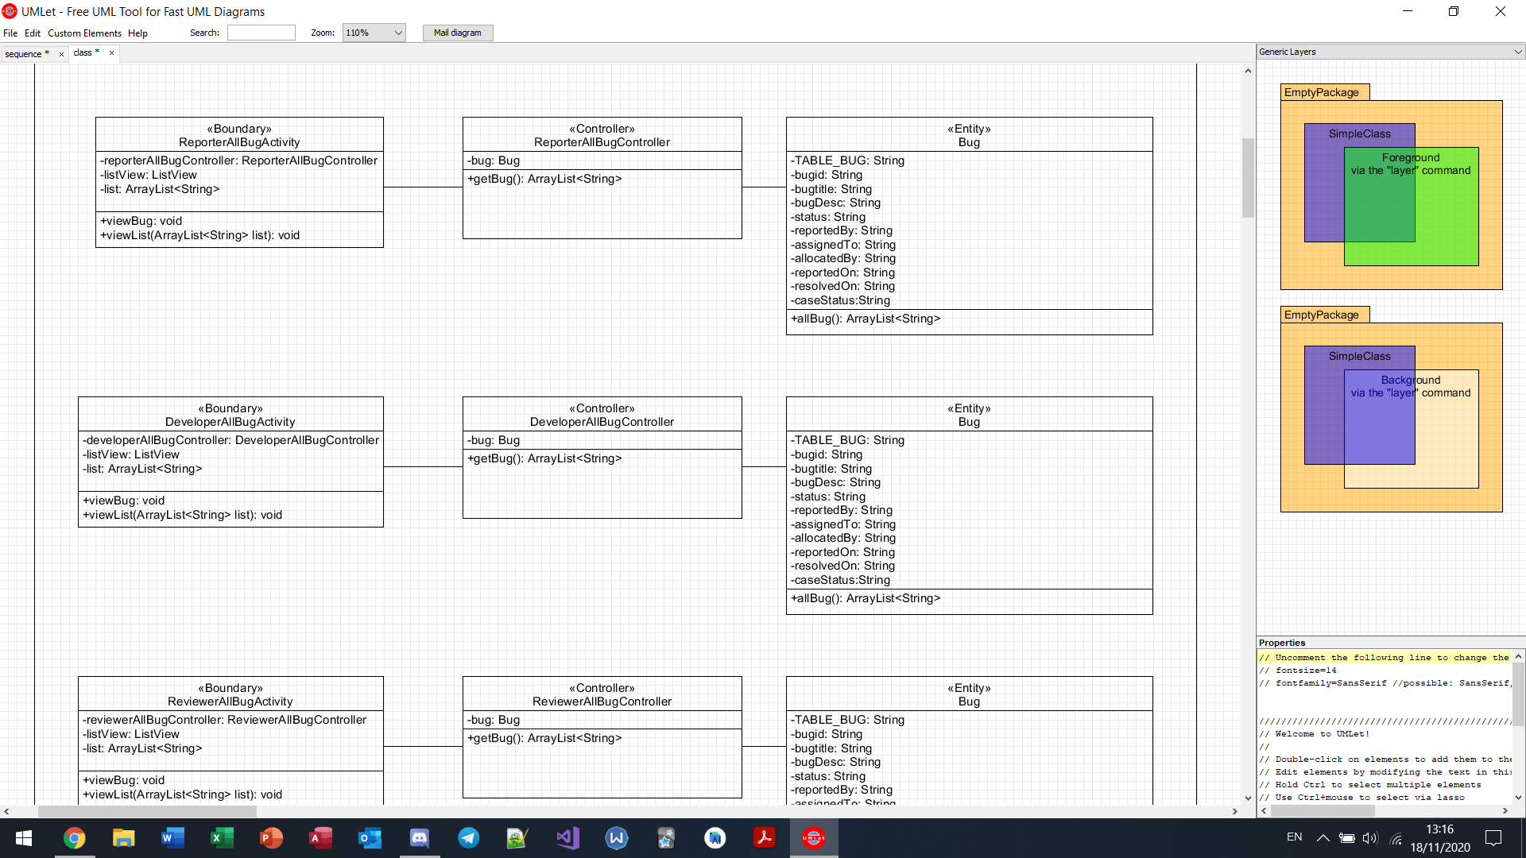



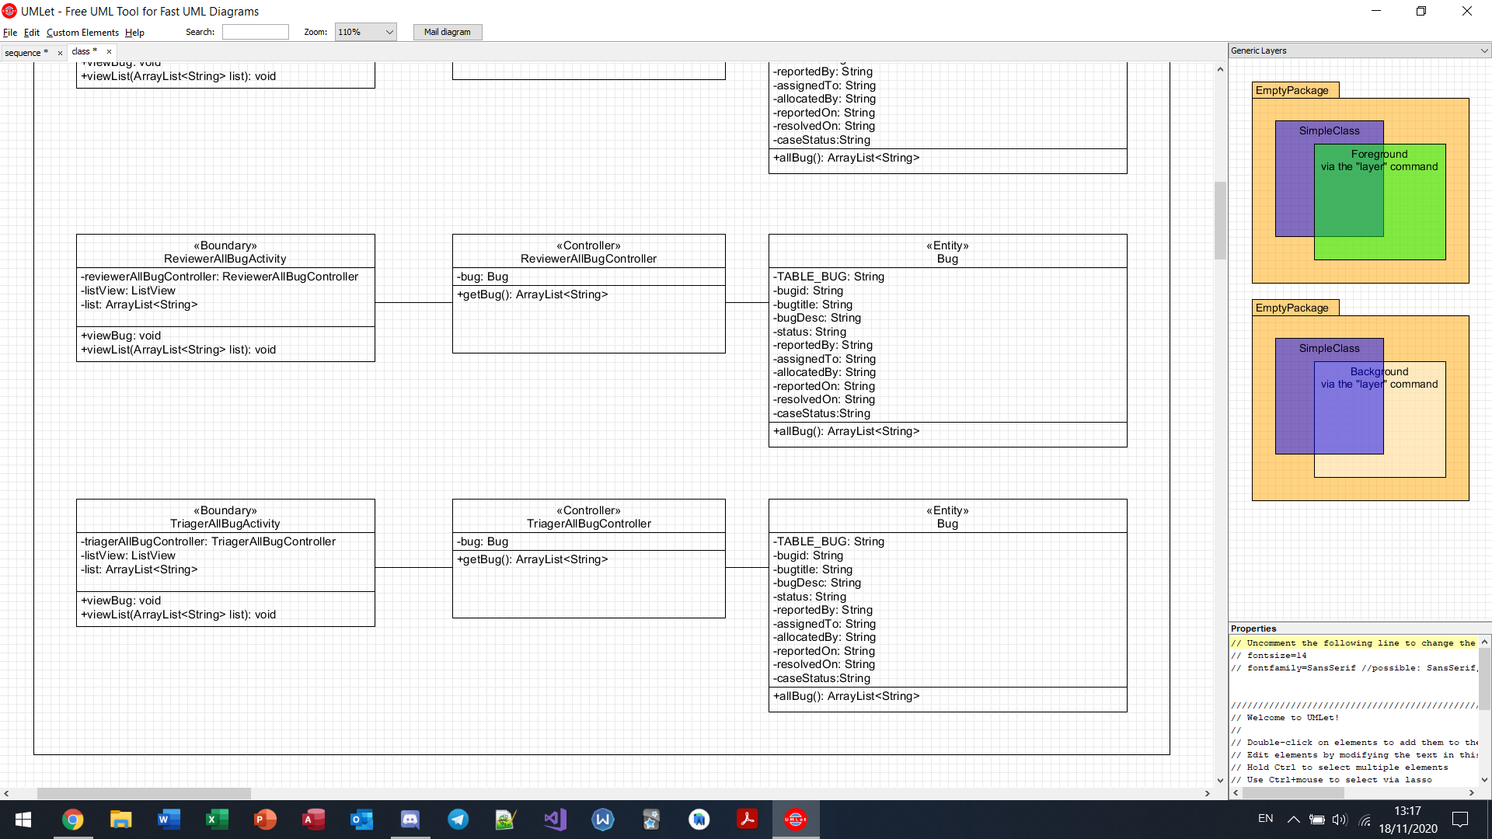



Search bugs by keyword

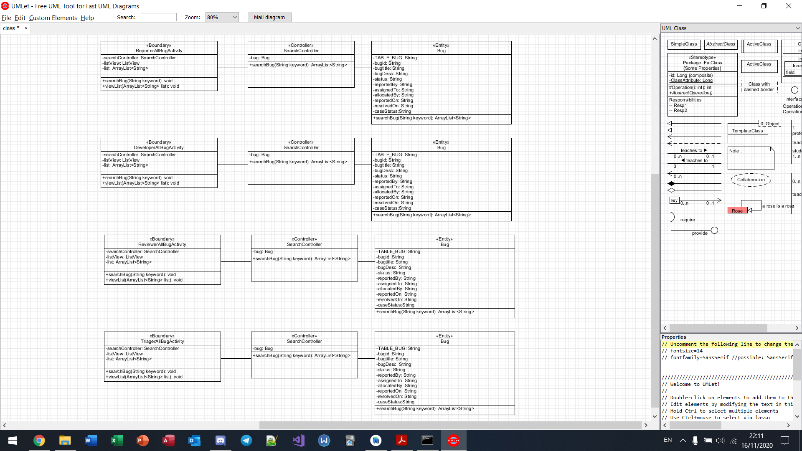







View forum comments

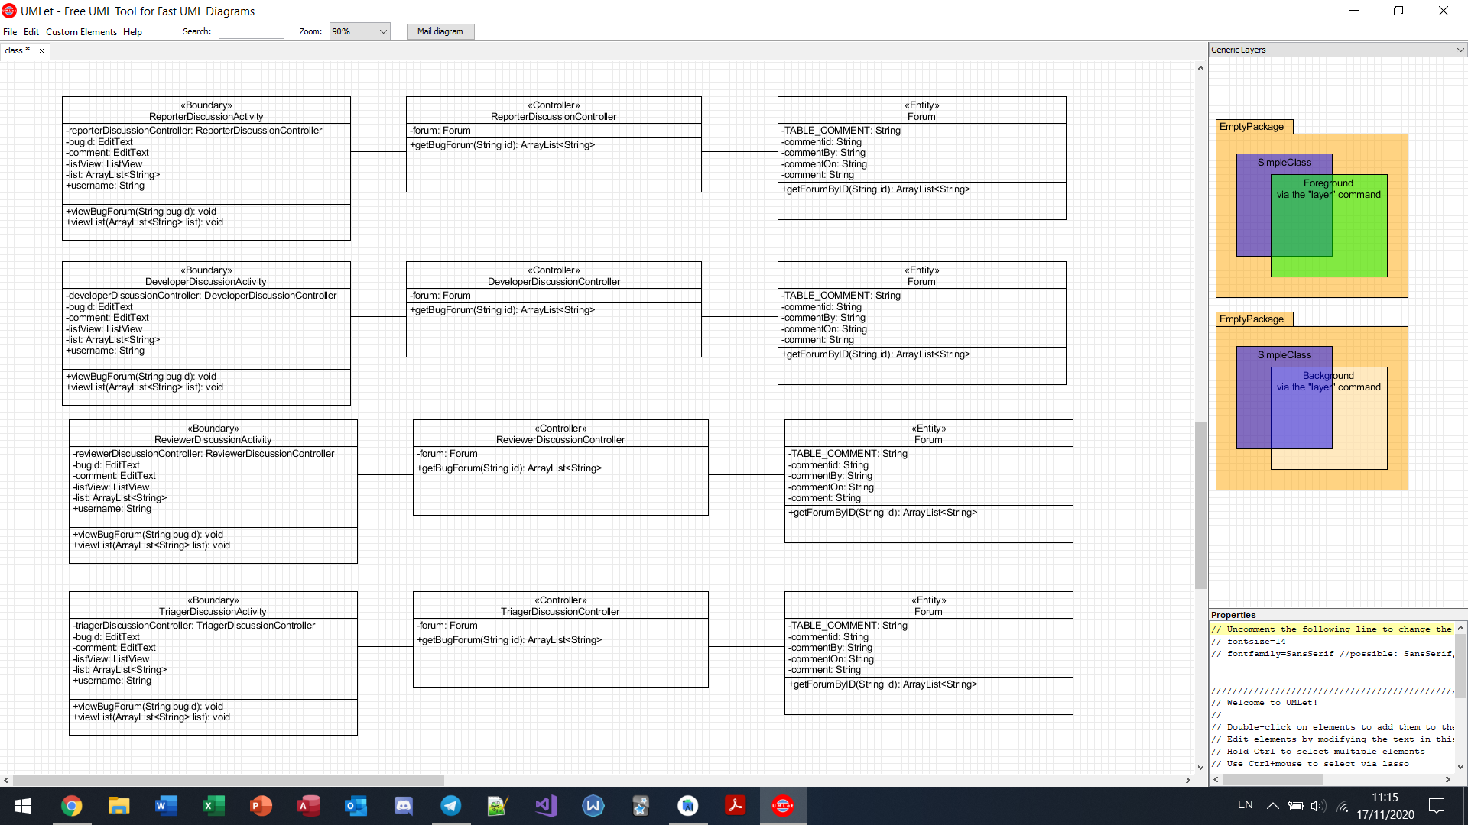







Insert comment into forum

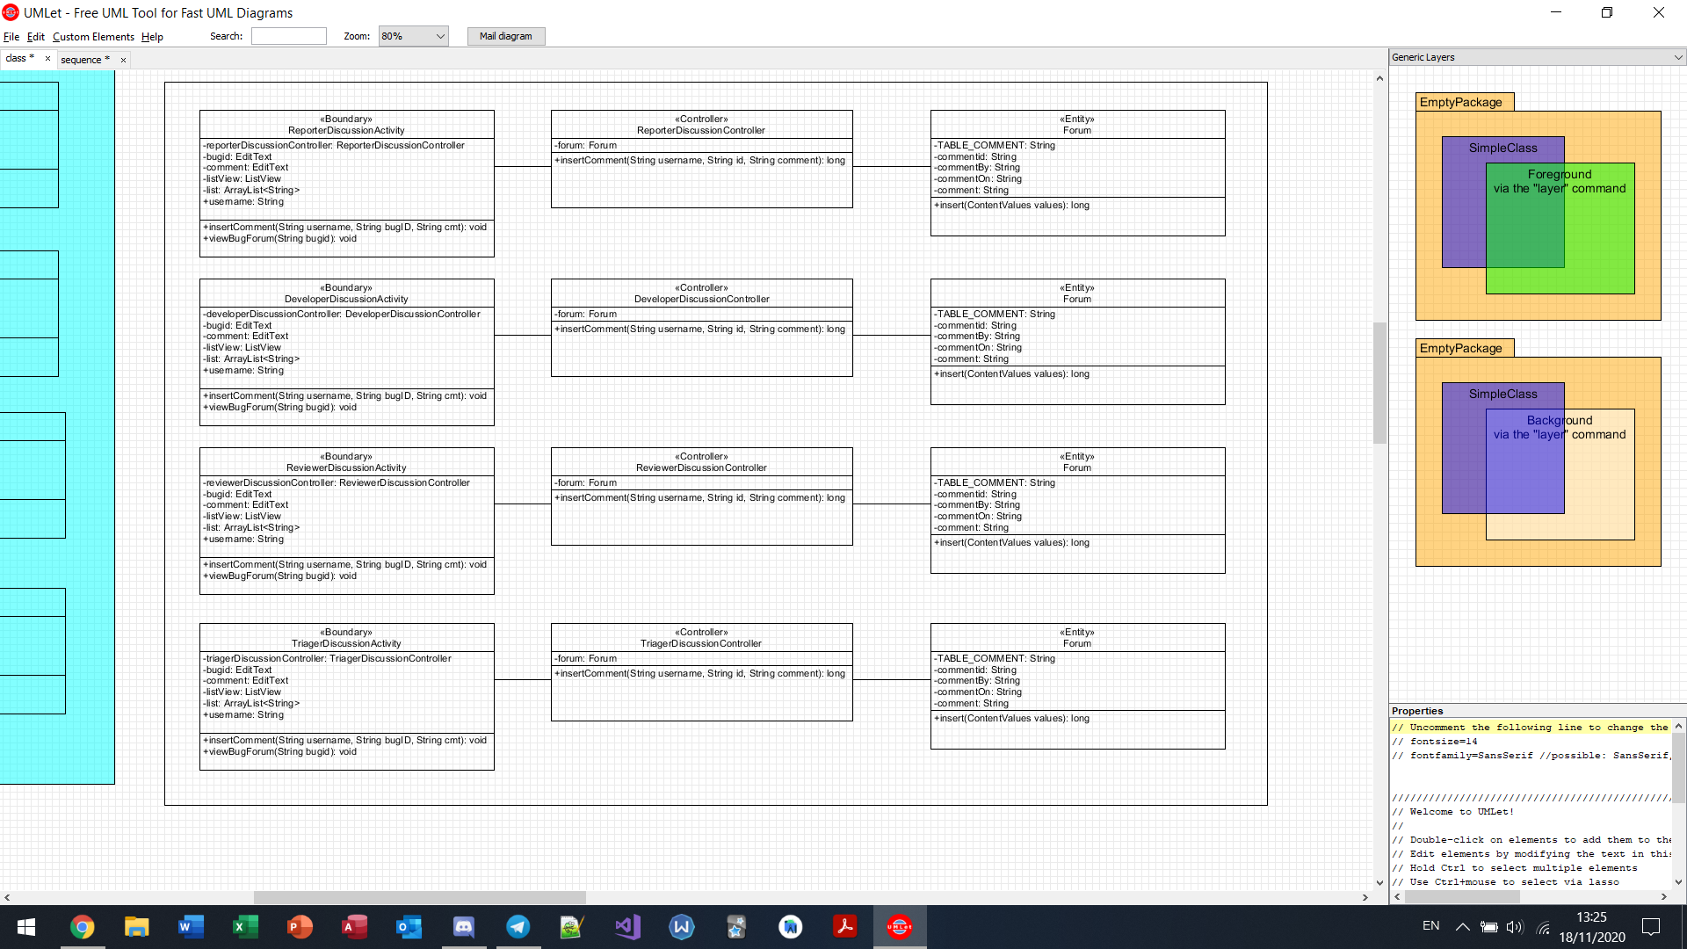







Submit report (reporter)

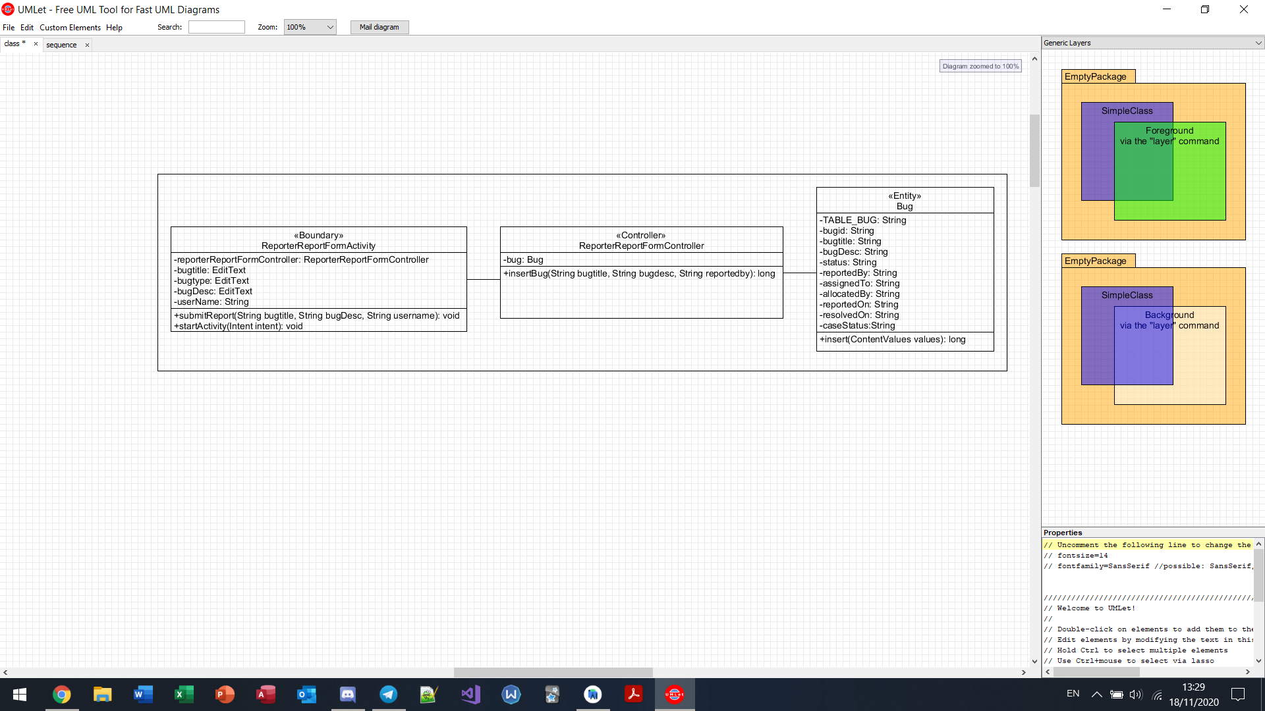

View my bugs (developer)

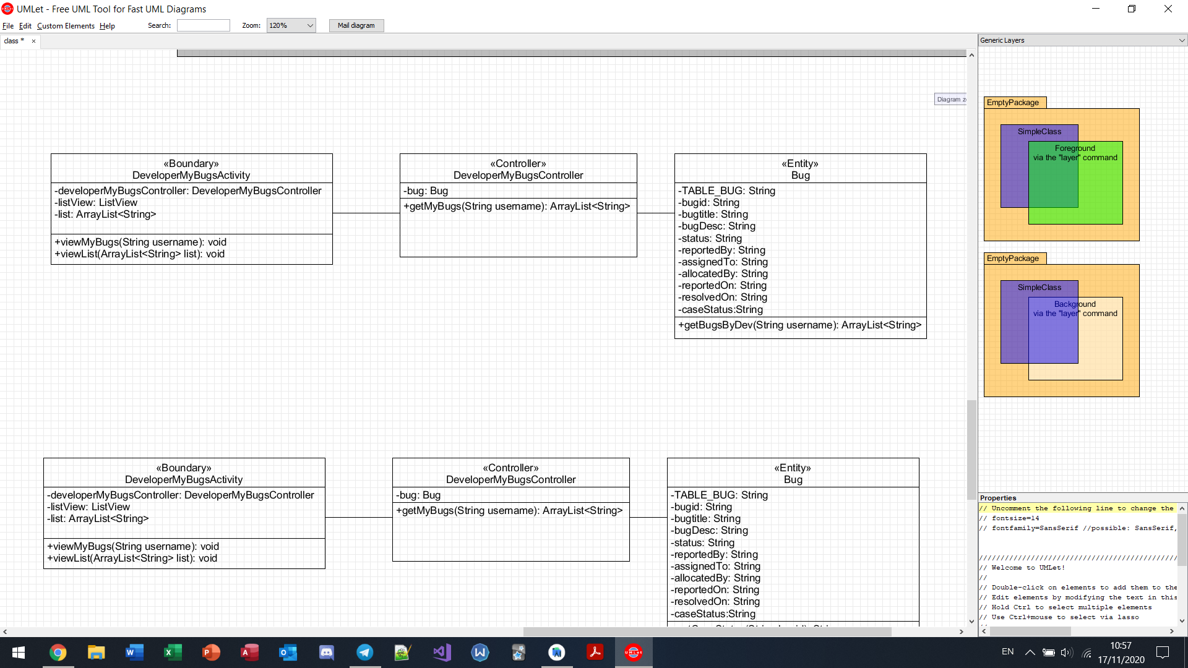

Mark bug as “pending review” (developer)

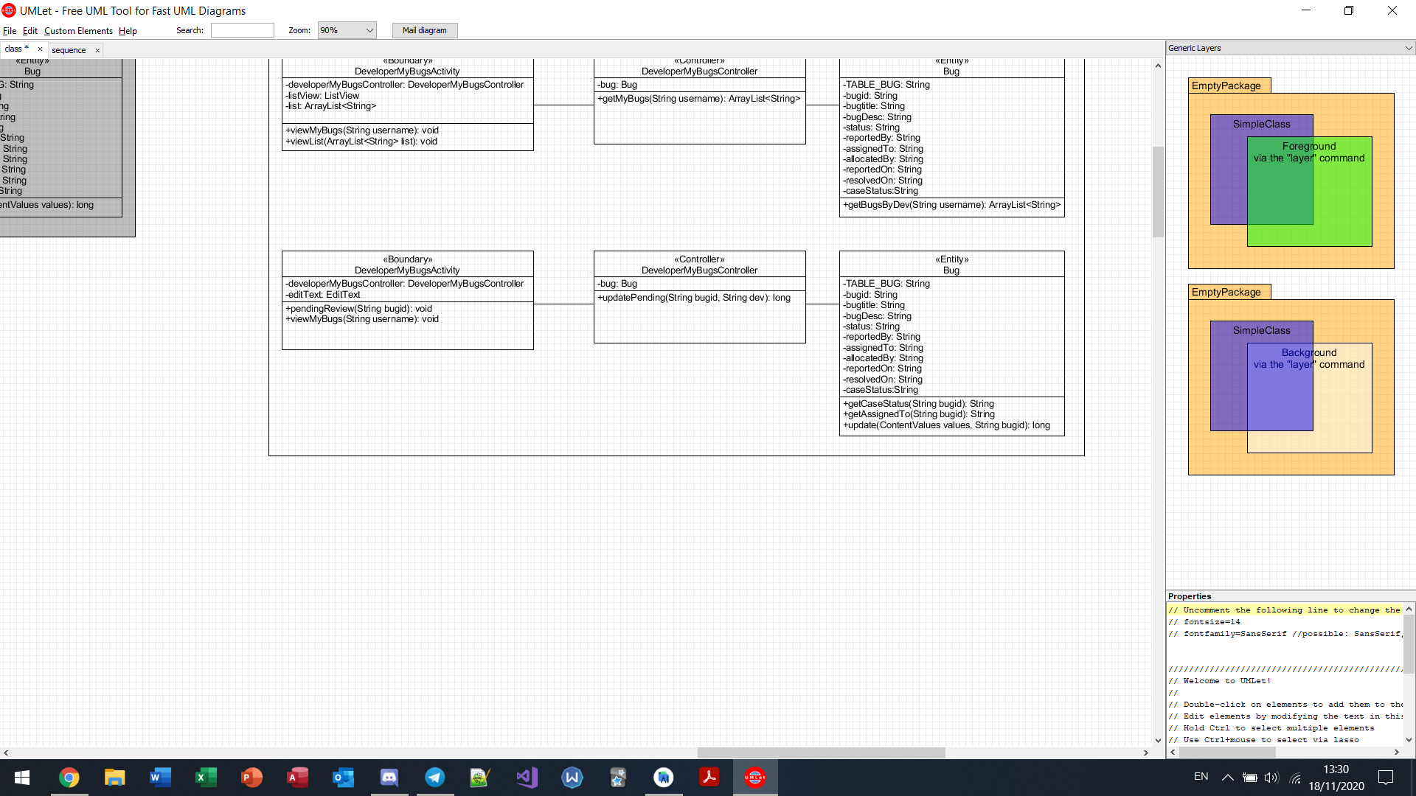

View “pending review” bugs (reviewer)

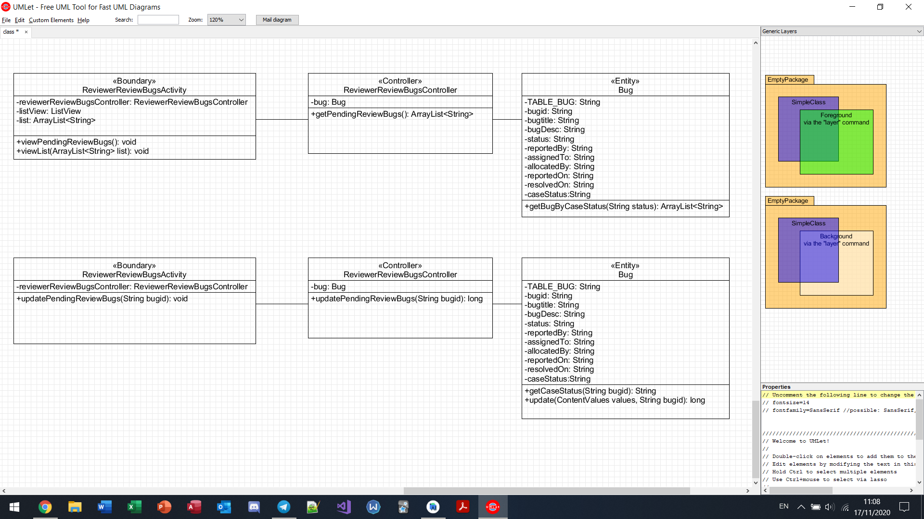

Update “pending review” bugs to “reviewed” (reviewer)

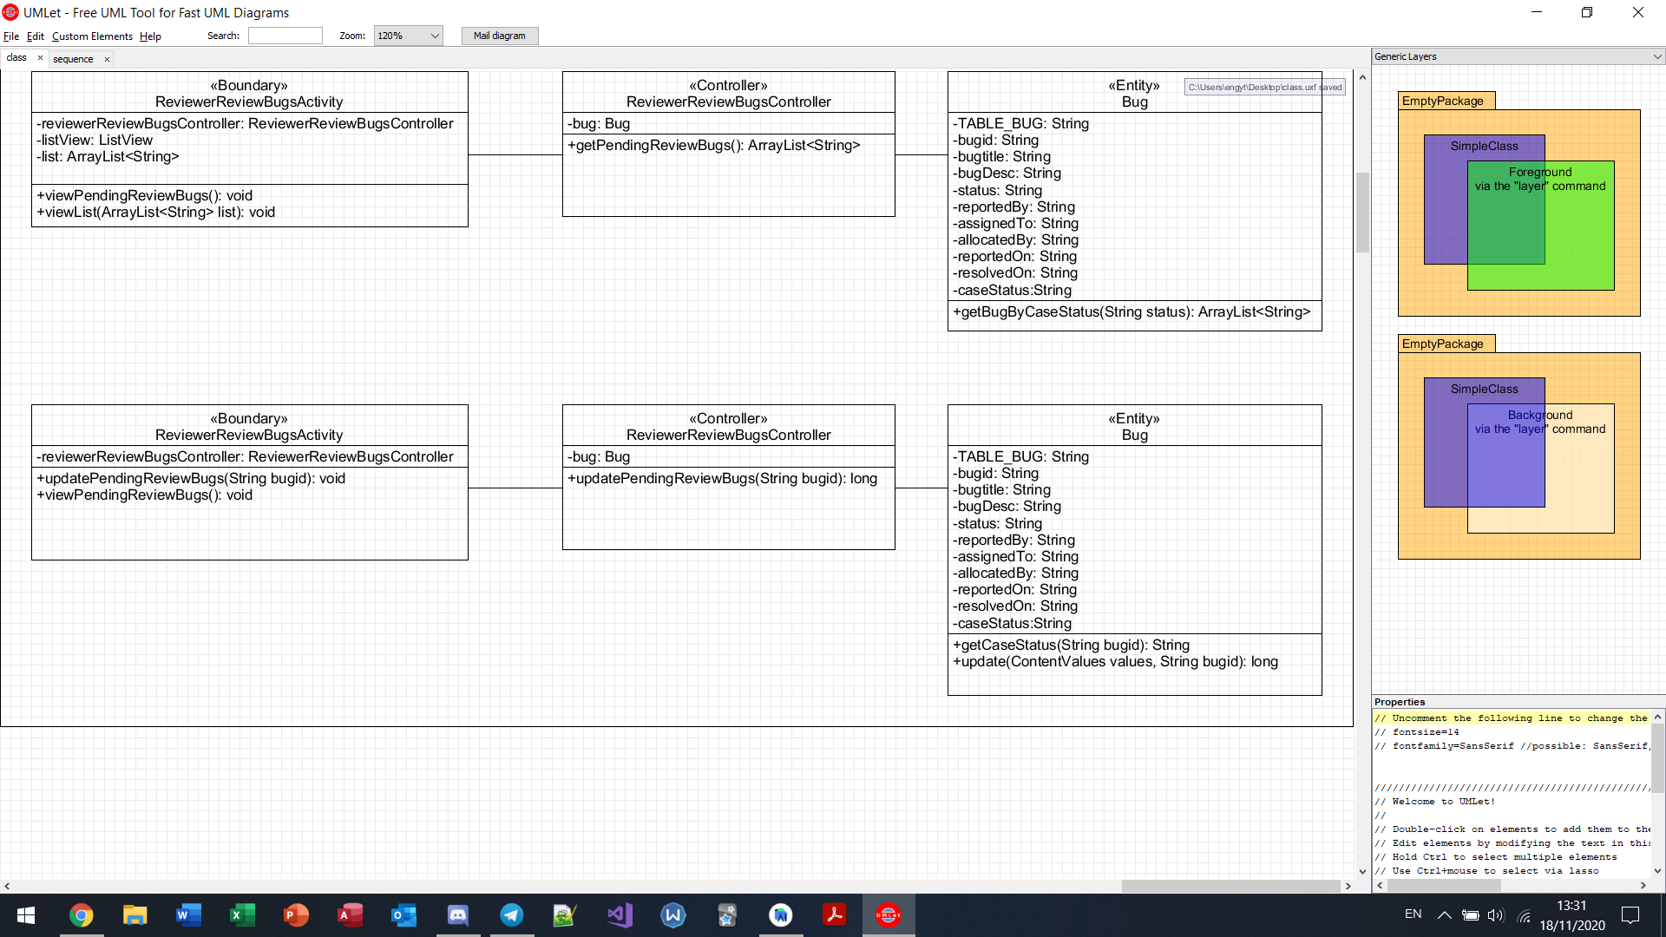

View unassigned bug (triager)

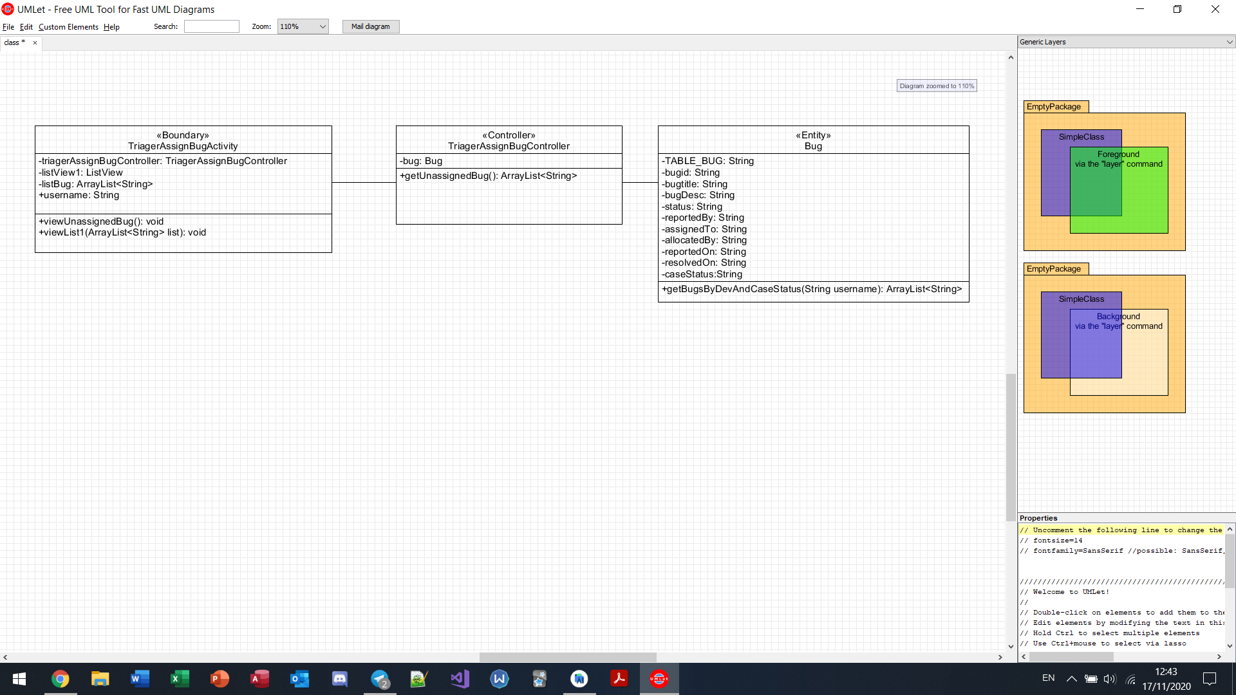

View developers (triager)

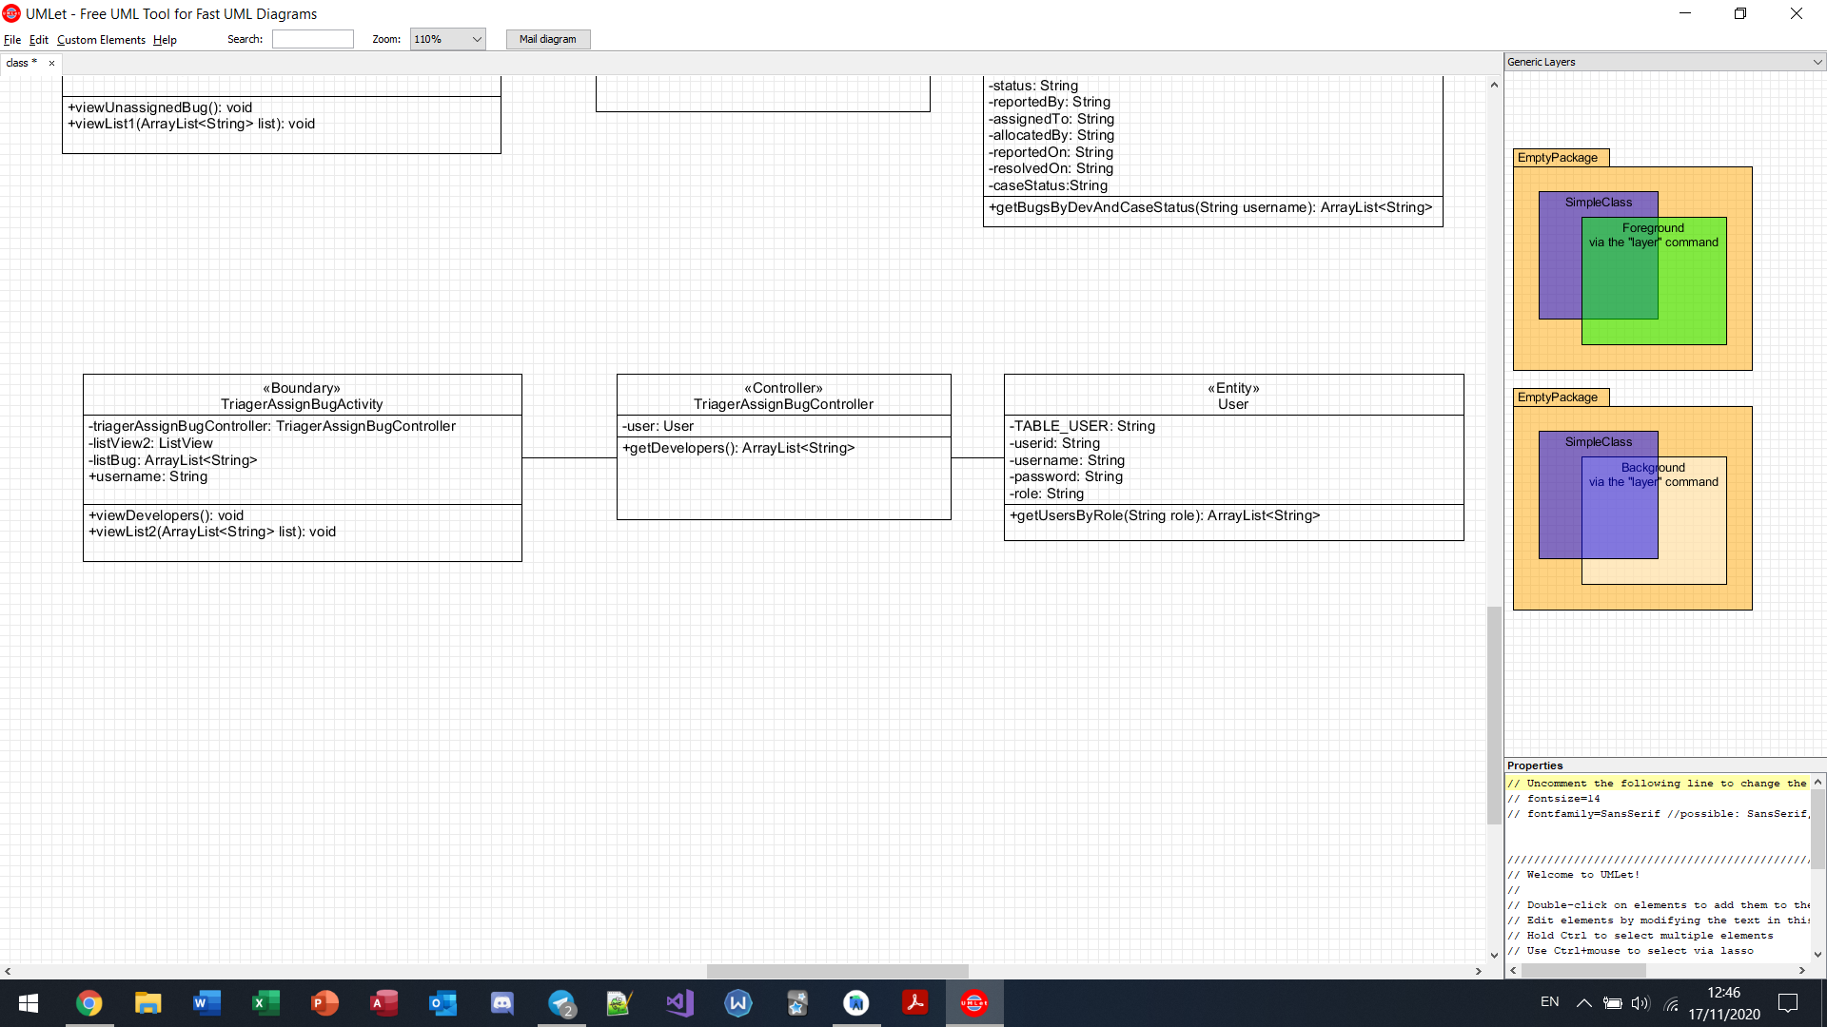

Assign bug (triager)

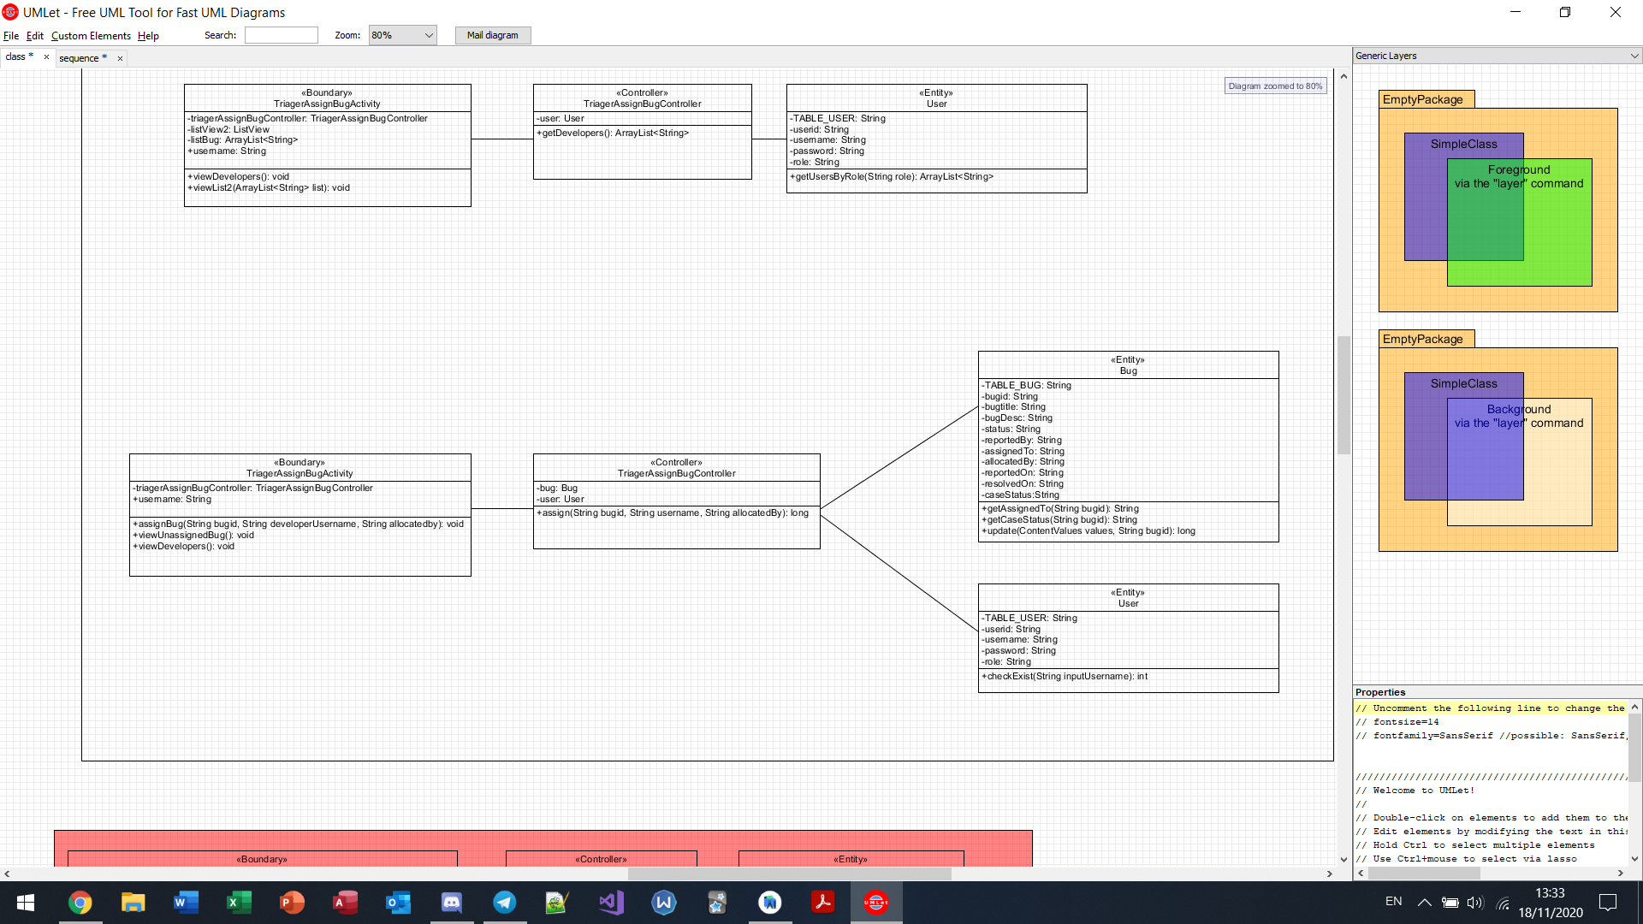

View unresolved bugs (triager)

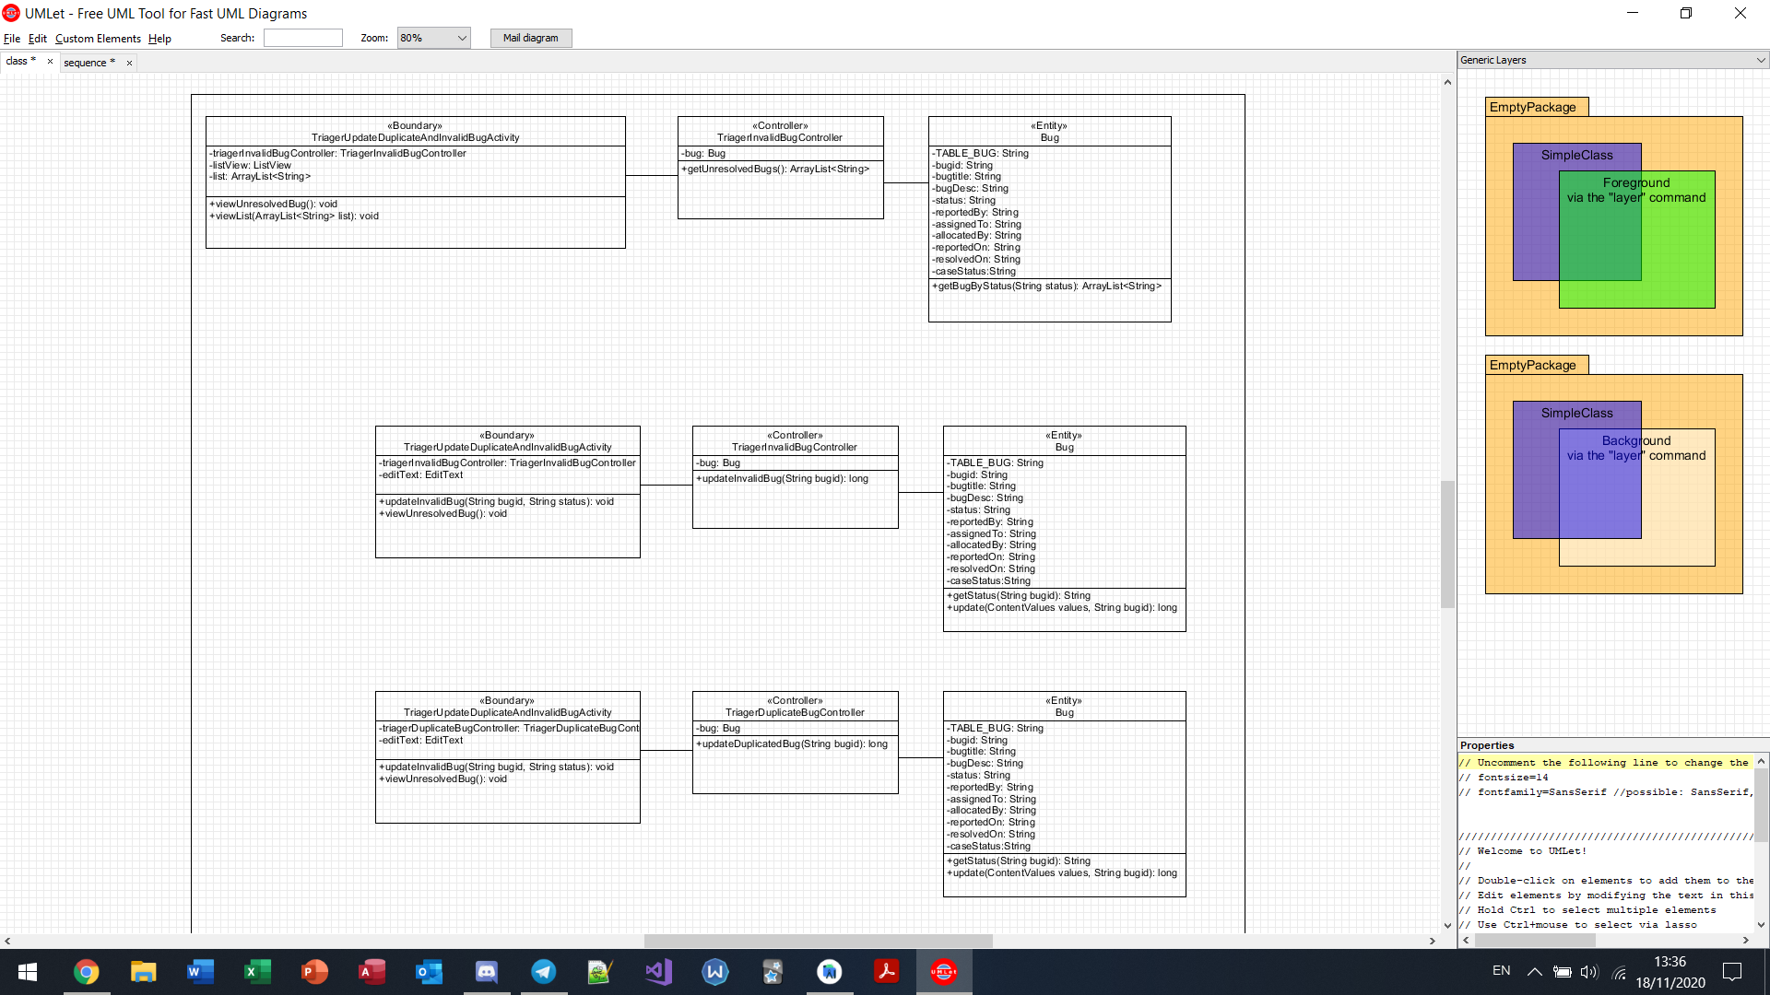

Mark bug as “invalid” (triager)



Mark bug as “duplicated” (triager)



View bugs reported in a month (Triager)

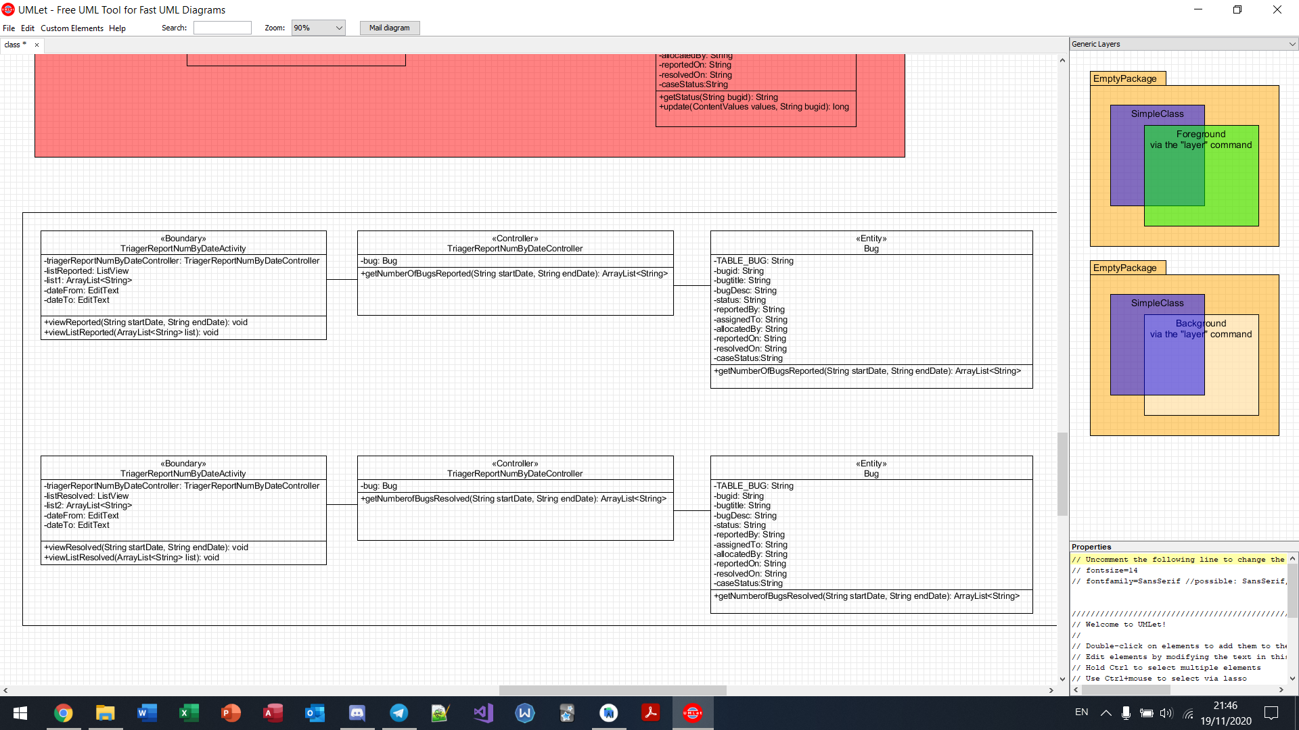

View bugs resolved in a week(Triager)

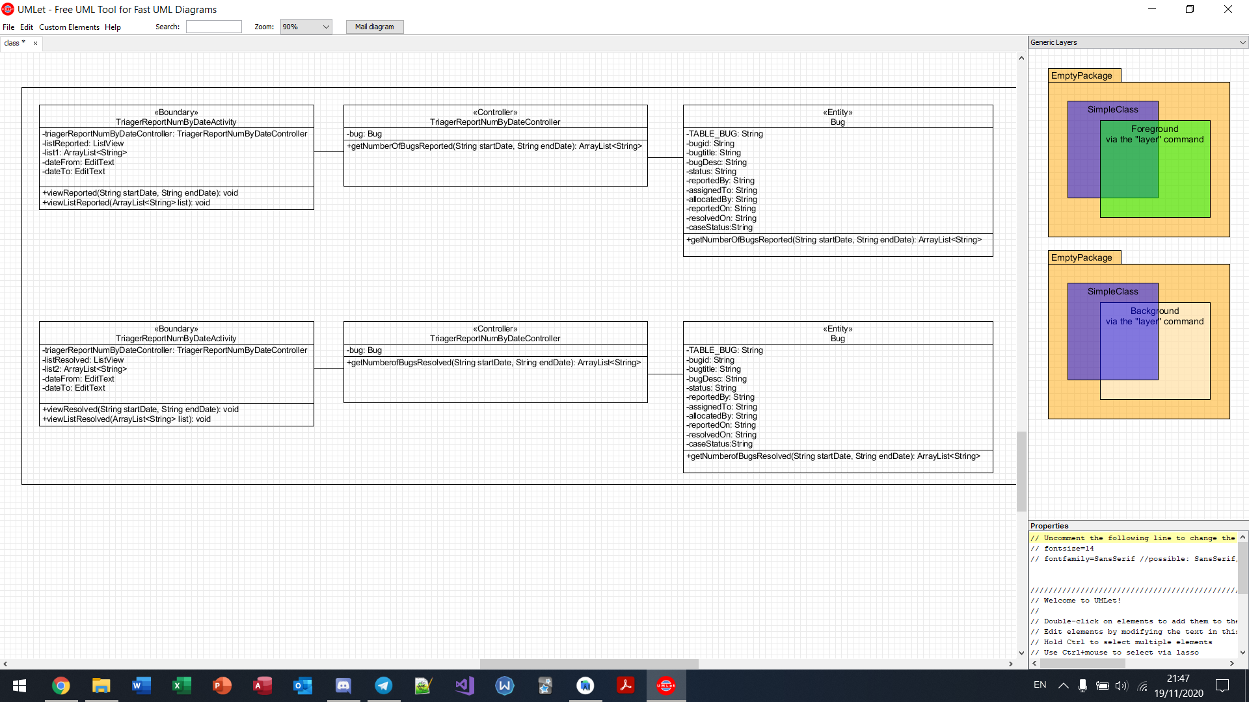

View best performed developer (Triager)

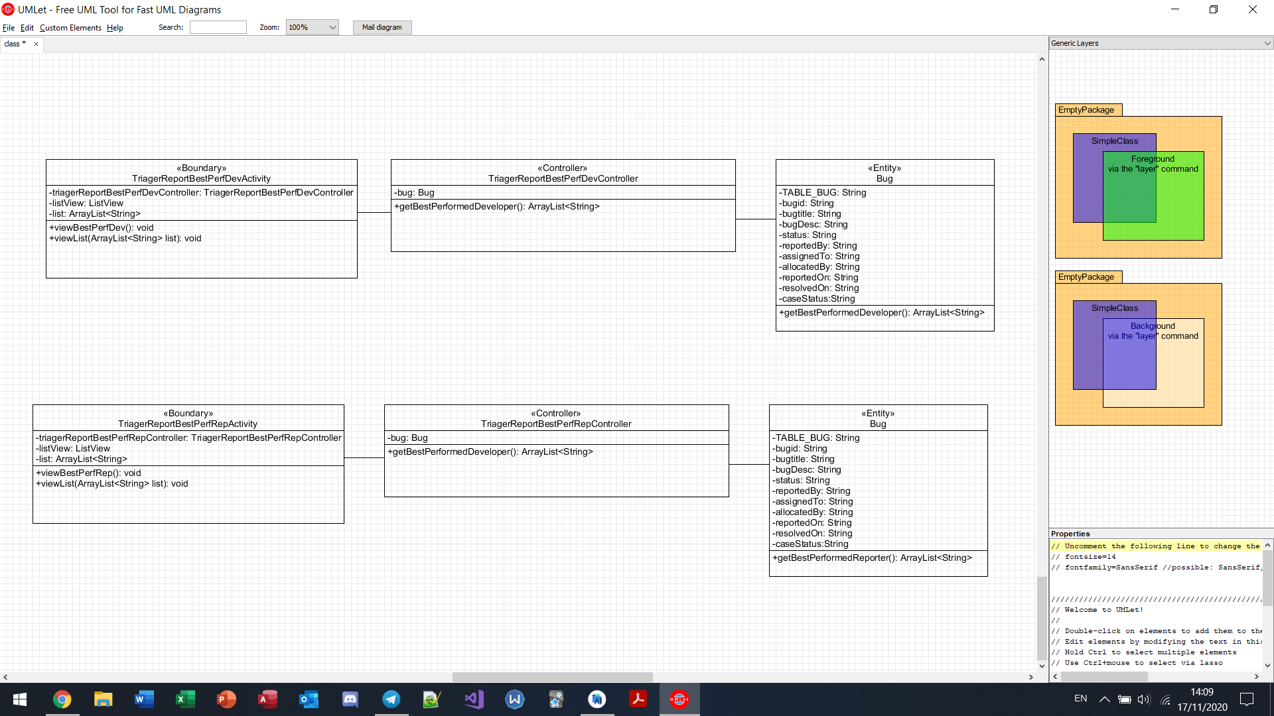

View best performed reporter (Triager)

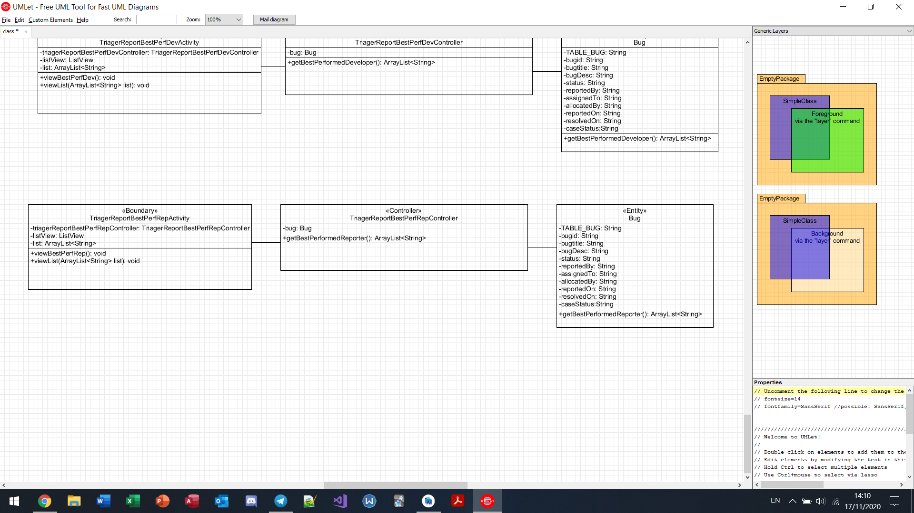

View “reviewed” bugs (triager)

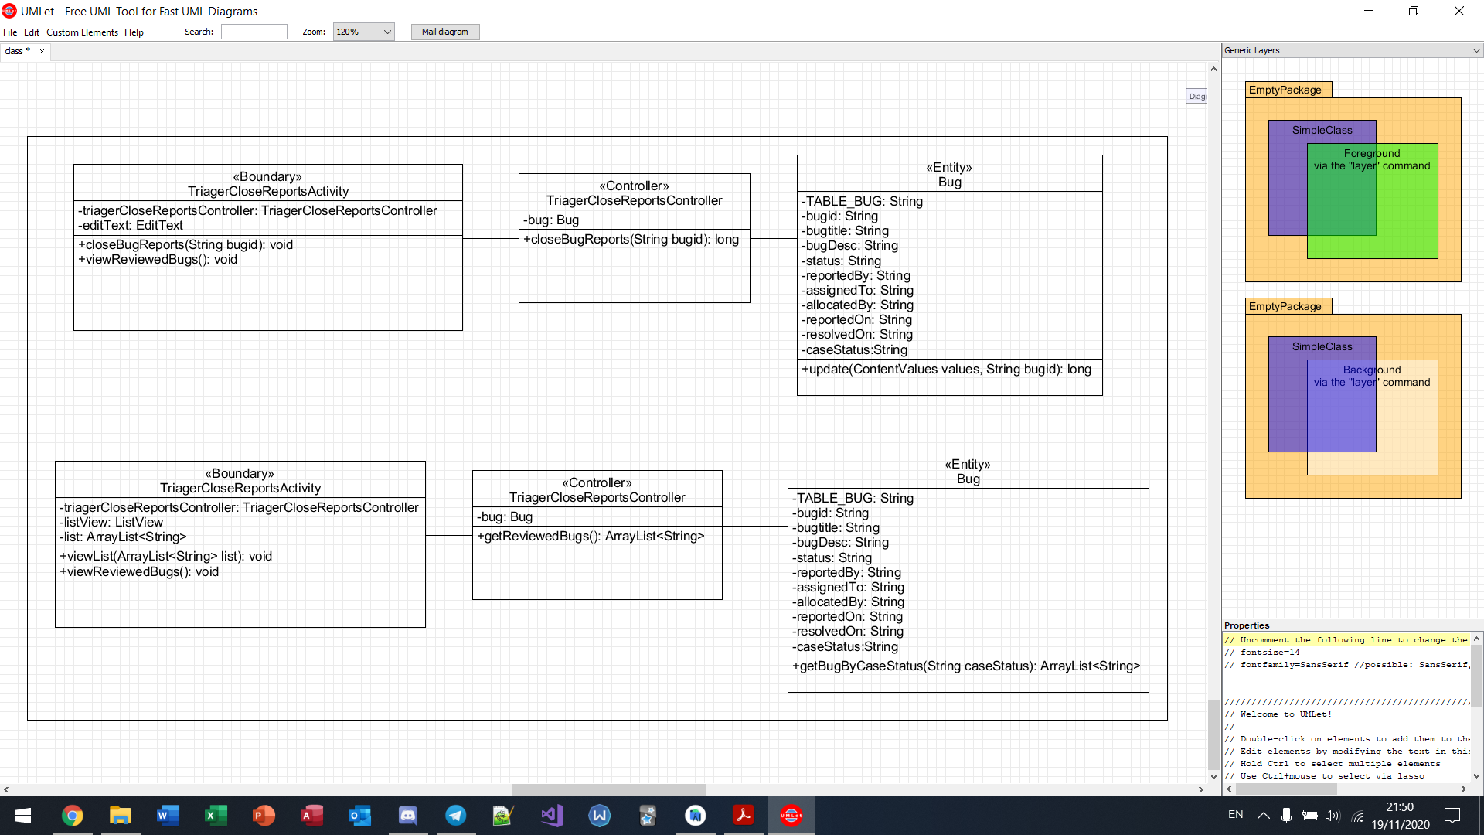

Close bug (triager)



# 

# 

# 

# 

# **7. BCE Sequence Diagram**

Login

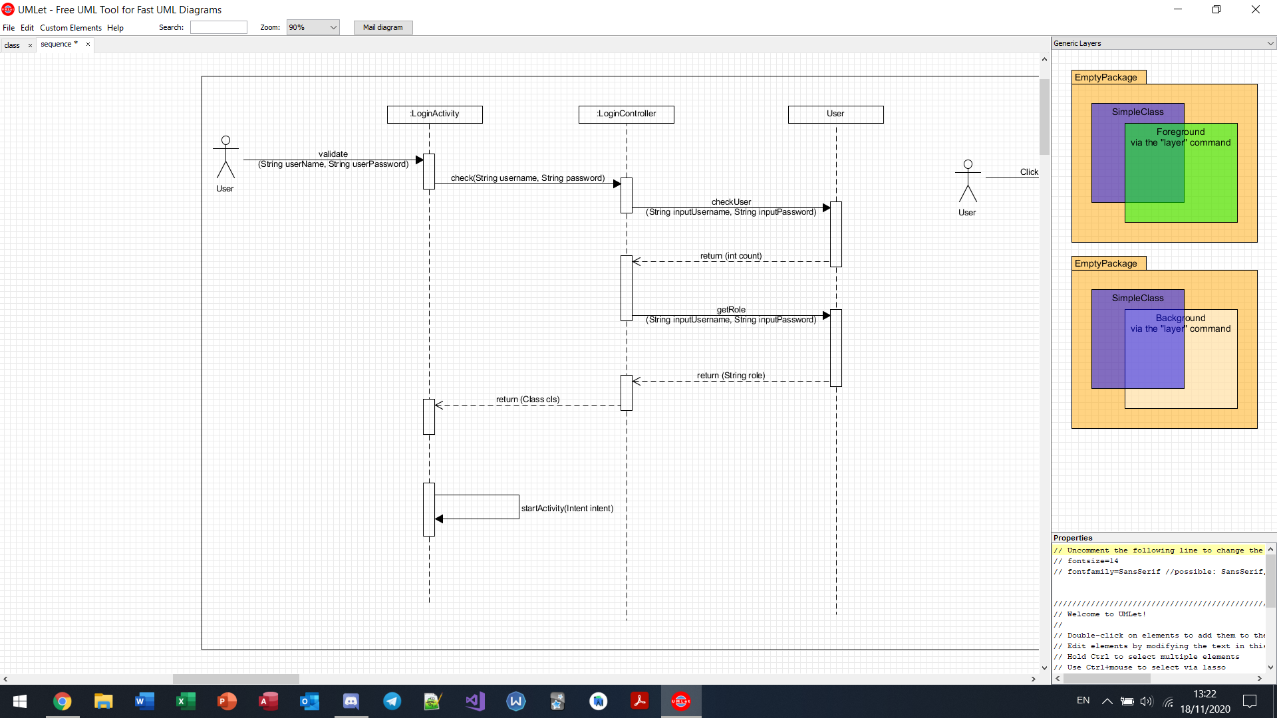

Logout

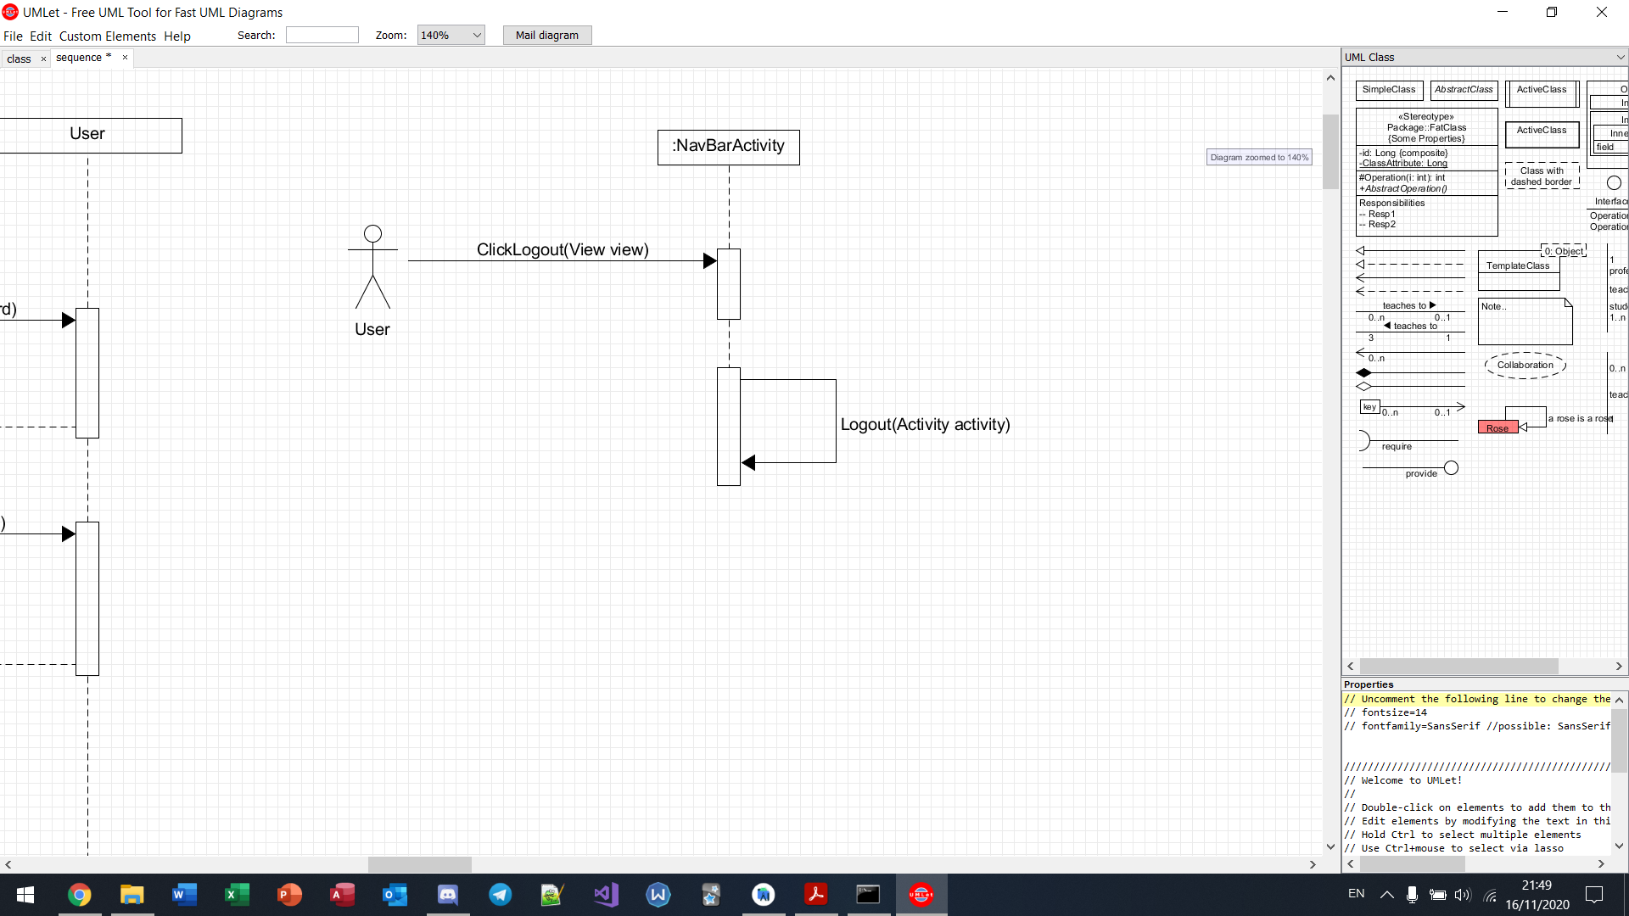

View all bugs

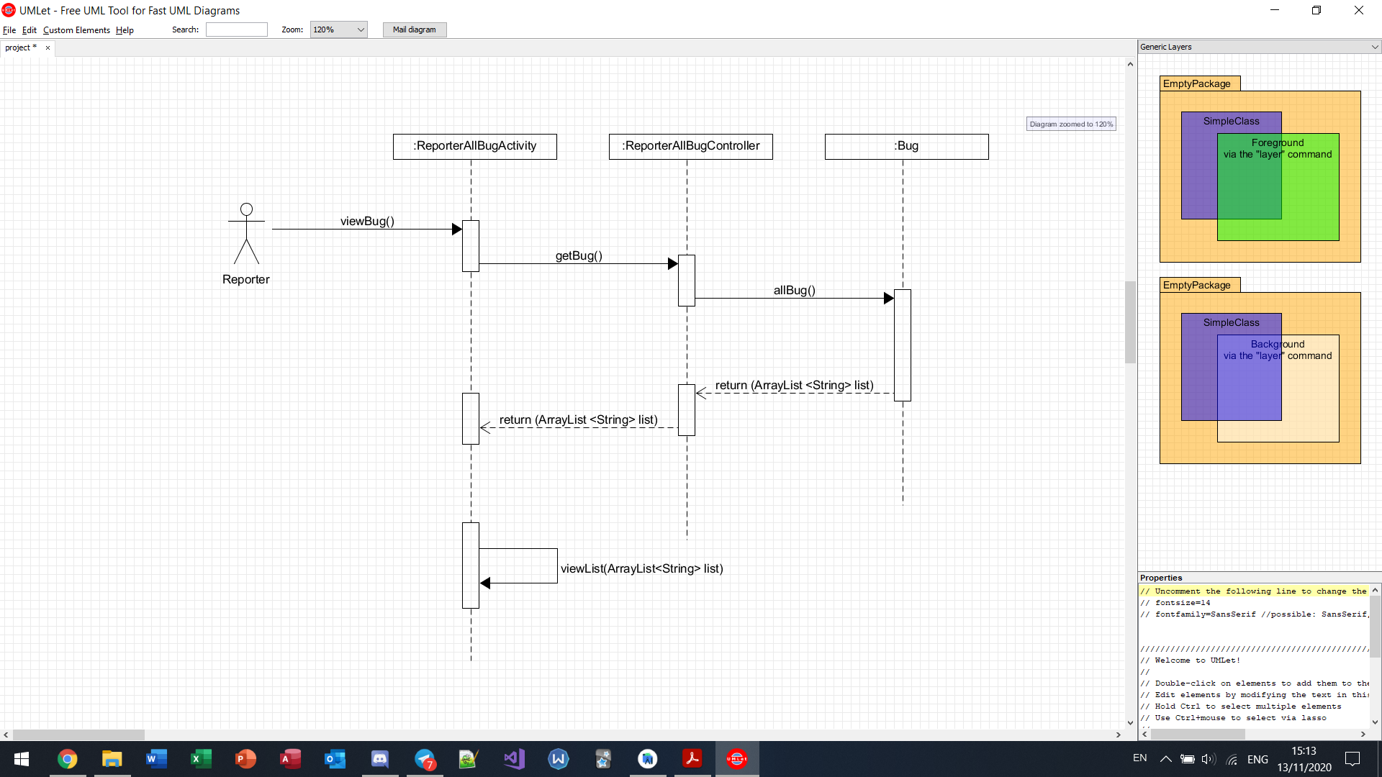

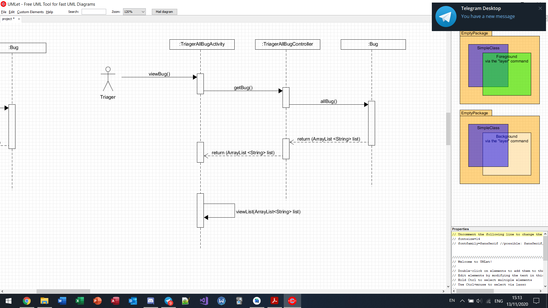

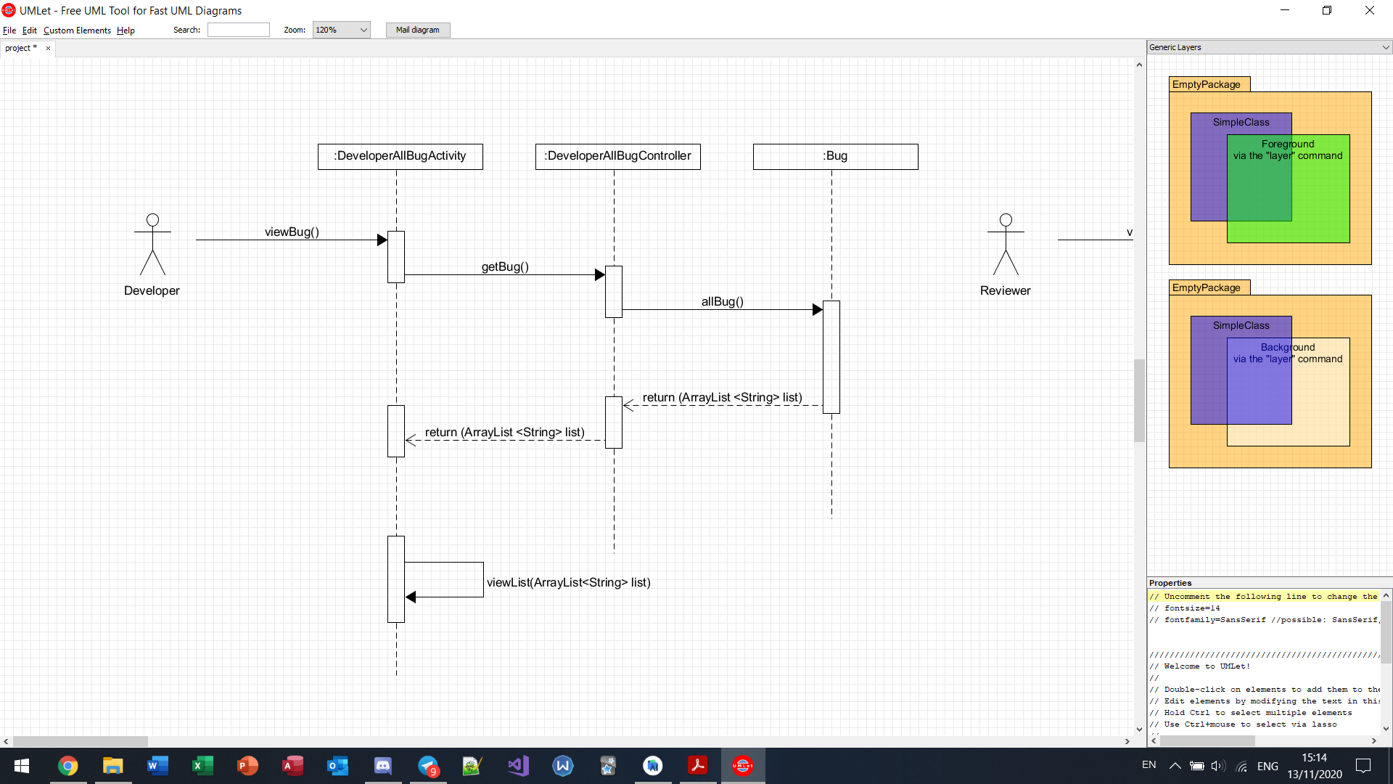

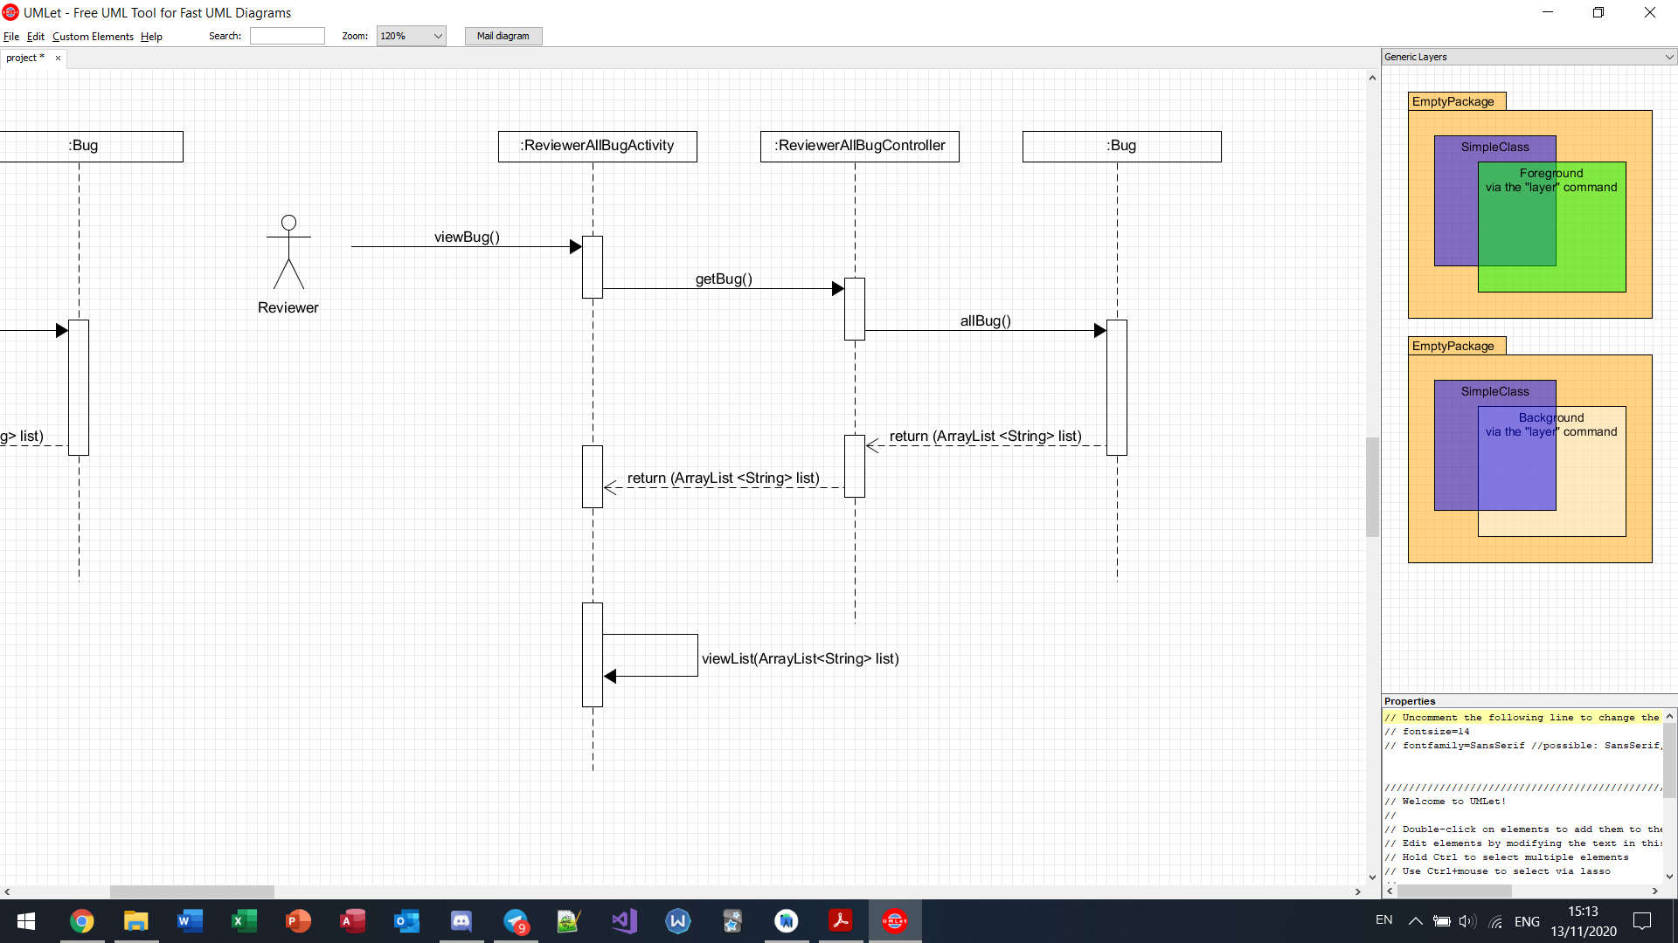

Search bugs by keyword

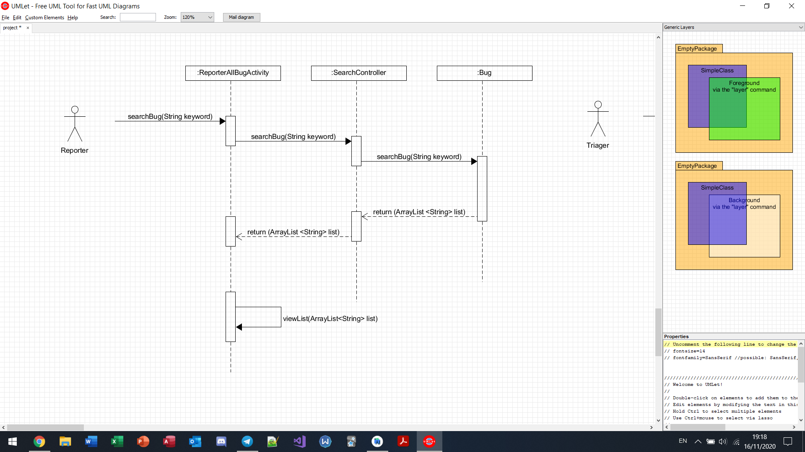

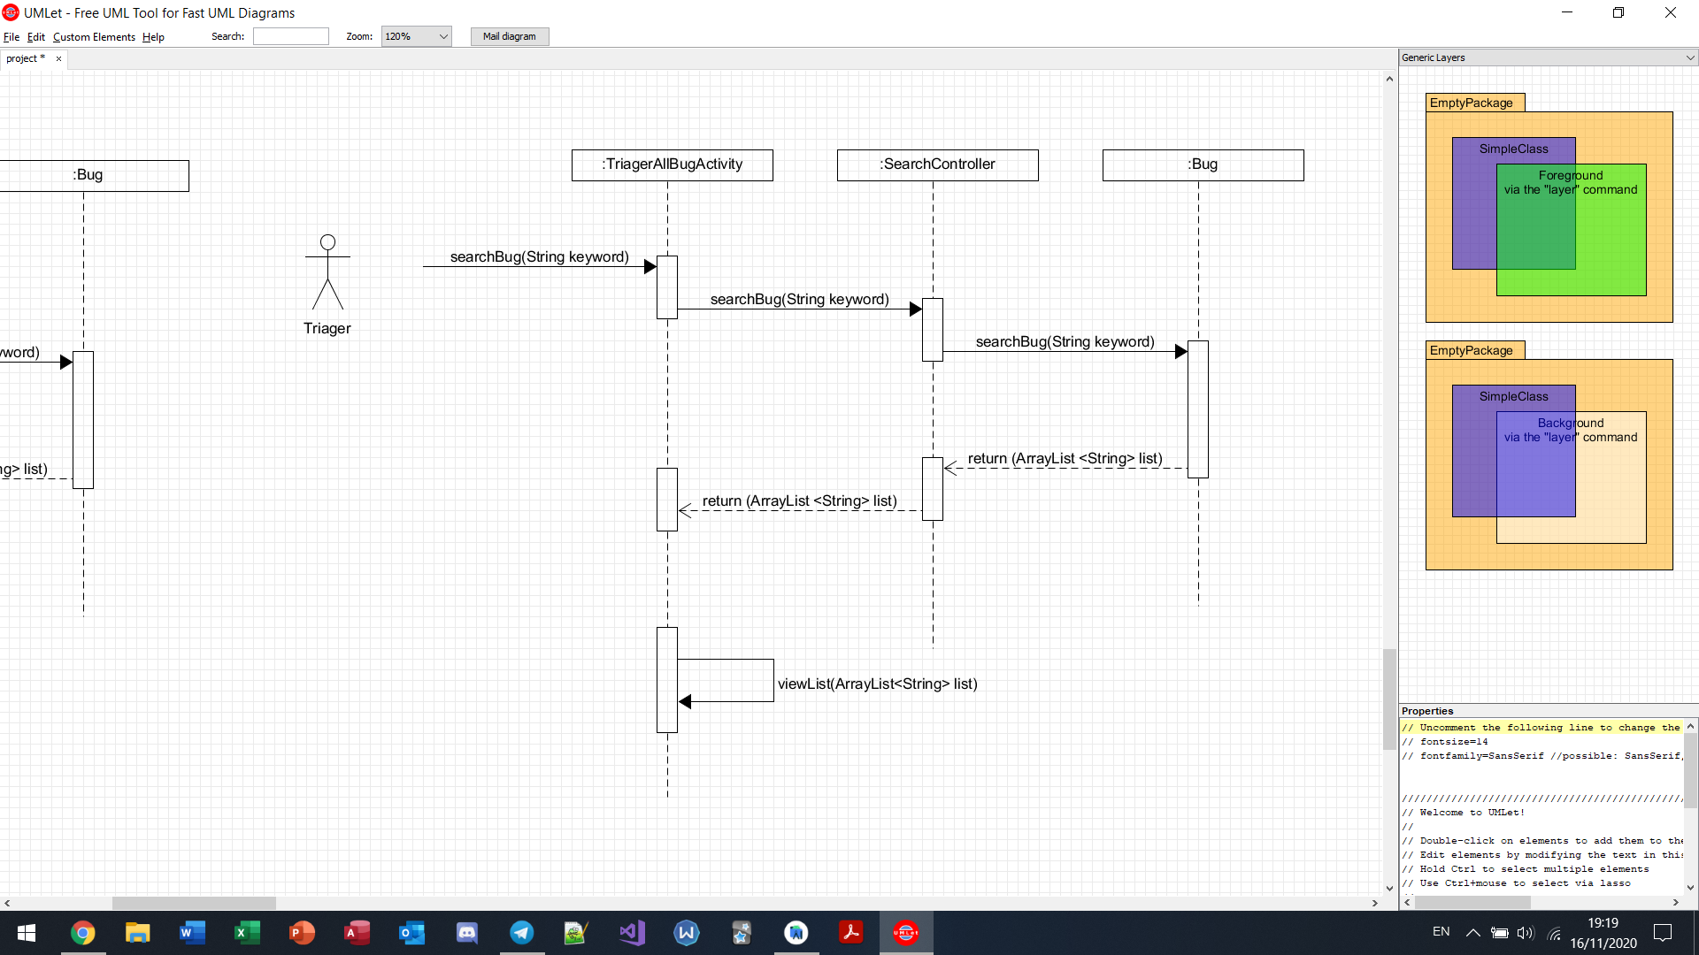

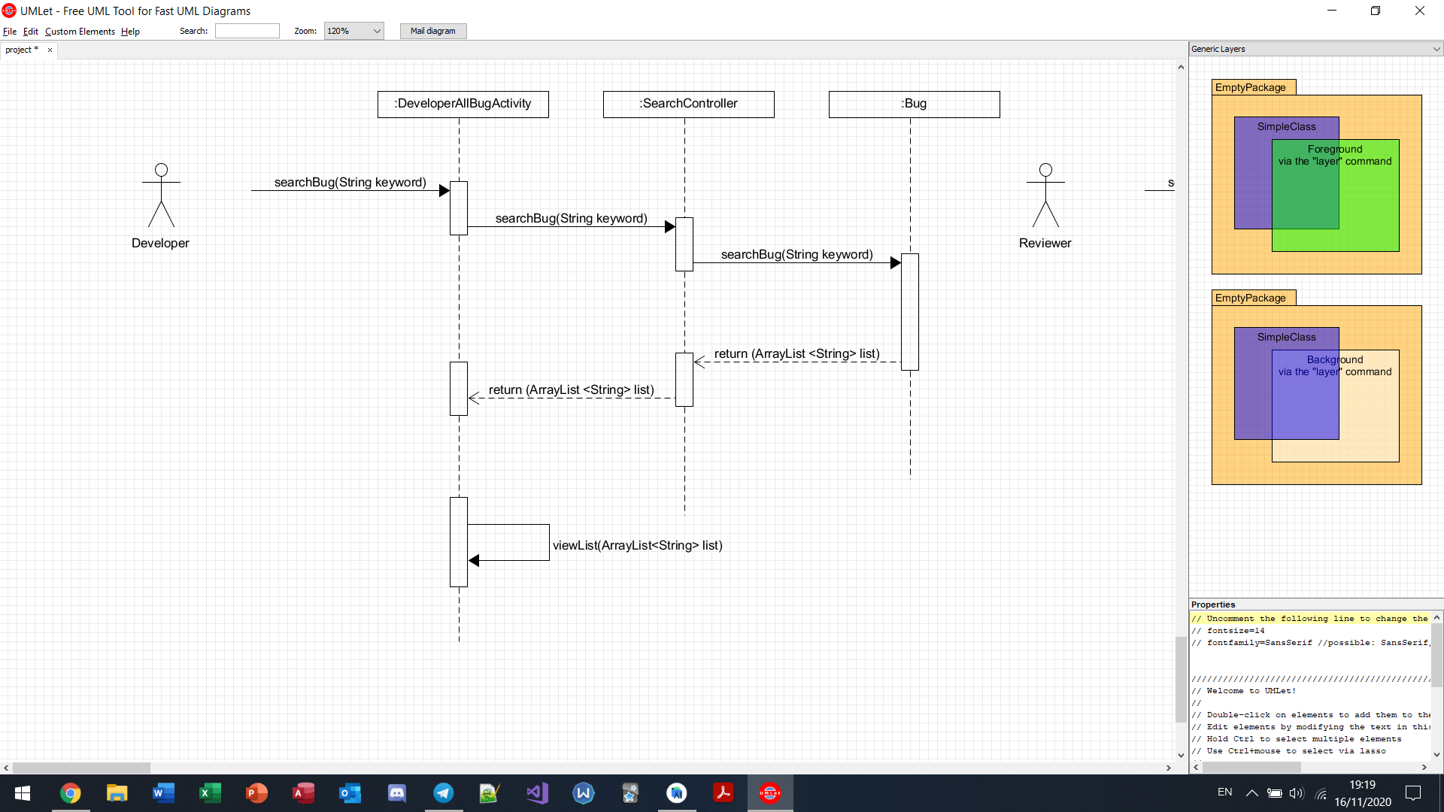

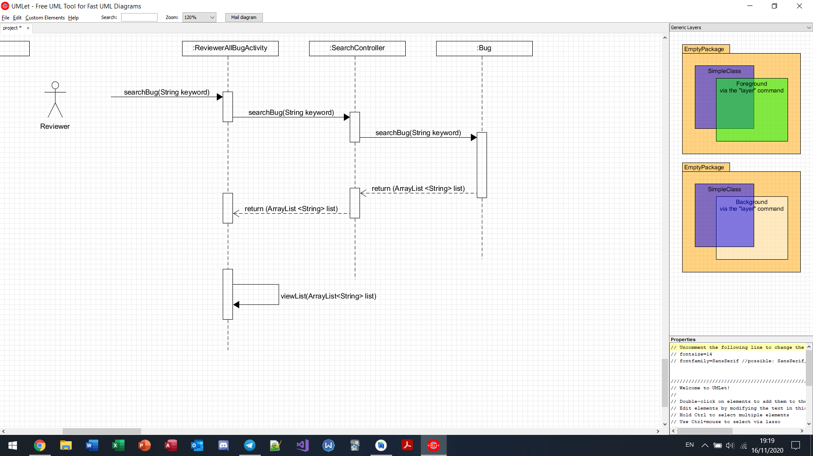

View forum comments

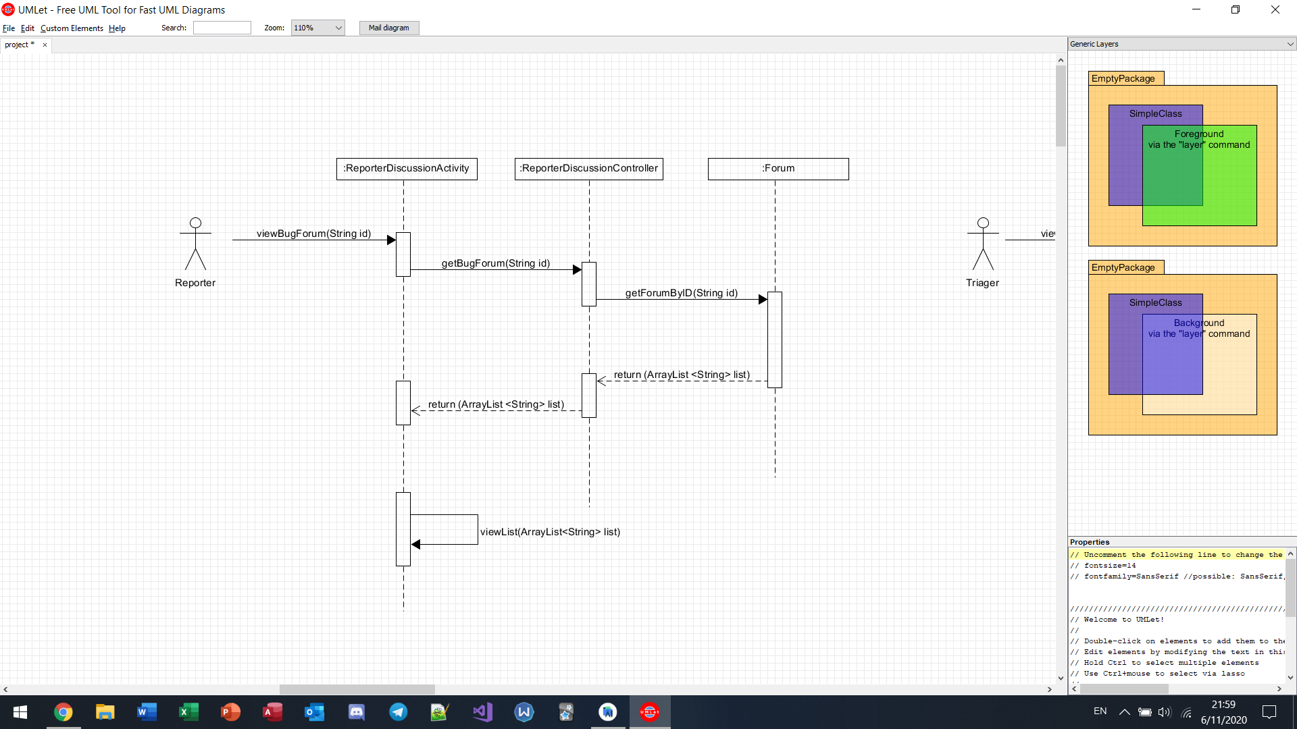

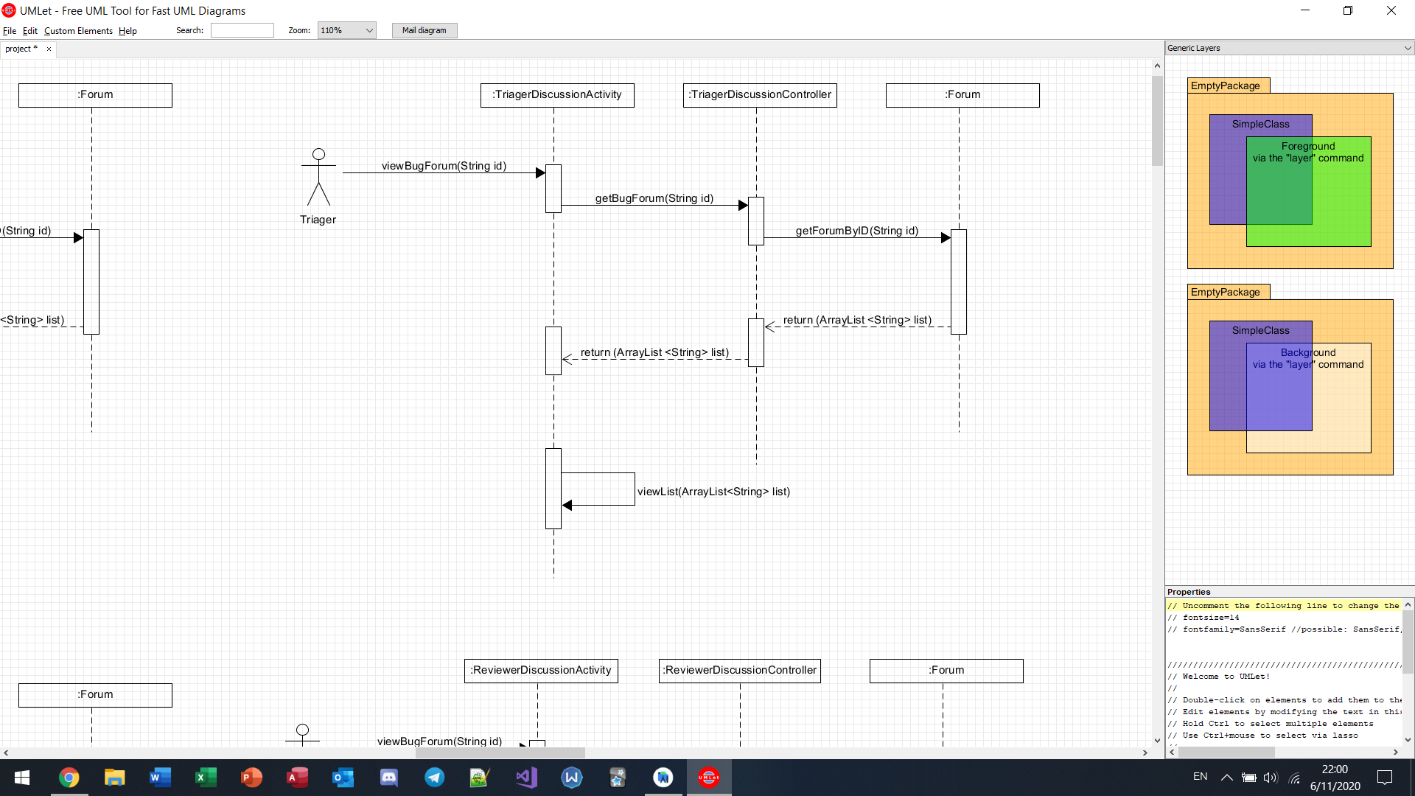

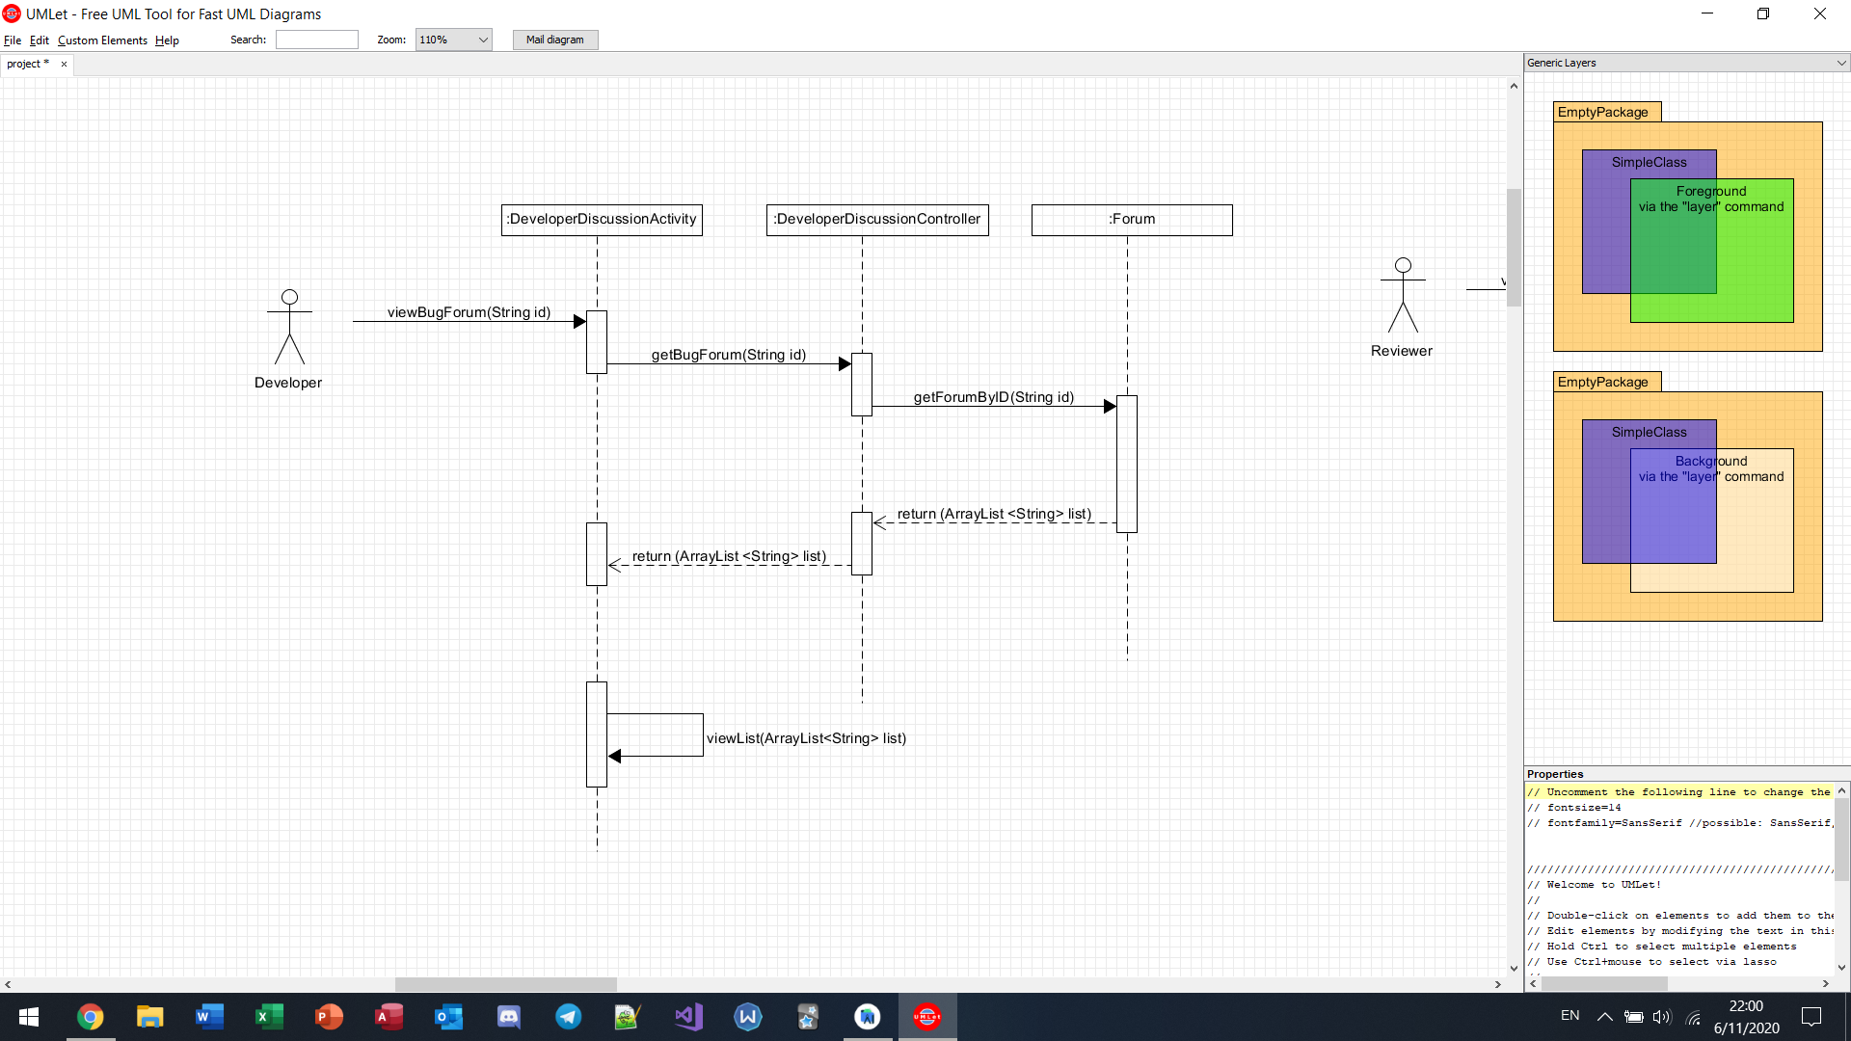

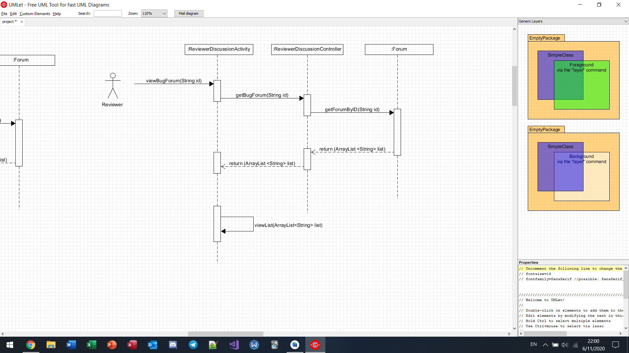

Insert comment into forum

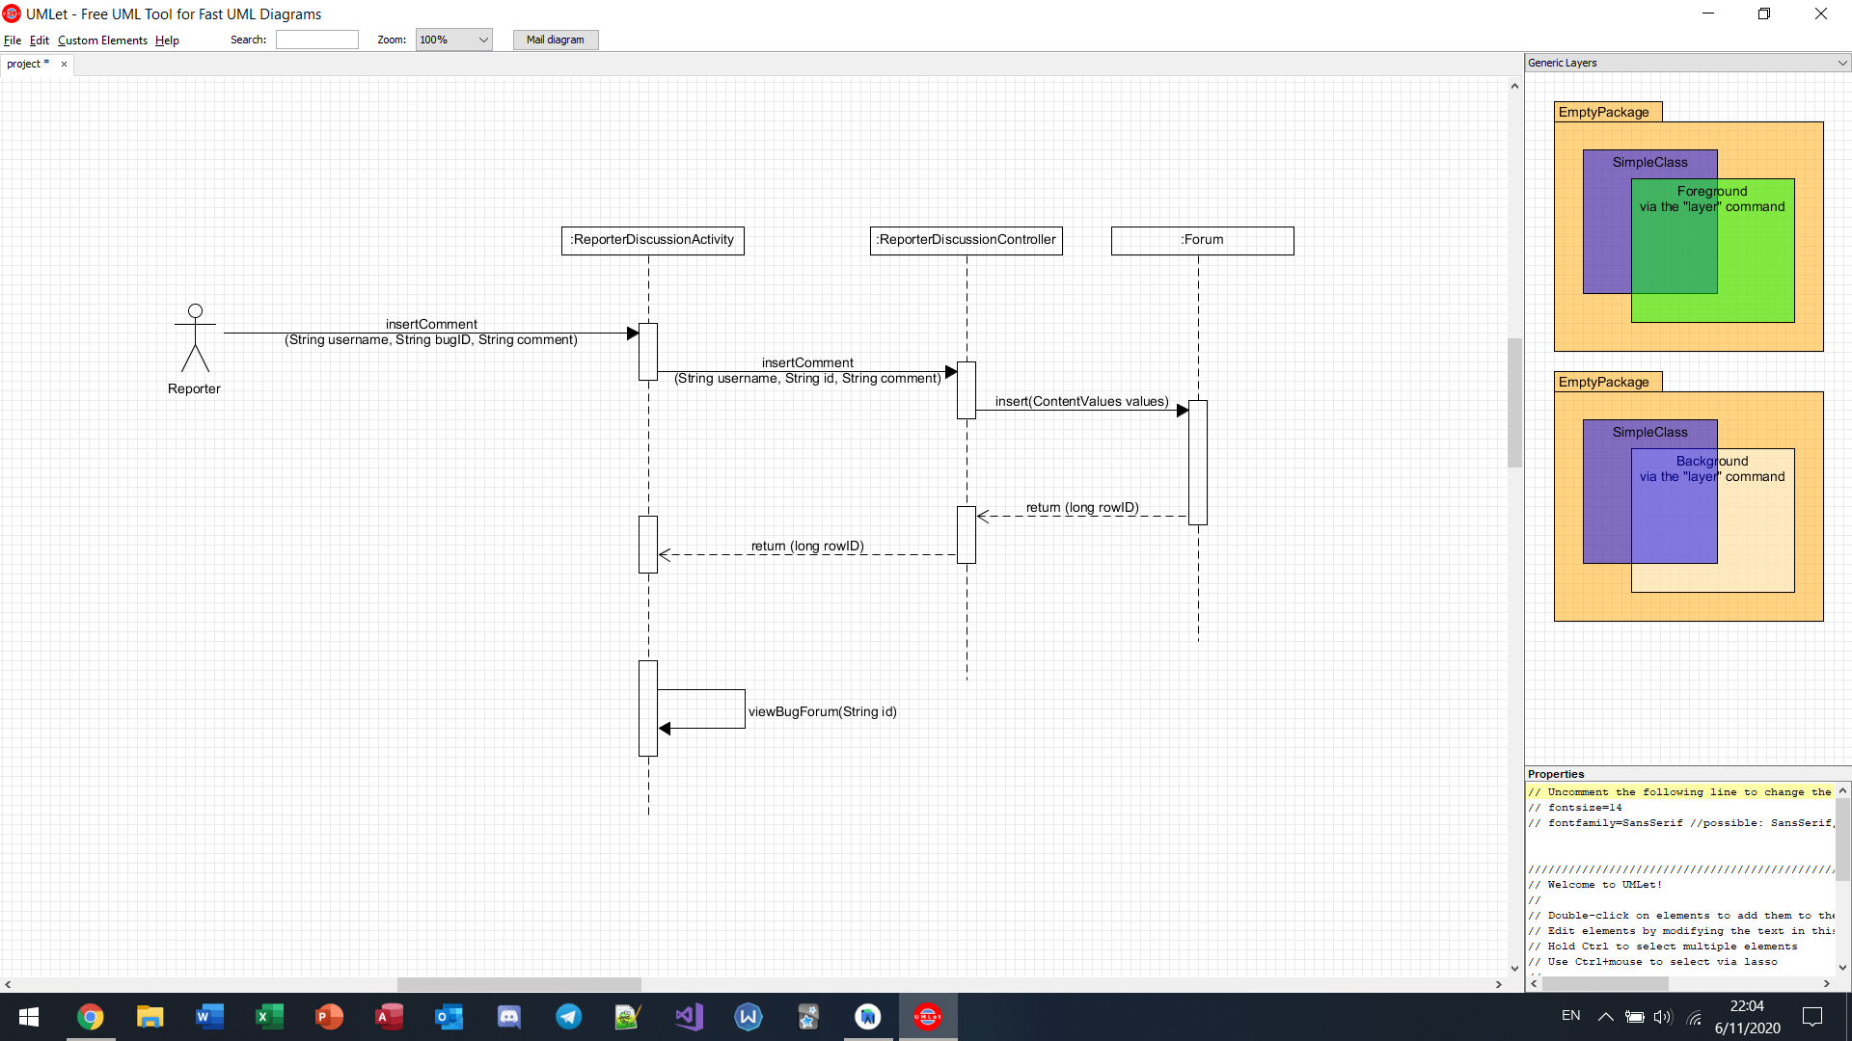

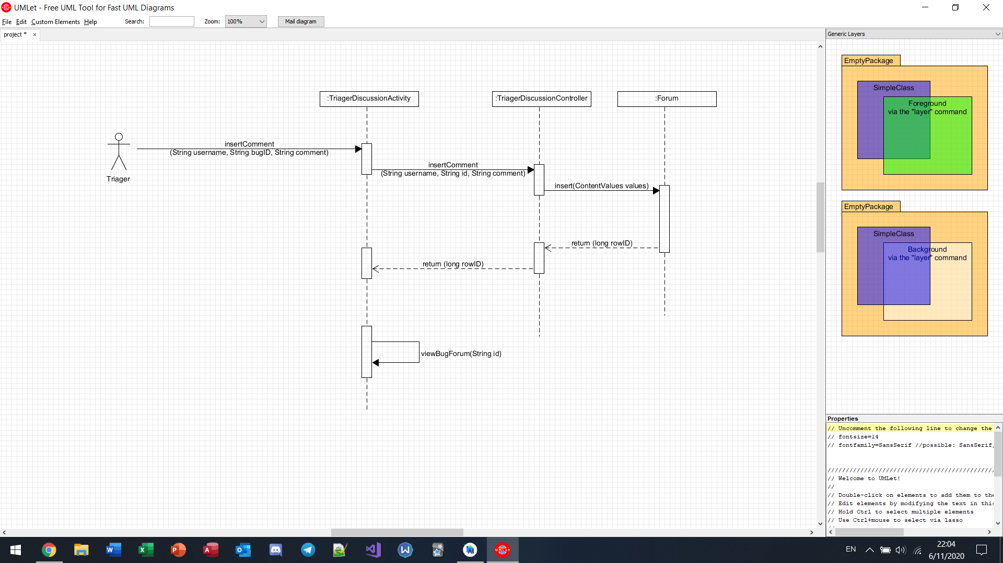

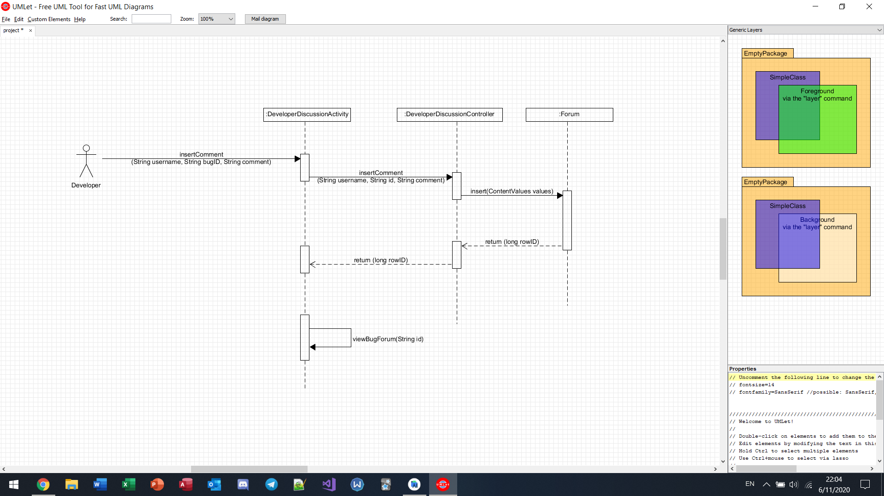

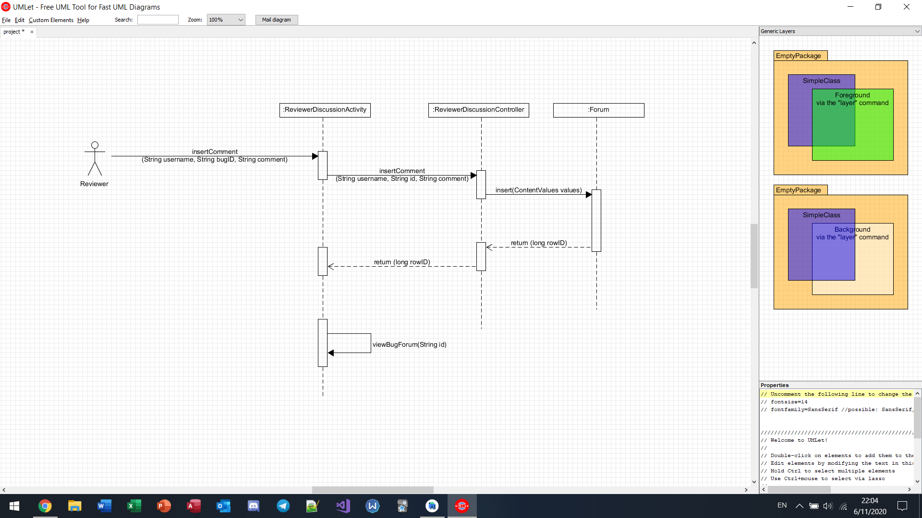

Submit report (reporter)

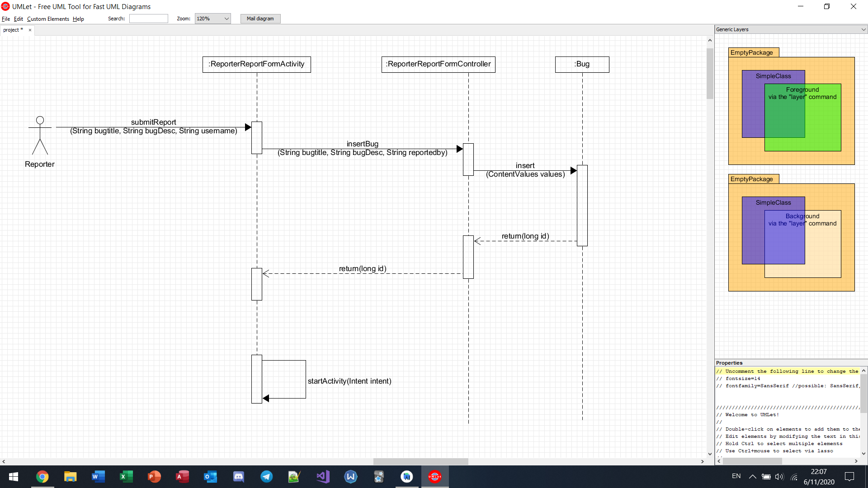

View my bugs (developer)

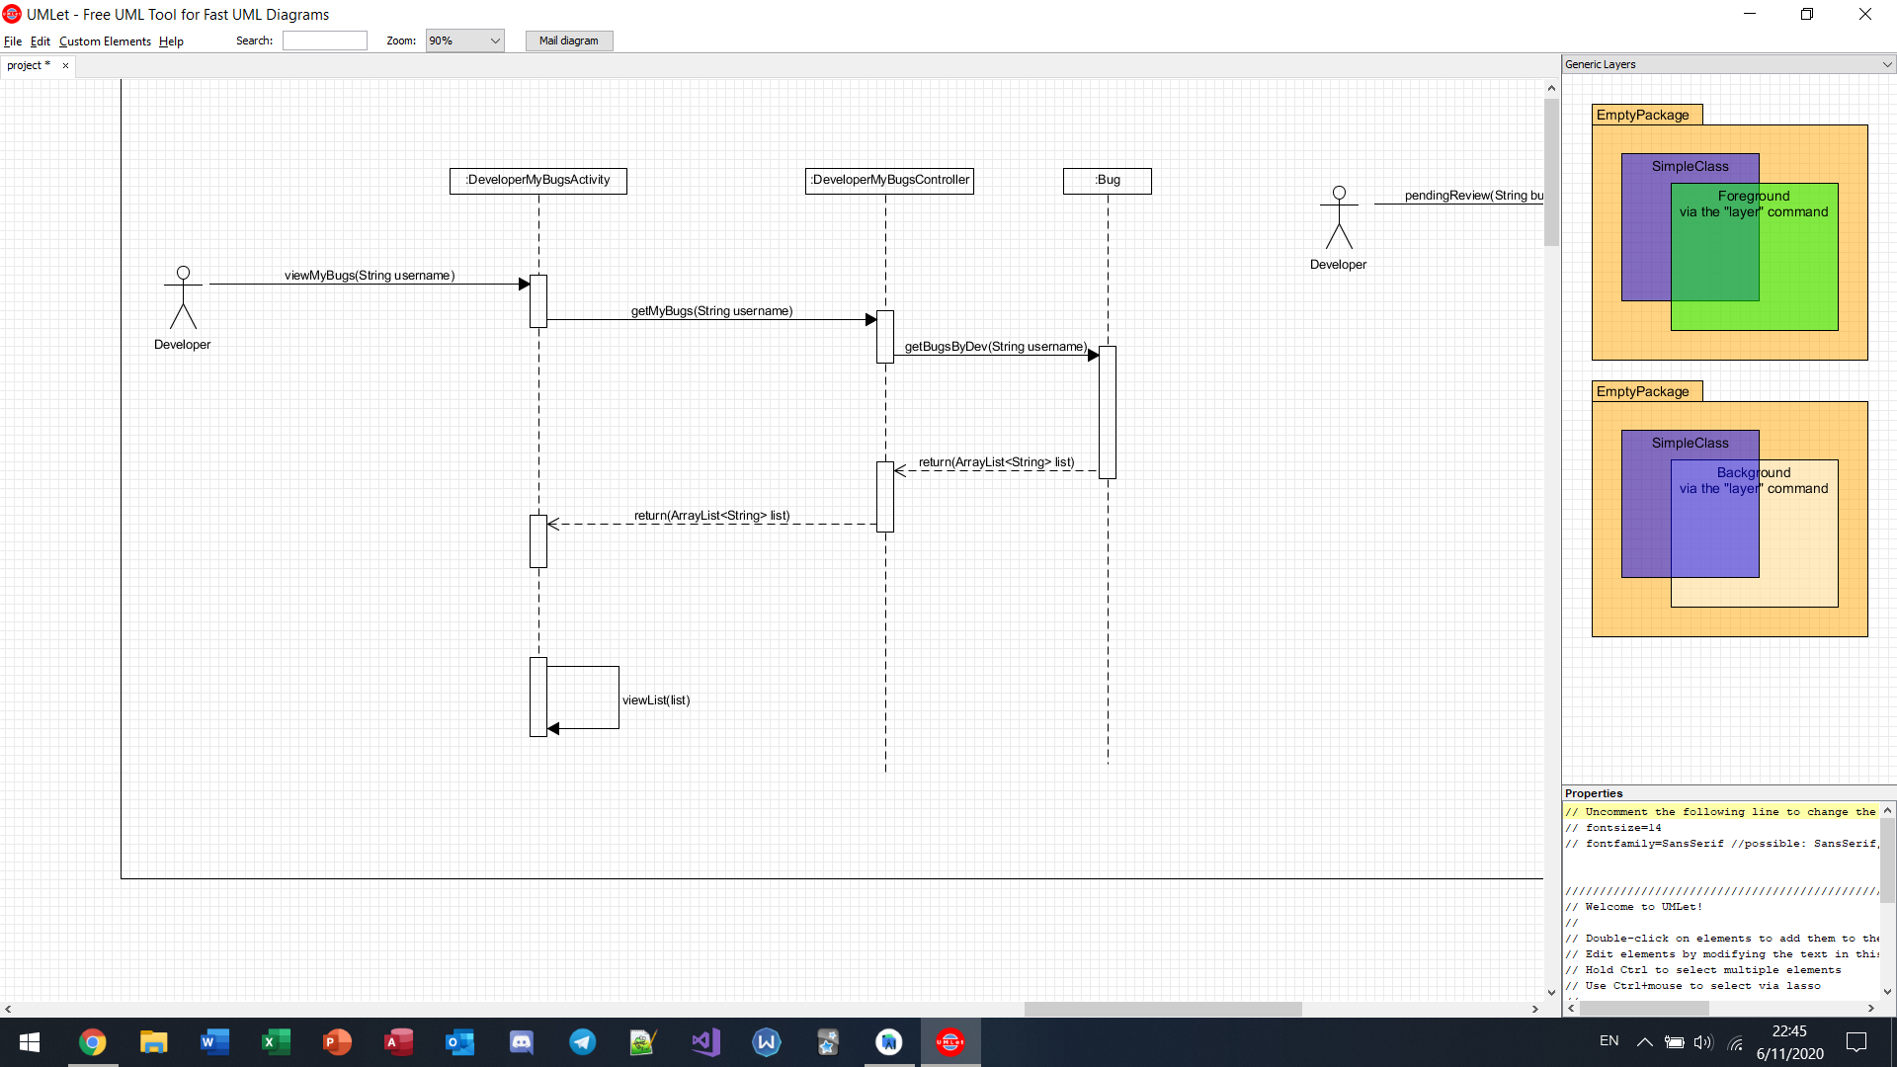

Mark bug as “pending review” (developer)

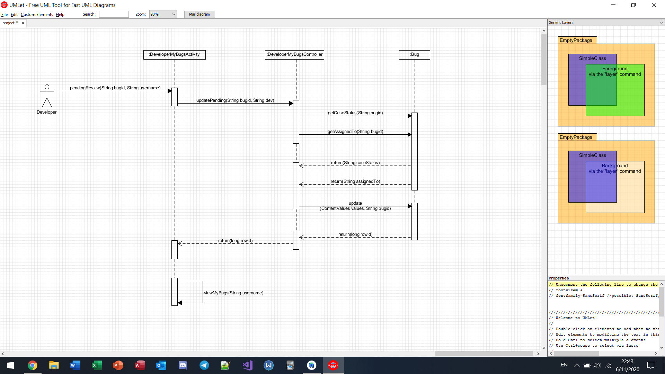

View “pending review” bugs (reviewer)

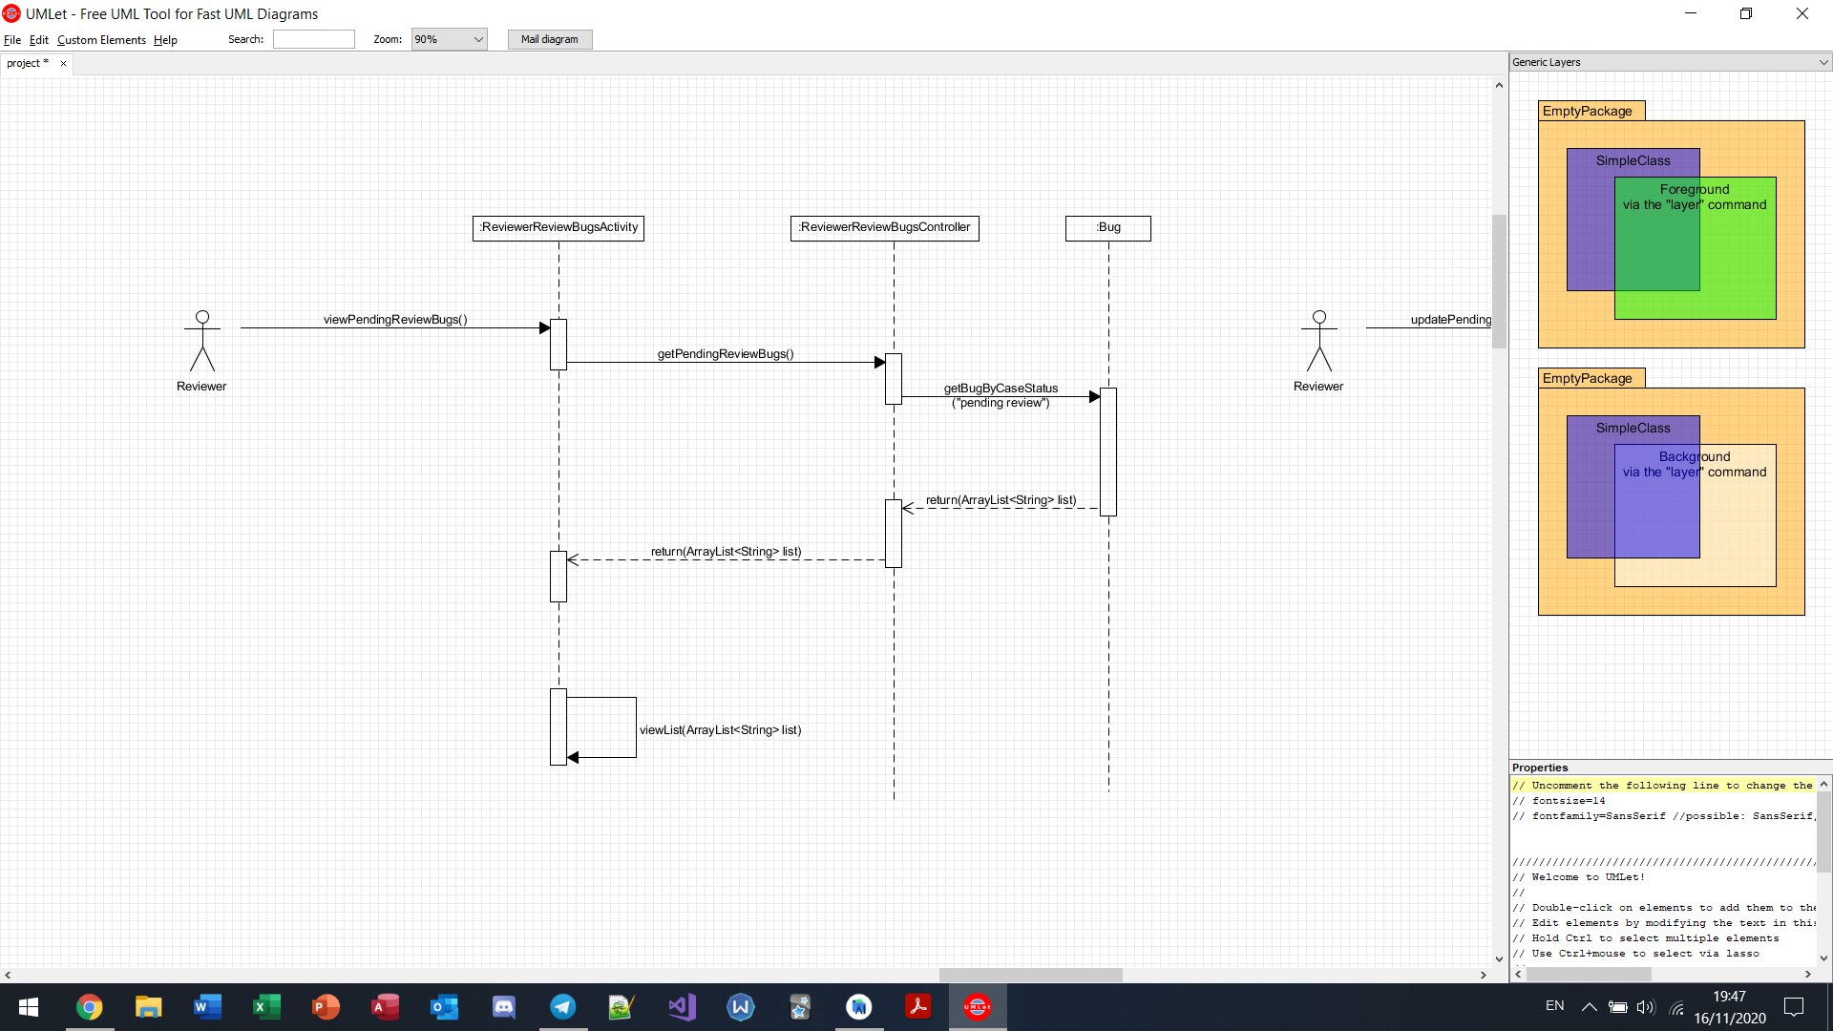

Update “pending review” bugs to “reviewed” (reviewer)

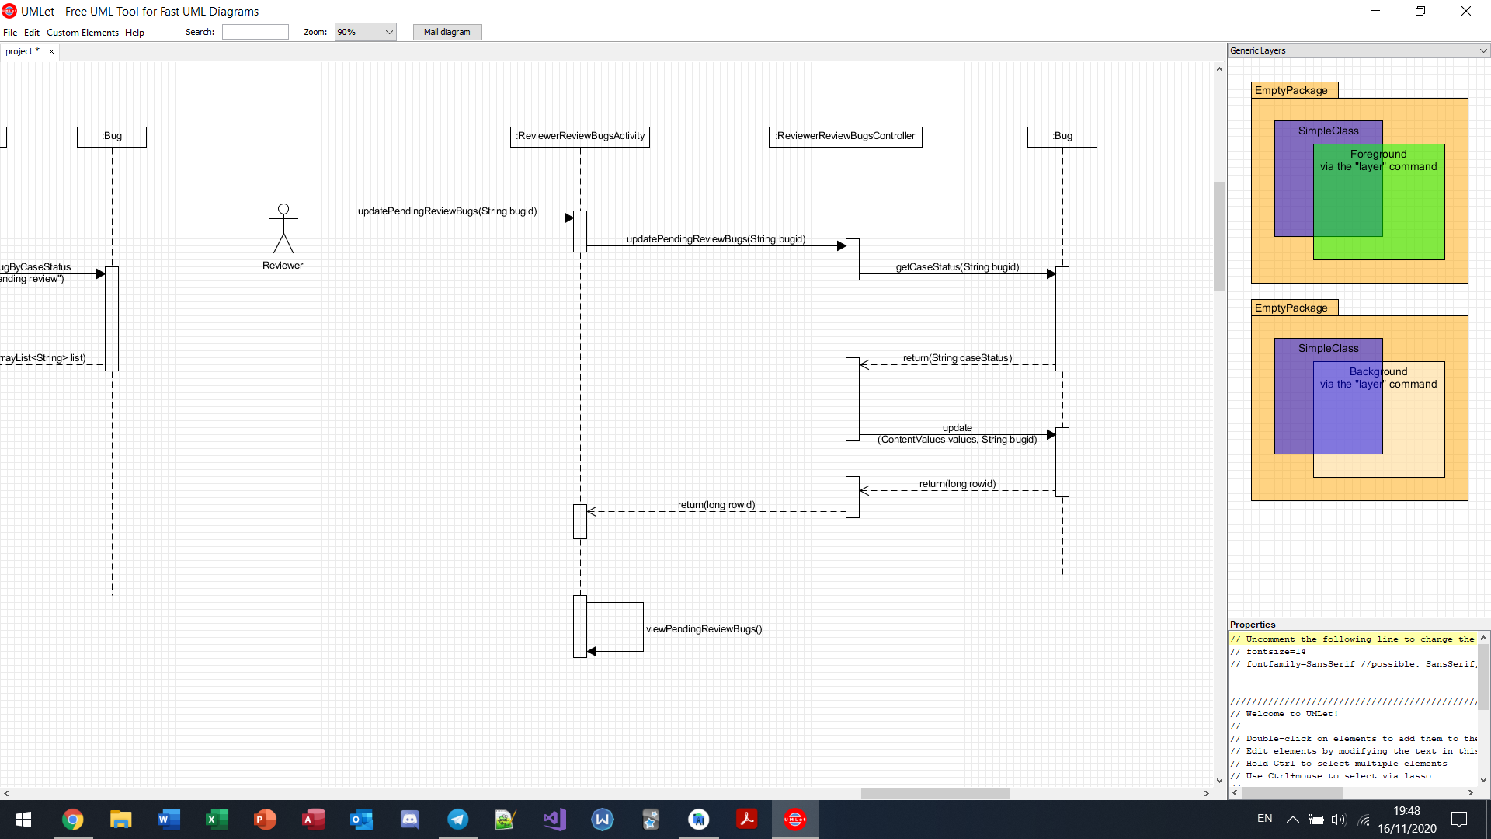

View unassigned bug (triager)

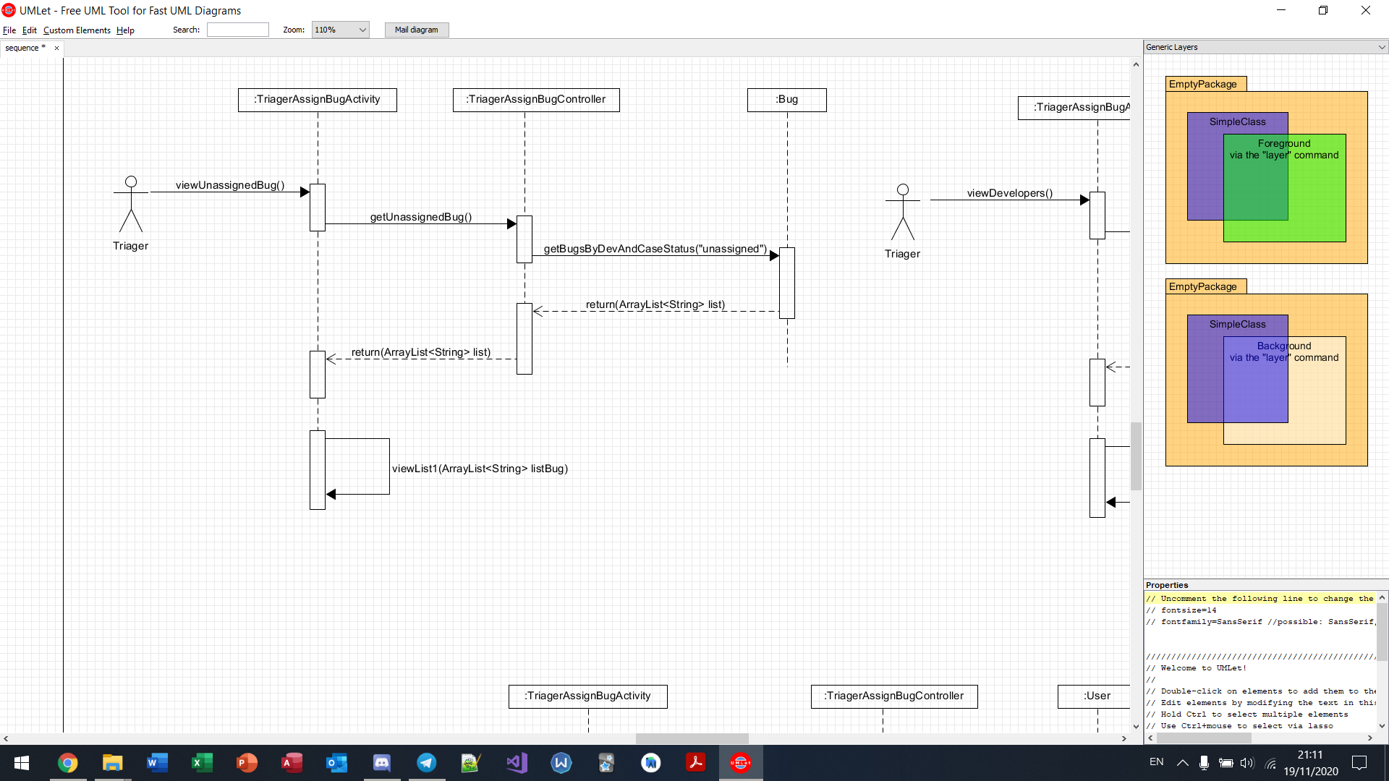

View developers (triager)

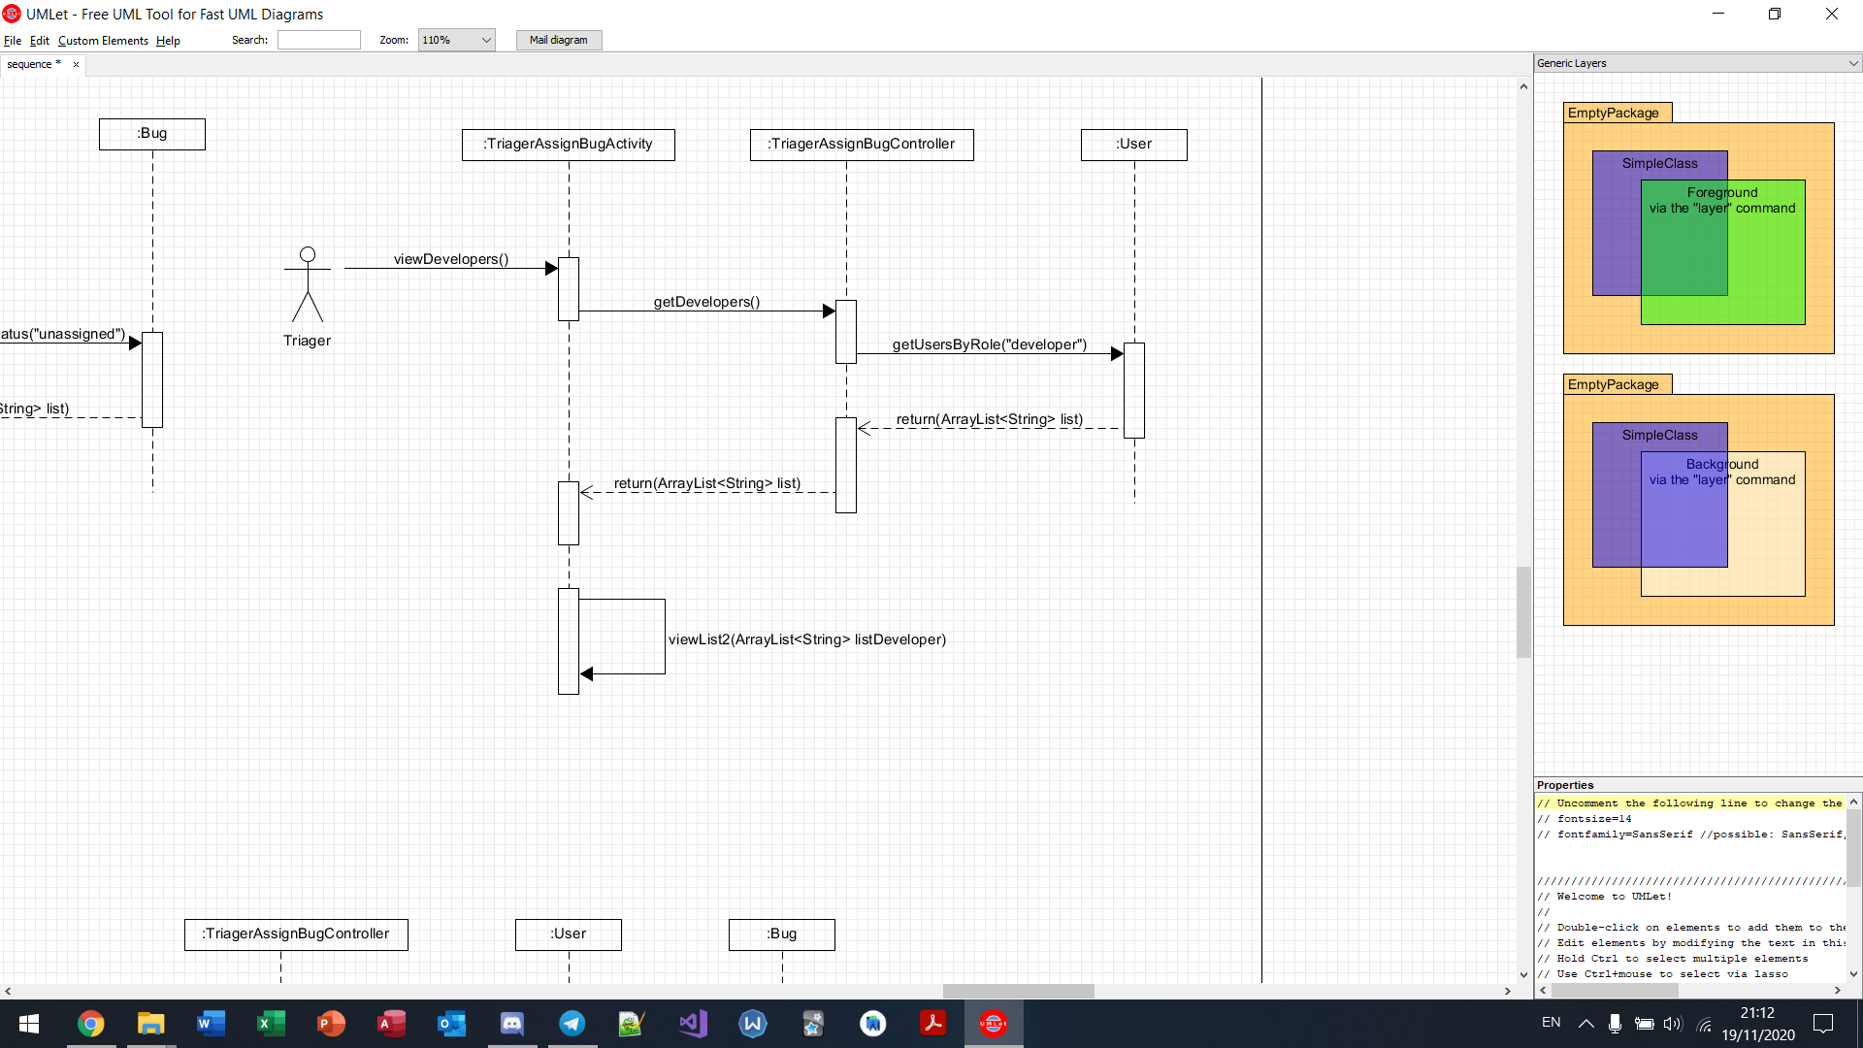

Assign bug (triager)

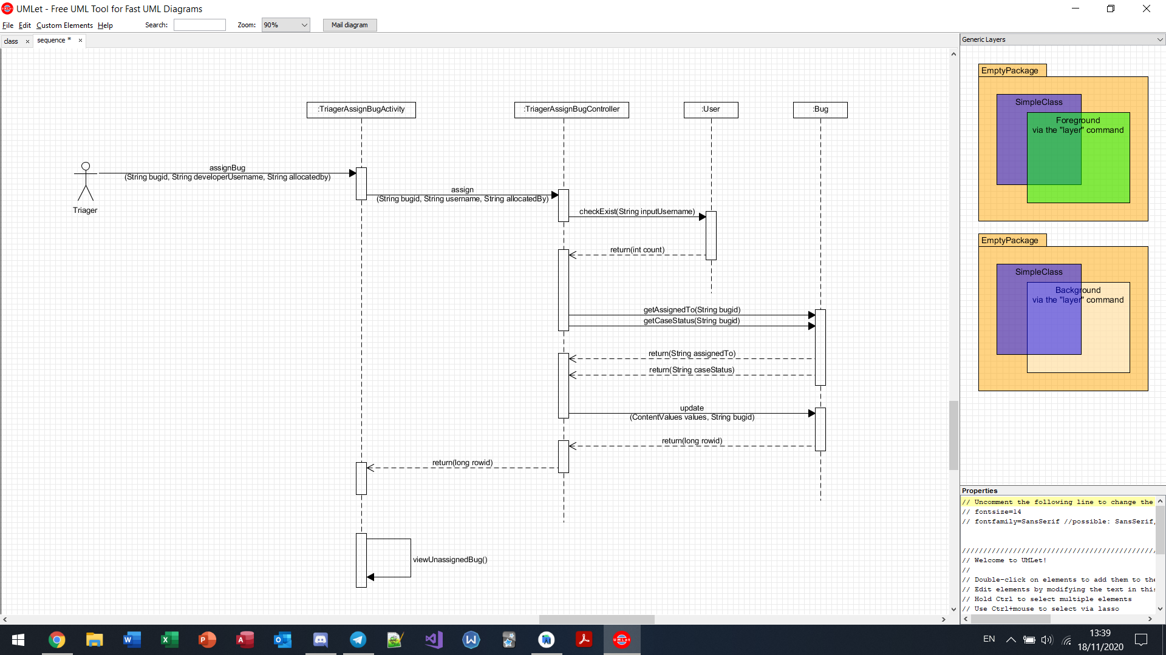

View unresolved bugs (triager)

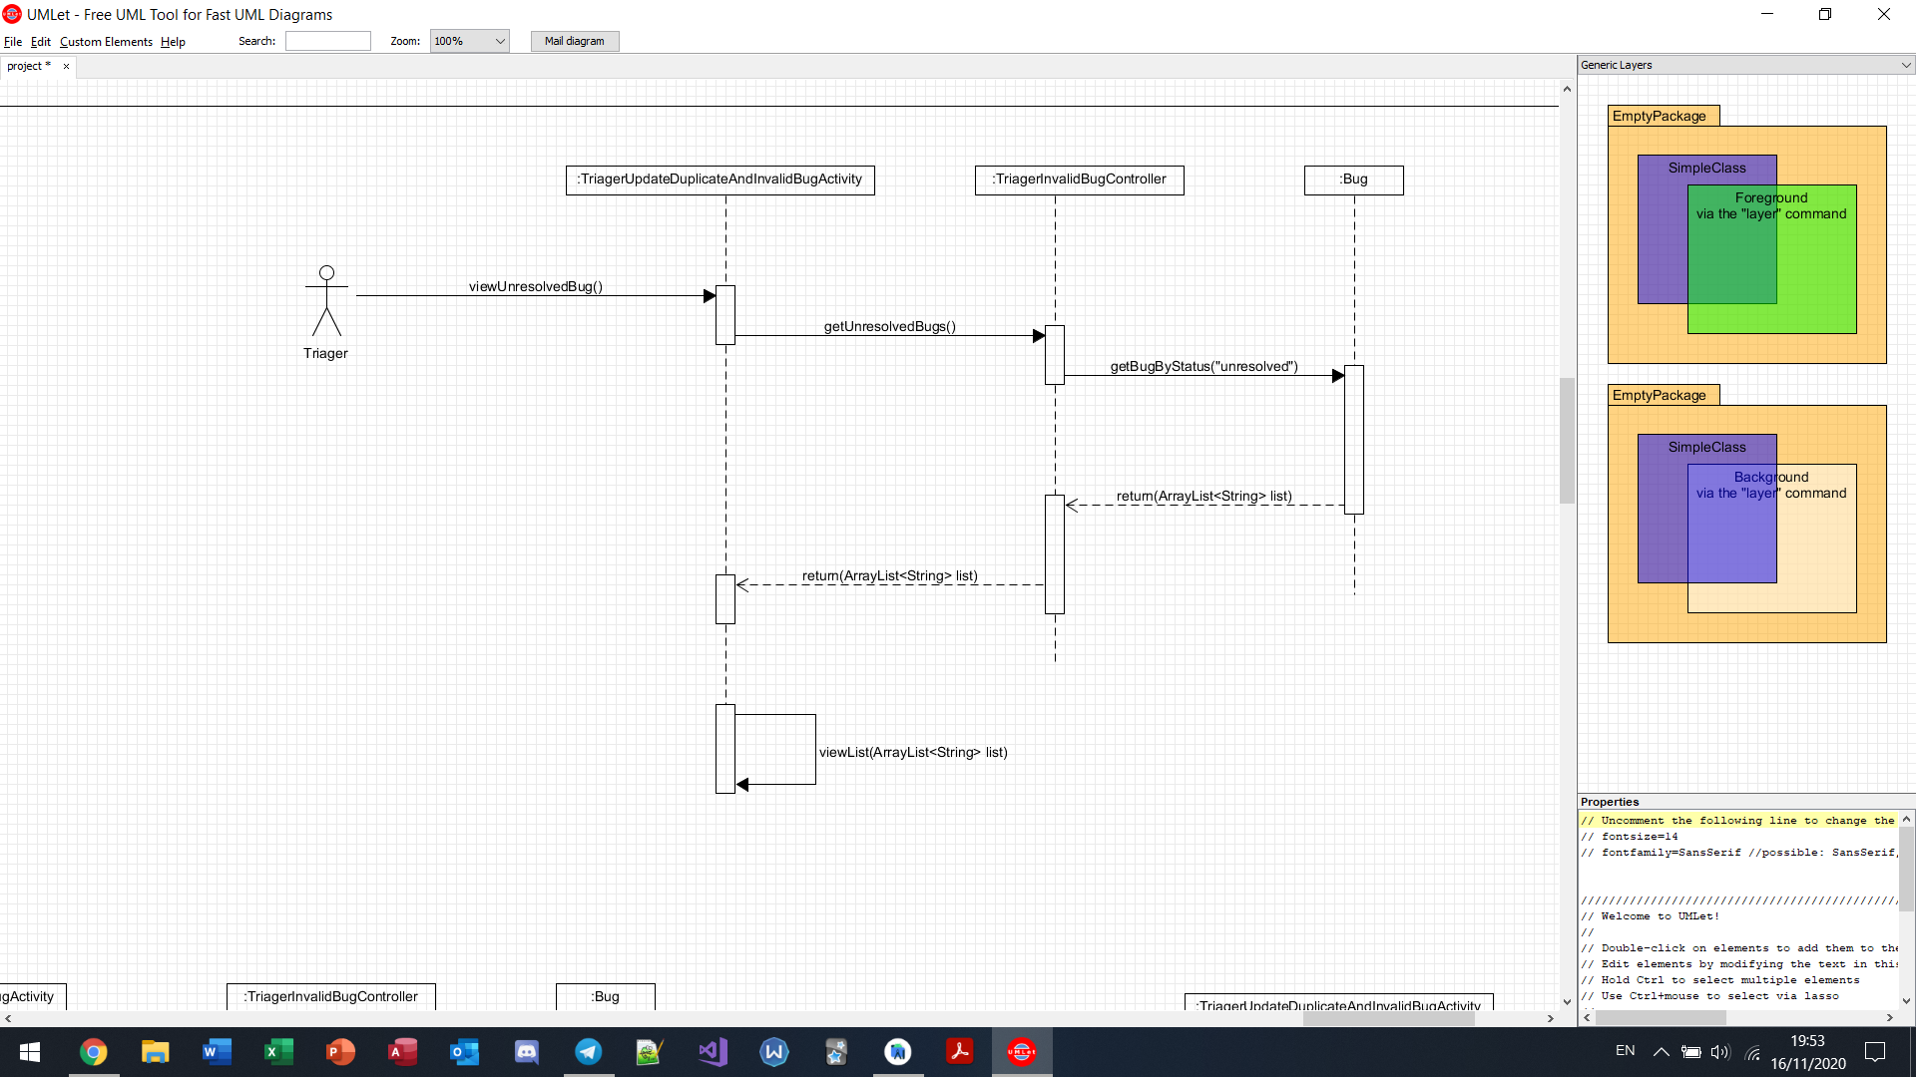

Mark bug as “invalid” (triager)

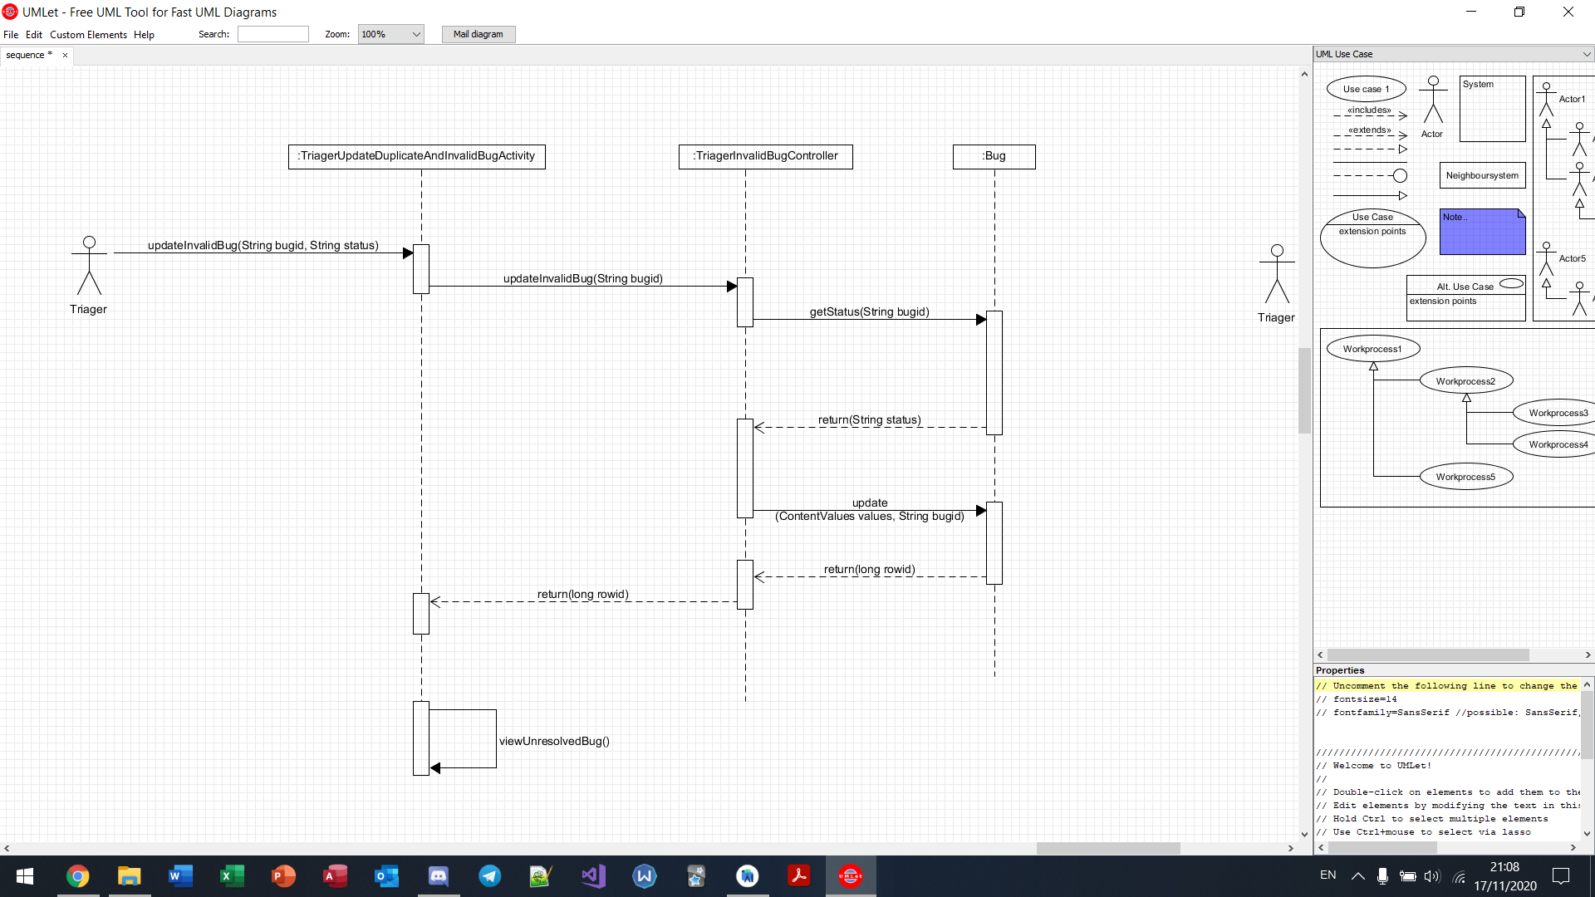

Mark bug as “duplicated” (triager)

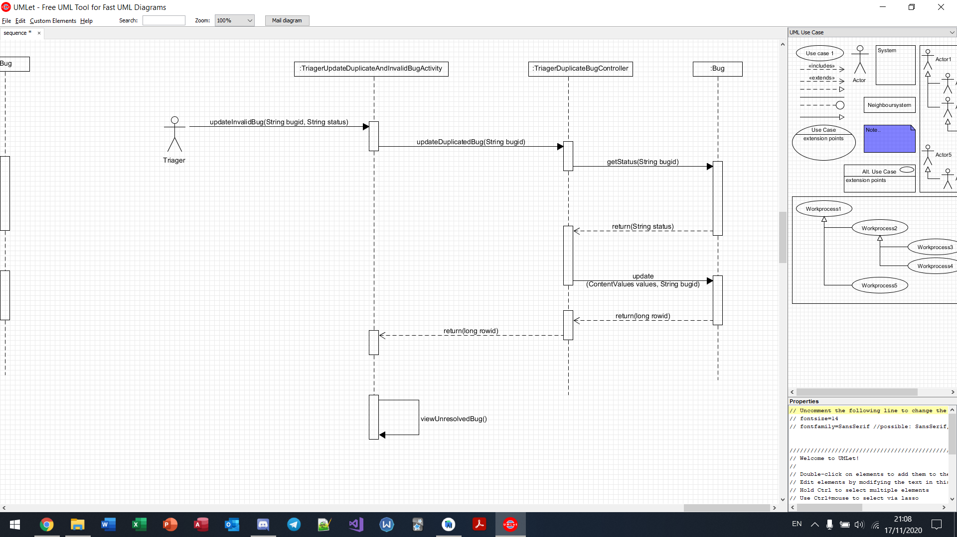

View bugs reported in a month (triager)

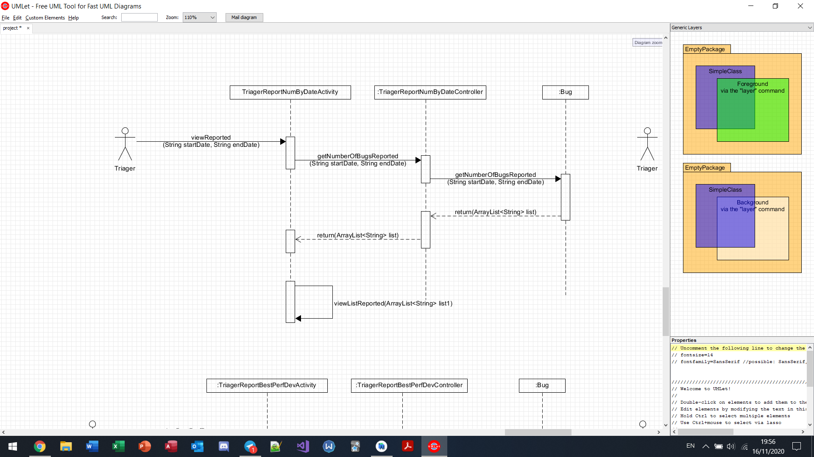

View bugs resolved in a week(triager)

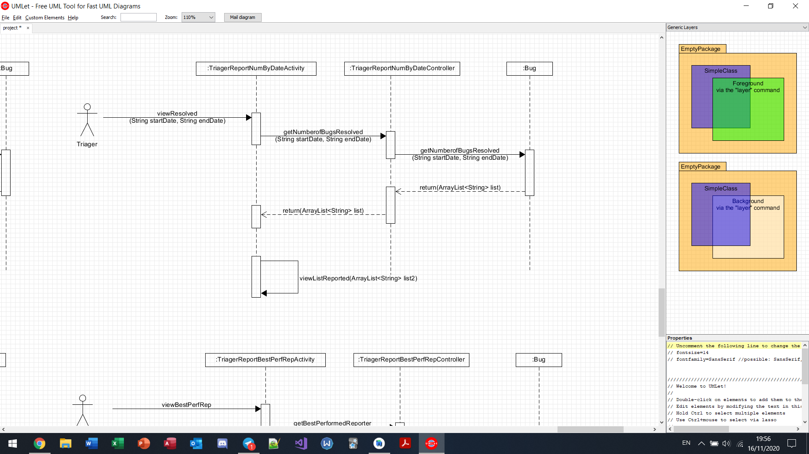

View best performed developer (triager)

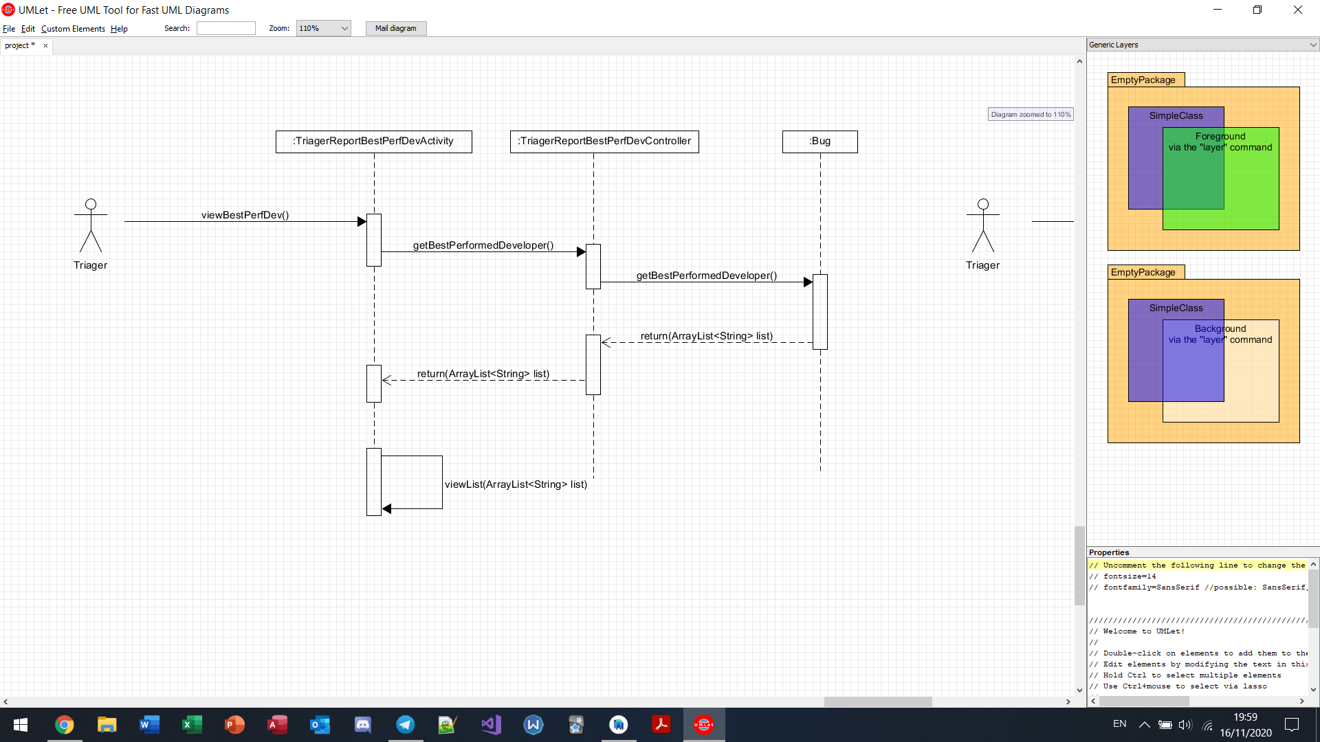

View best performed reporter (triager)

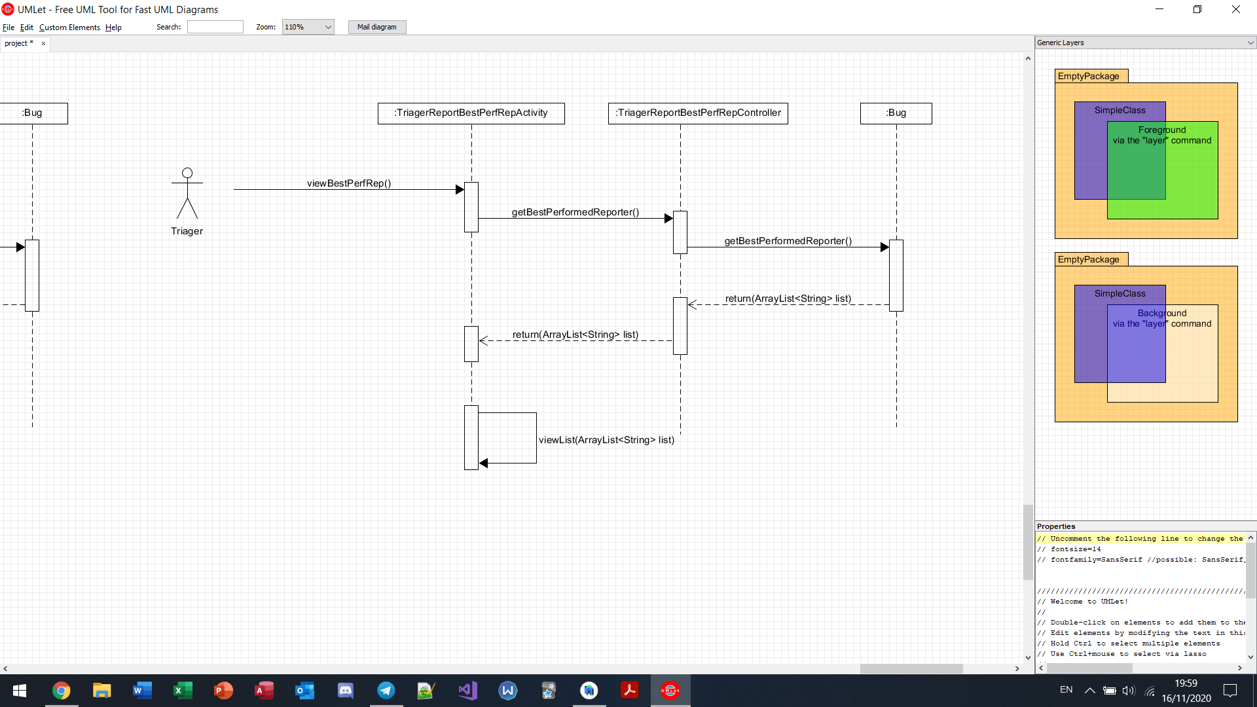

View “reviewed” bugs (triager)

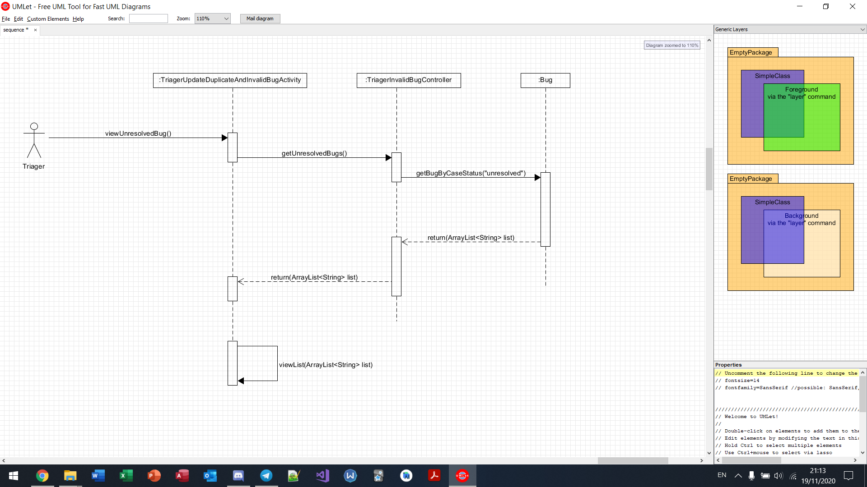

Close bug (triager)

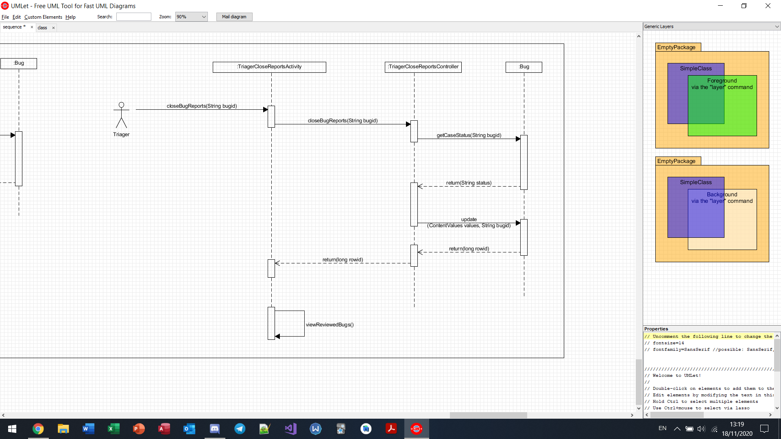

# **8. Sprints**

## **a. Sprint 1**

### **Wireframe**

#### Bug Reporter

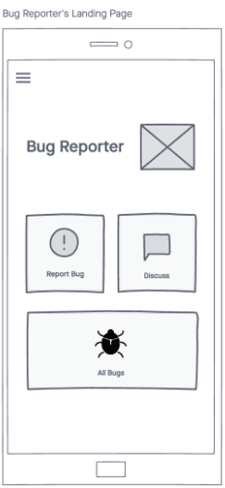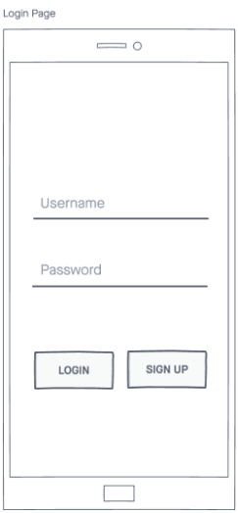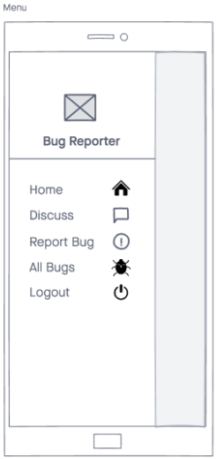

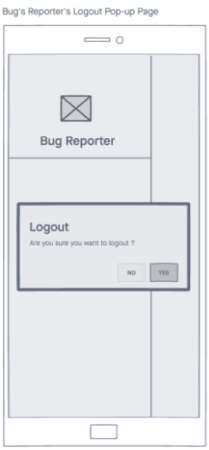

#### Triager

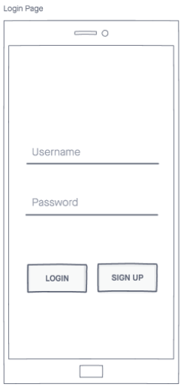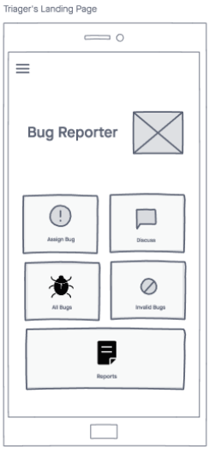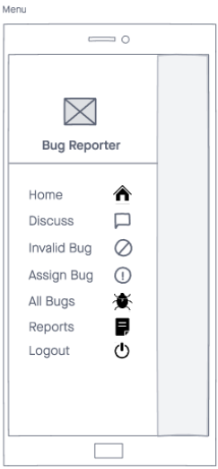

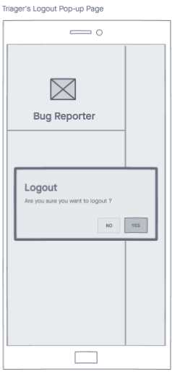

#### Developer

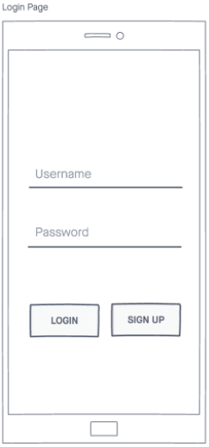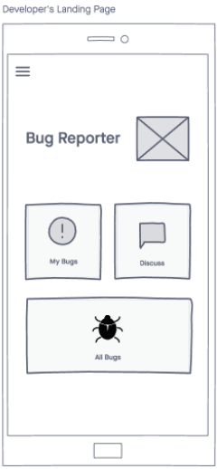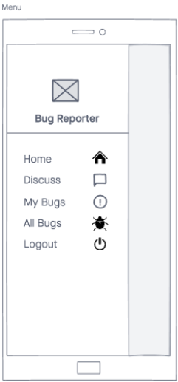

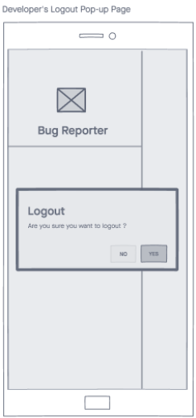

#### Reviewer

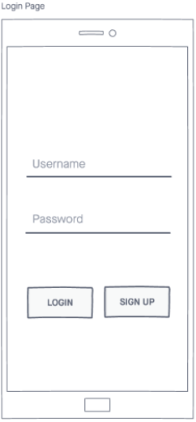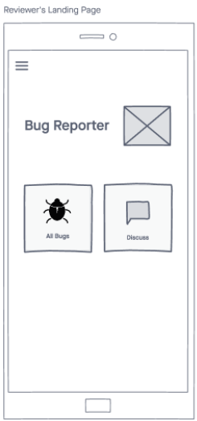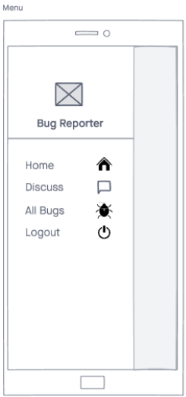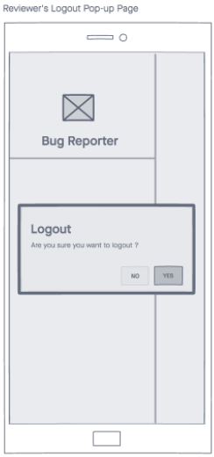

#### 

### **Screenshot of interface**

#### Bug Reporter

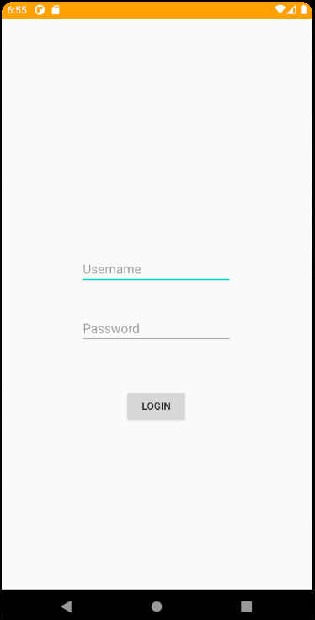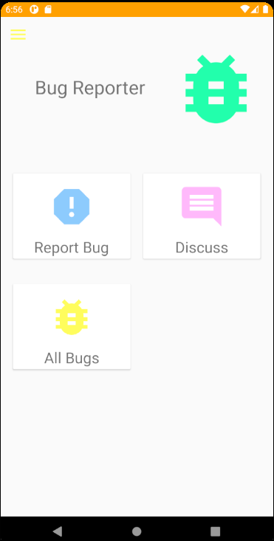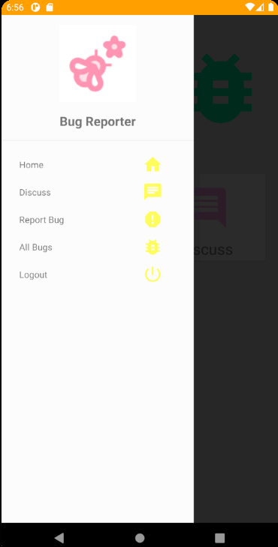

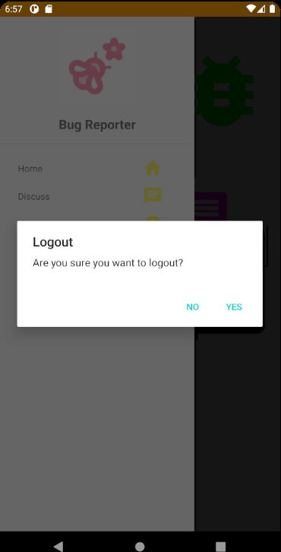

##### 

#### Triager

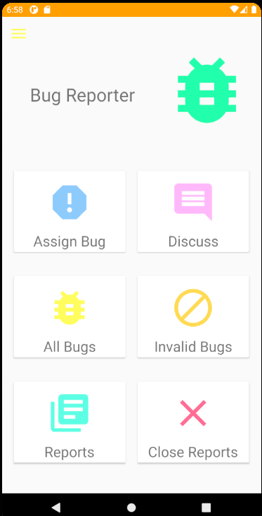

#### Developer

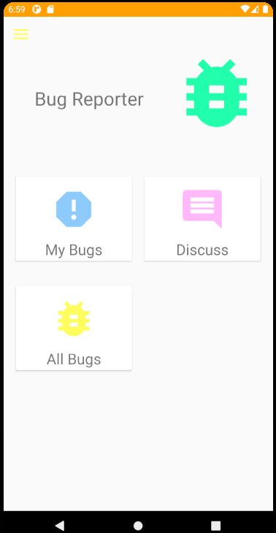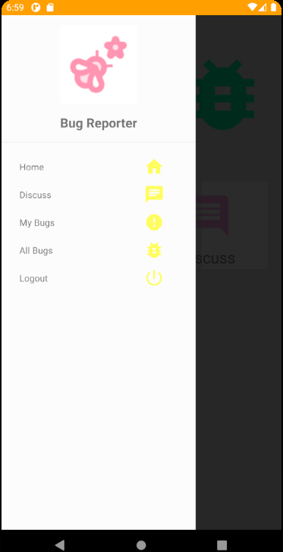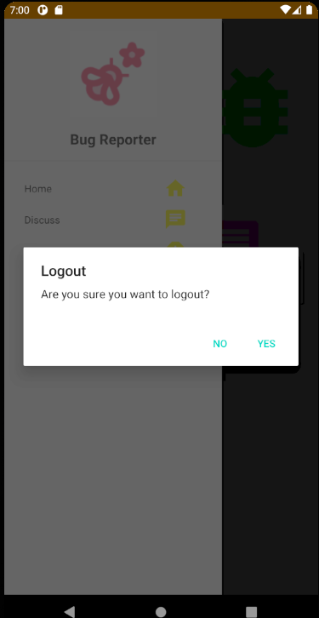

#### Reviewer

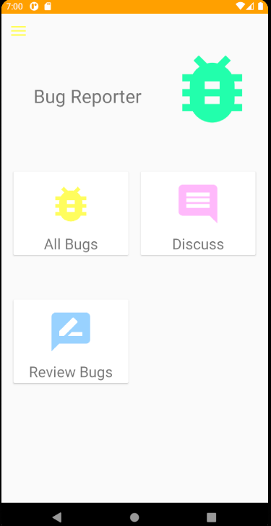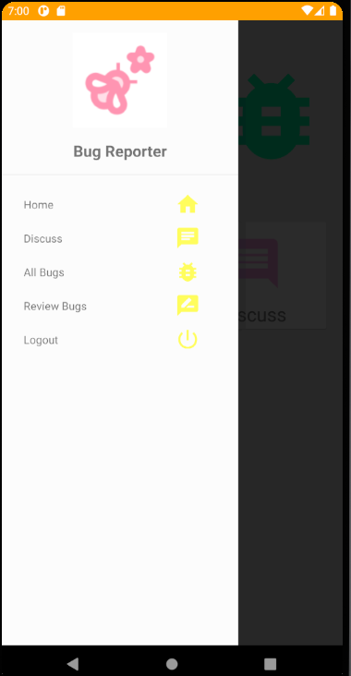

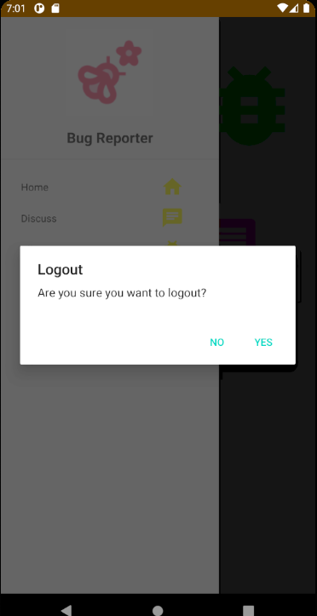

### **Screenshot of taiga**

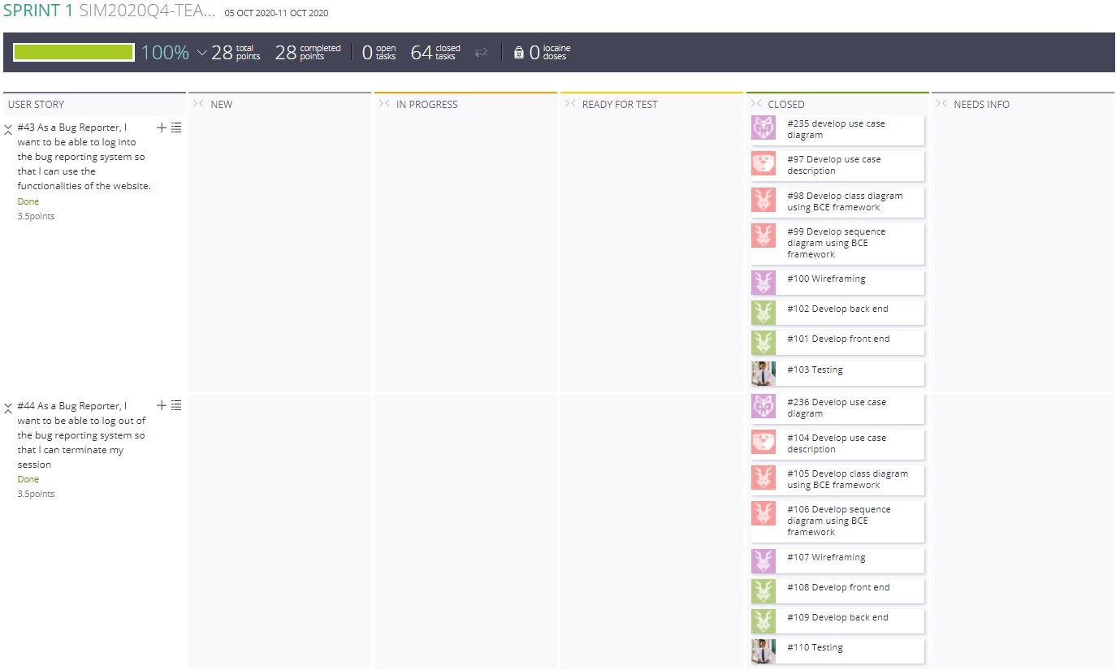

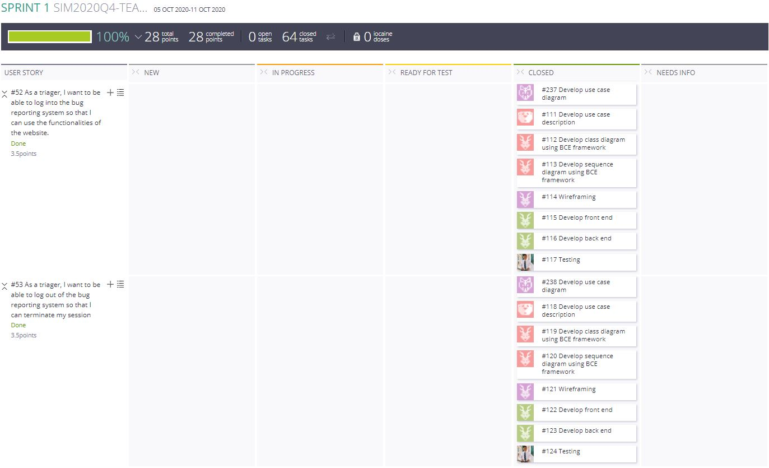

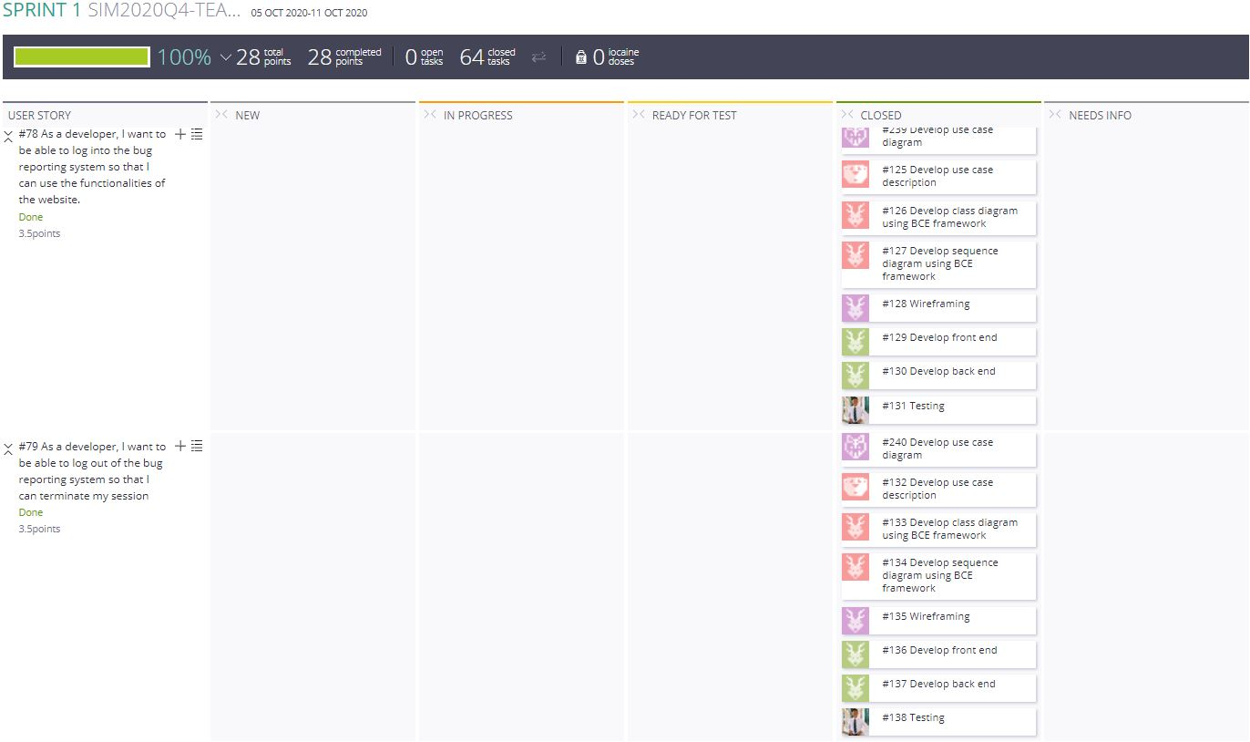

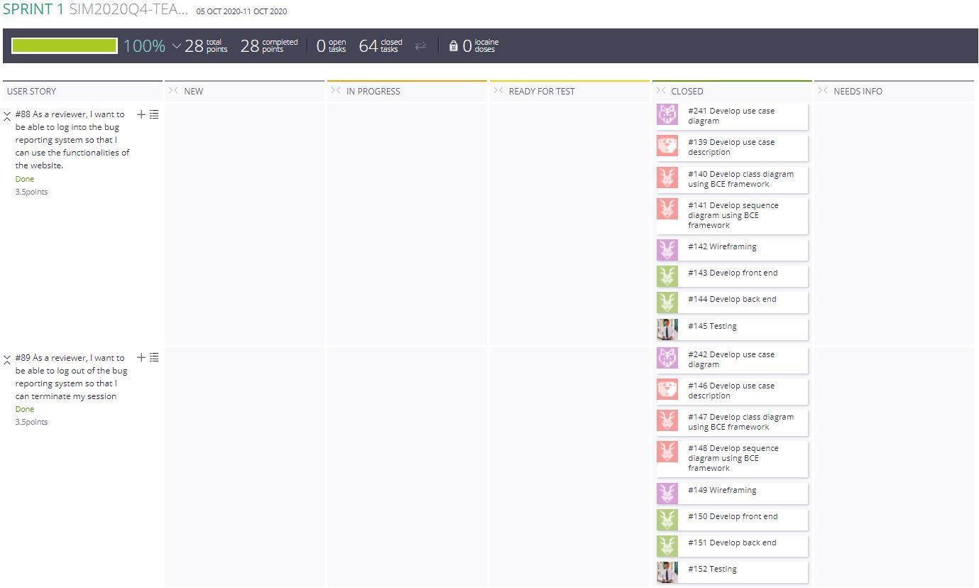

### **Test cases**

#### Bug Reporter

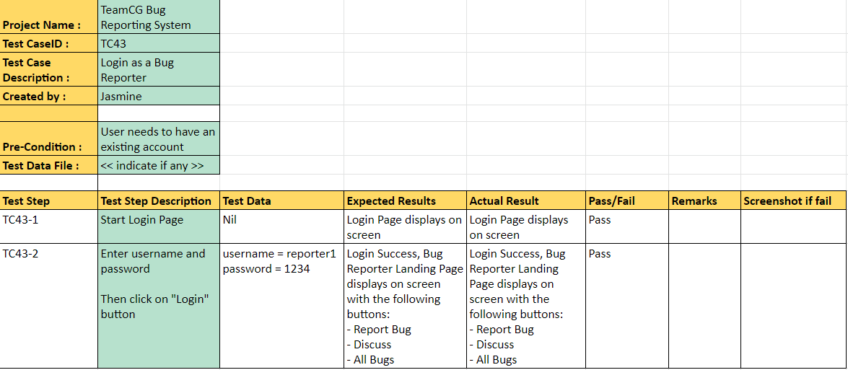

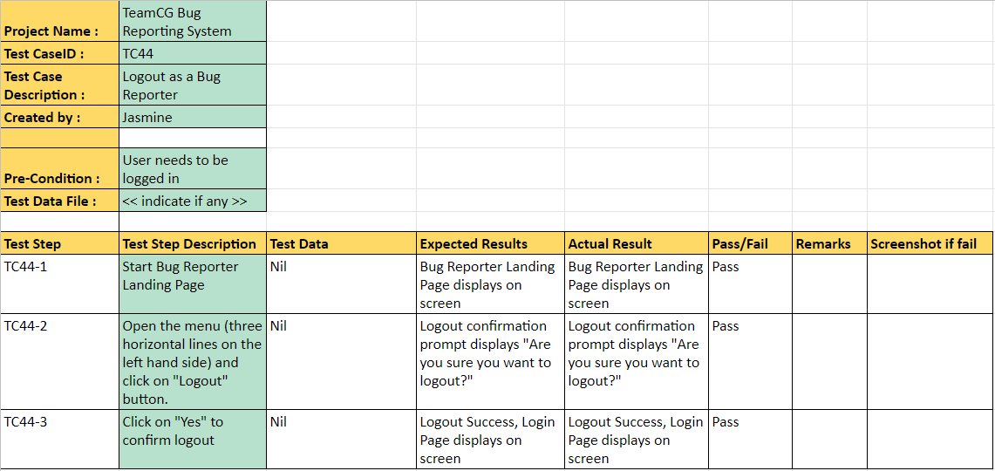

#### Triager

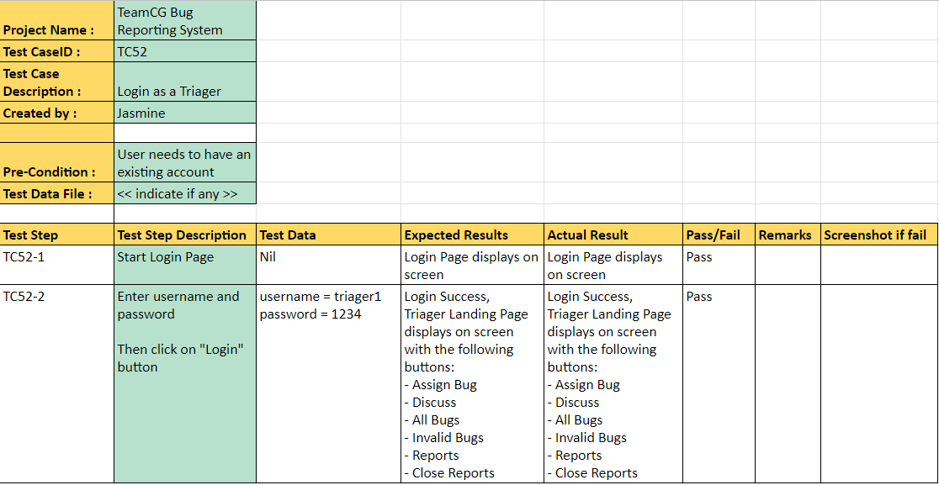

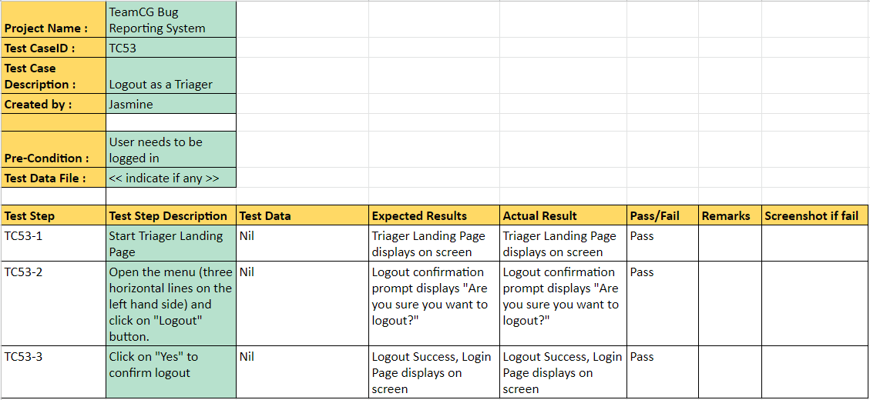

#### Developer

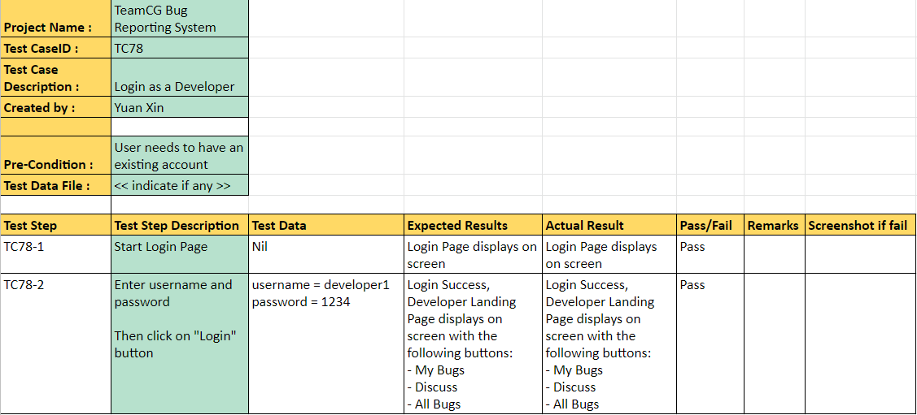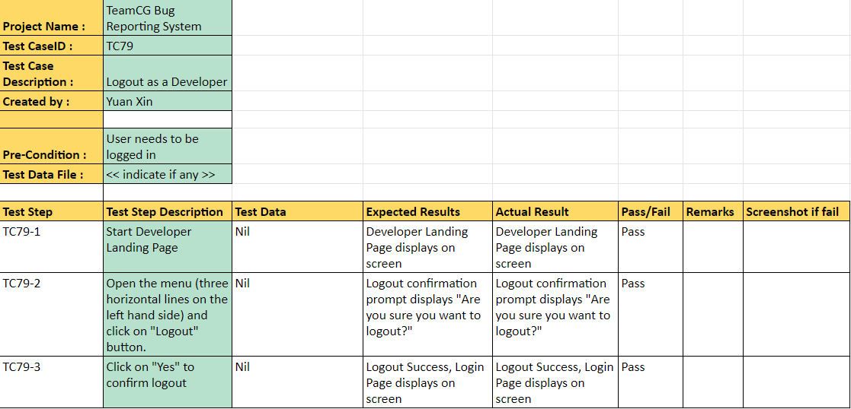

#### Reviewer

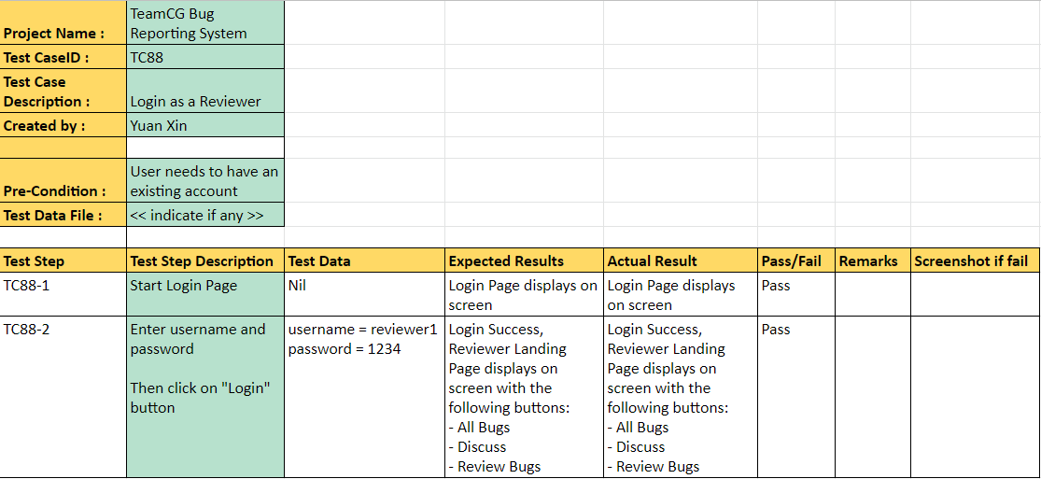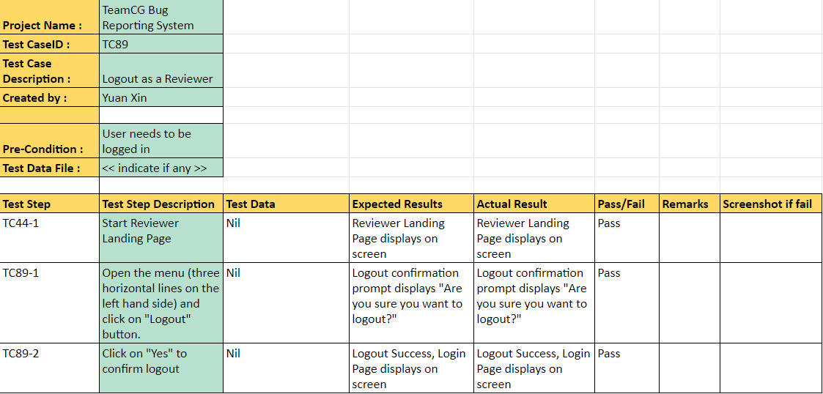

#### 

### **Test Driven Development**

For our teams Test Driven Development (TDD), we have decided to do it in Sprint 1, where we have implemented the logins and logouts for all users.

The following code snippet is when a reporter successfully logs into the system and logs out.  
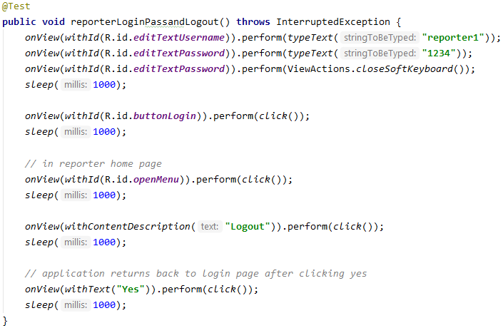

The following code snippet is when a developer successfully logs into the system and logs out.

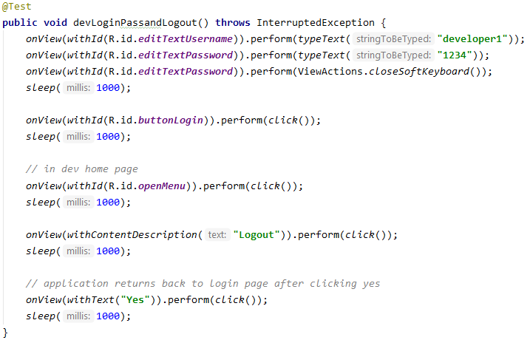

The following code snippet is when a triager successfully logs into the system and logs out.

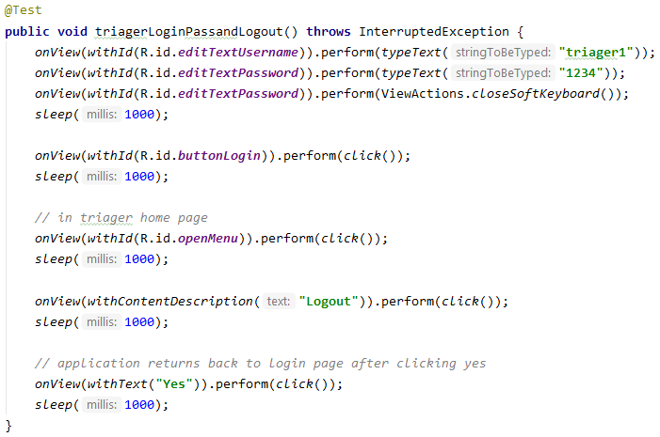

The following code snippet is when a reviewer successfully logs into the system and logs out.

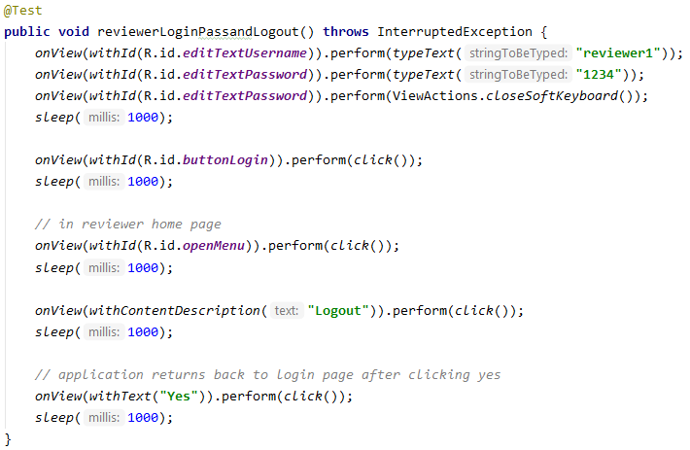

The following code snippet is when a user enters an invalid username or password with the maximum allowed number of times (5).

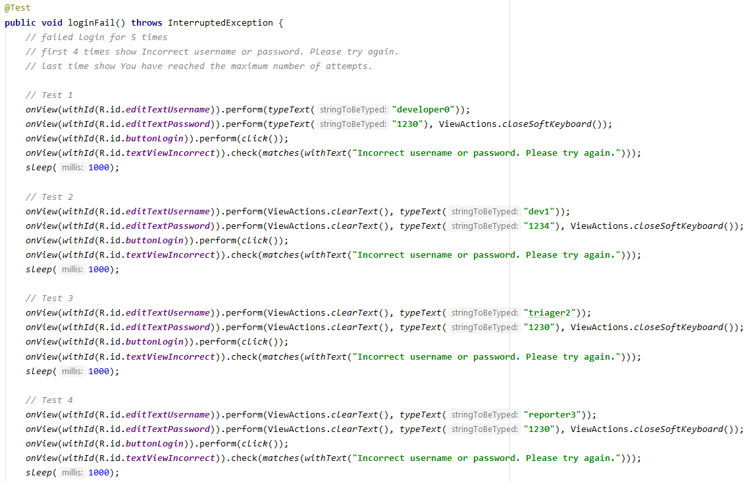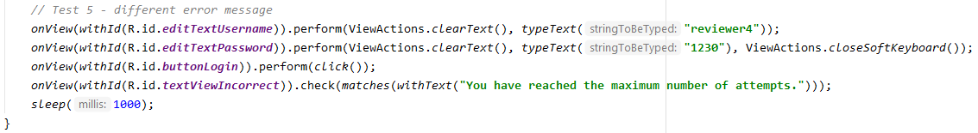

In test case 1, the wrong username and wrong password is entered.

In test case 2, the wrong username but correct password is entered.

In test cases 3, 4 and 5, the correct username but wrong password is entered.

sleep(1000); in all the code snippets is used to pause the process for 1 second, so that it is easier to capture screenshots and to view what is happening, as the actual test runs at a fast speed.

The following are screenshots that were taken during the test.

loginFail()

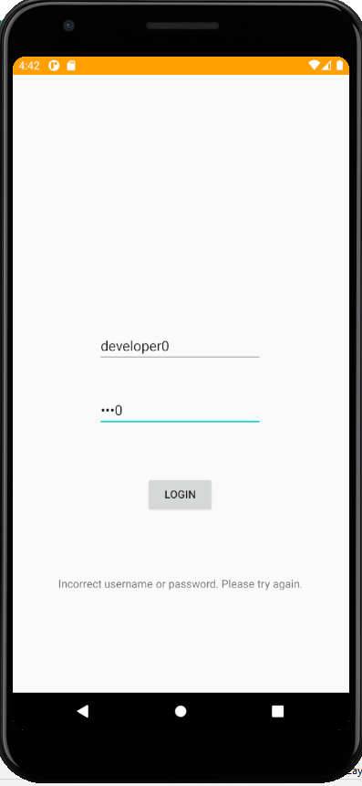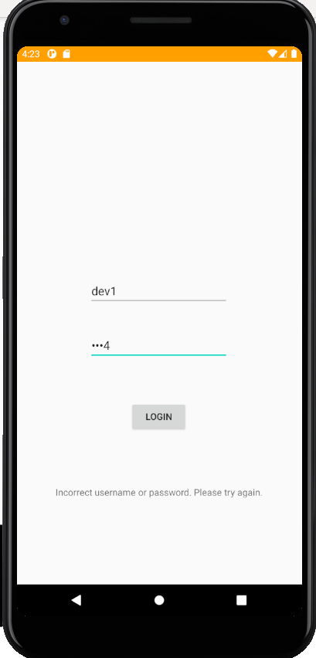

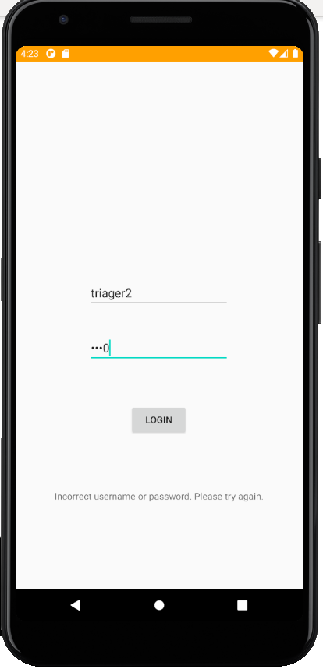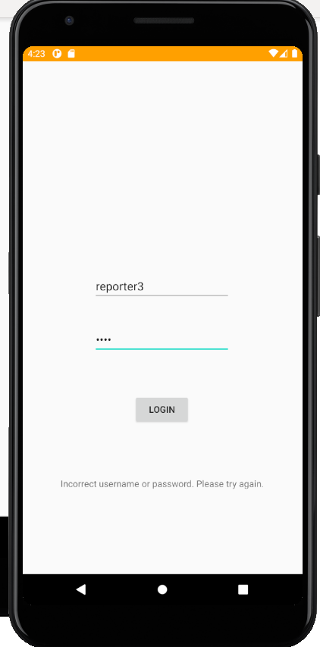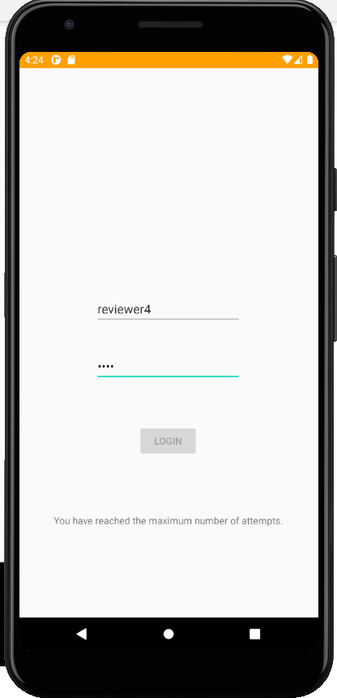

reporterLoginPassandLogout()

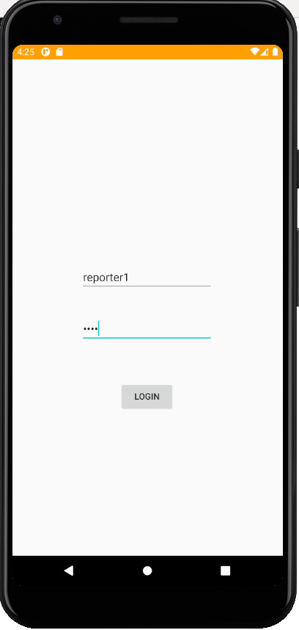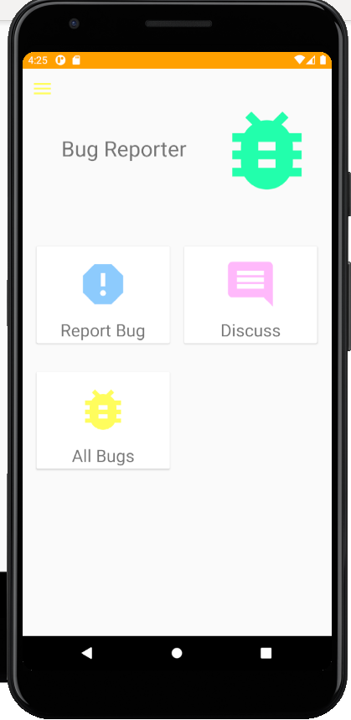

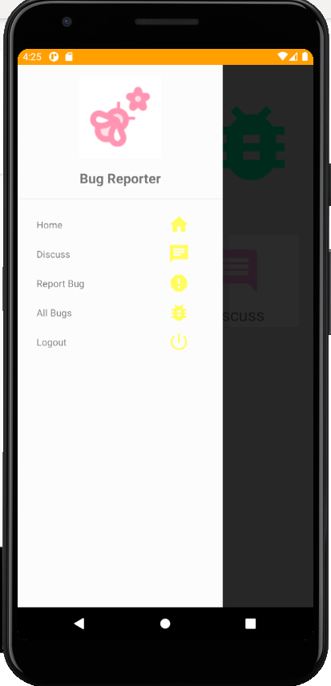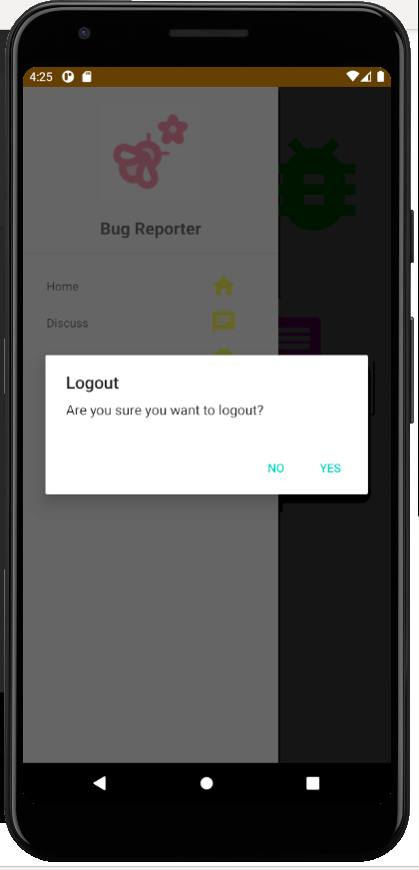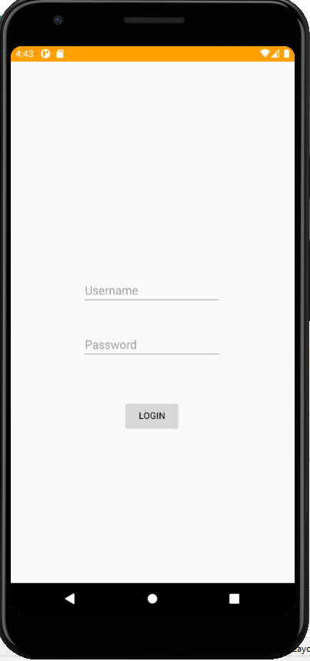

devLoginPassandLogout()

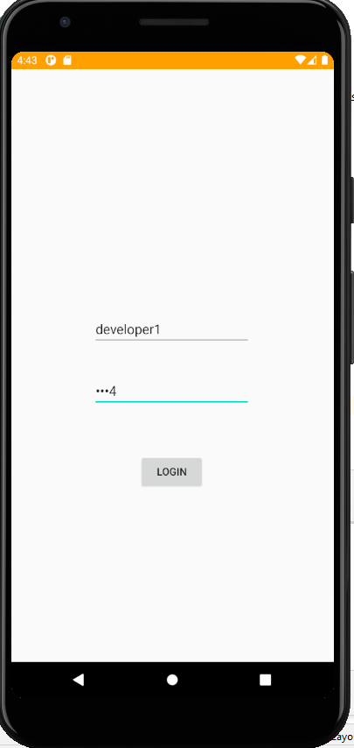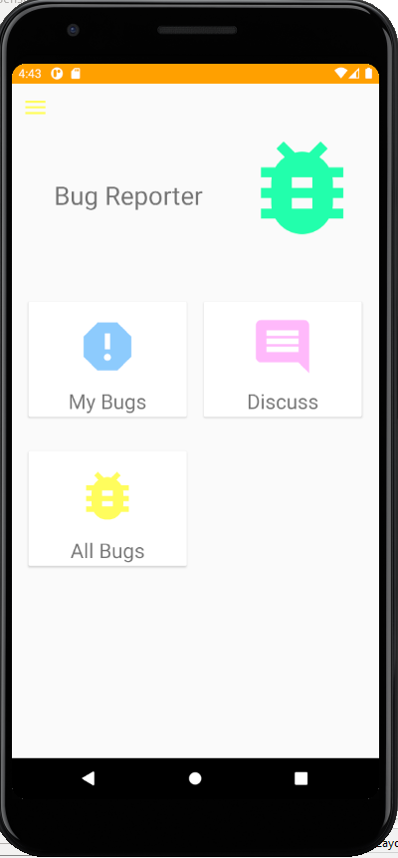

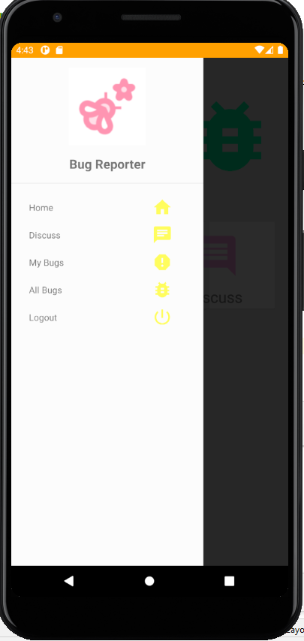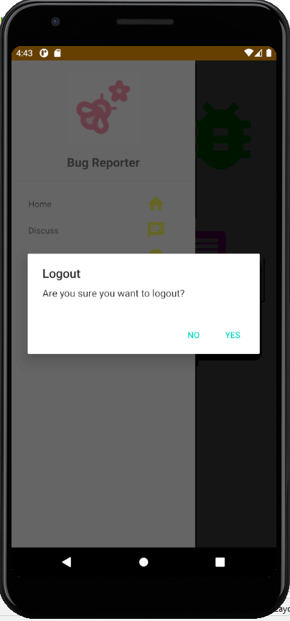

triagerLoginPassandLogout()

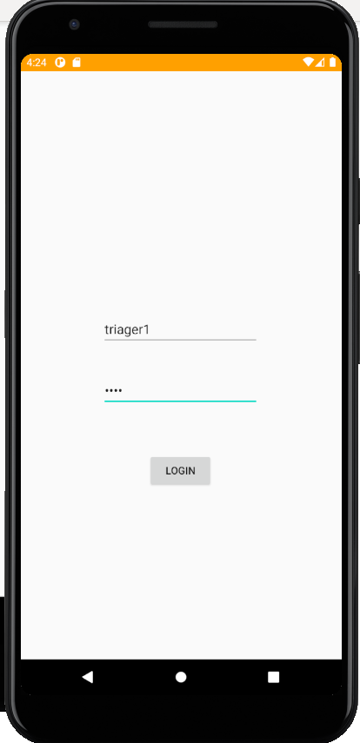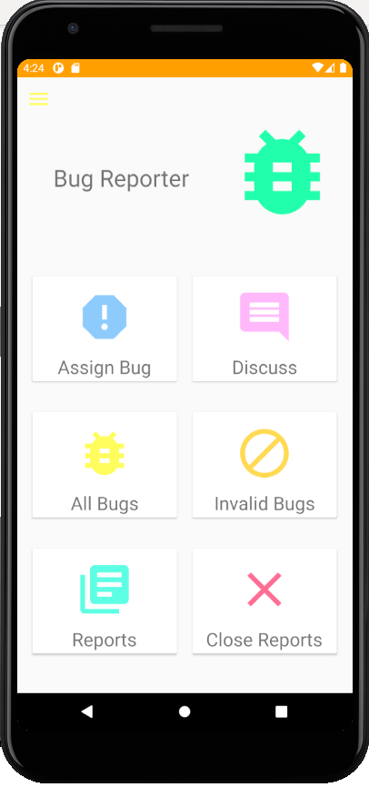

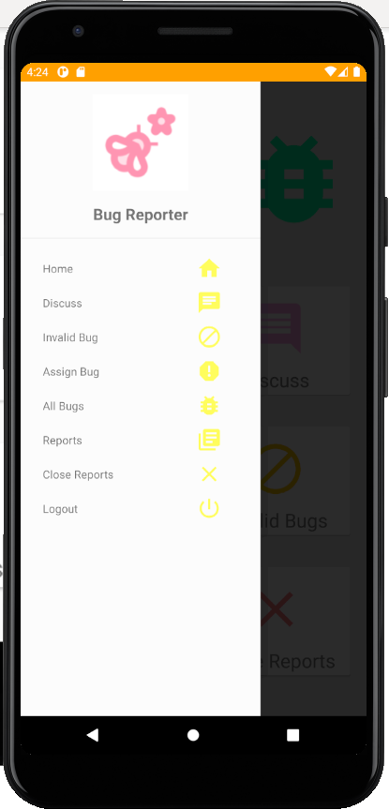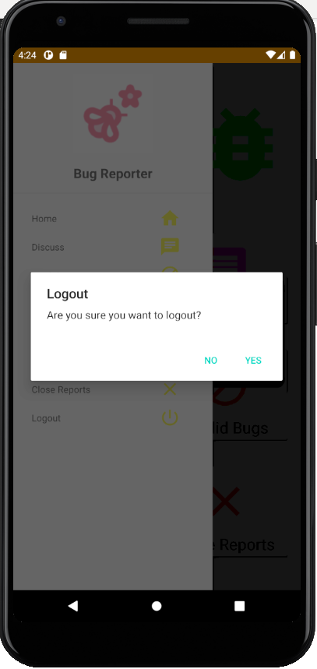



reviewerLoginPassandLogout()

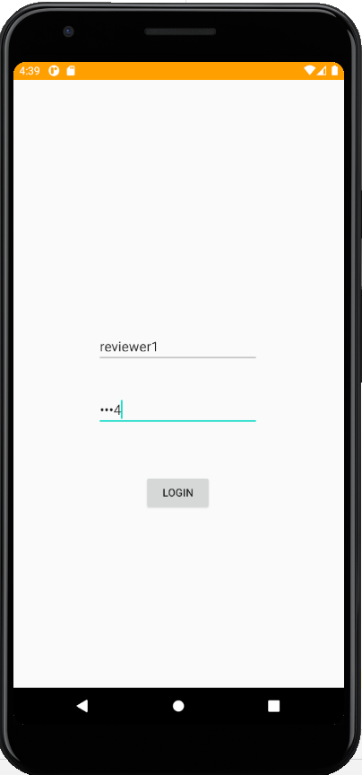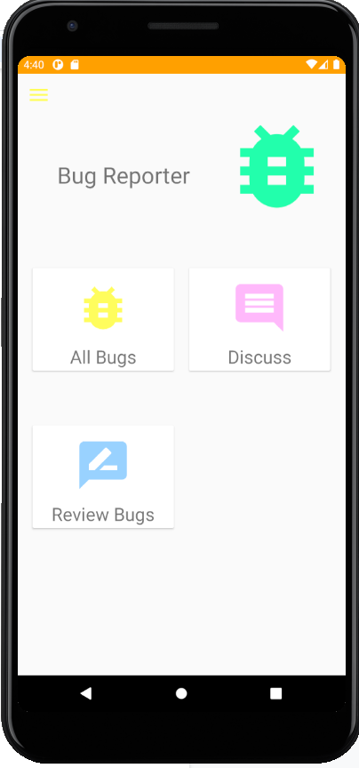

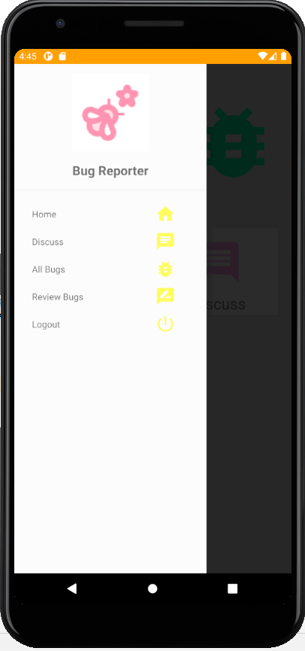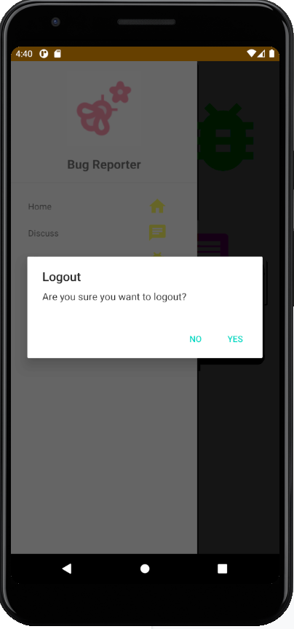

## **b. Sprint 2**

### **Wireframe**

#### Bug Reporter

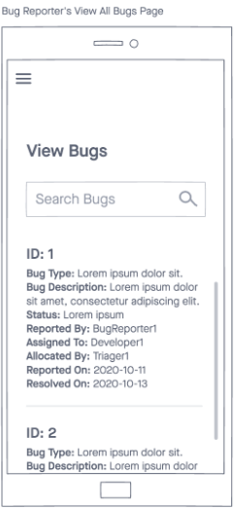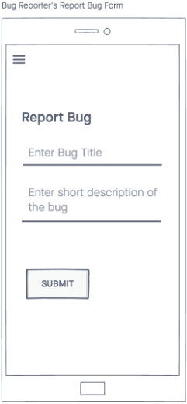

#### Triager

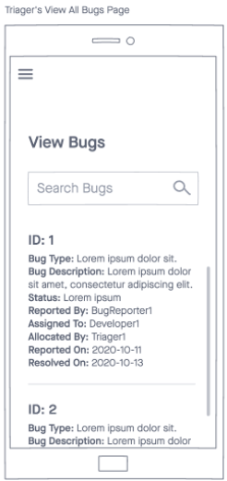

#### Developer

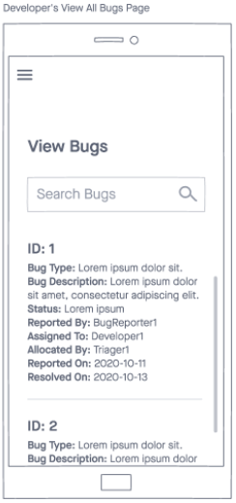

#### Reviewer

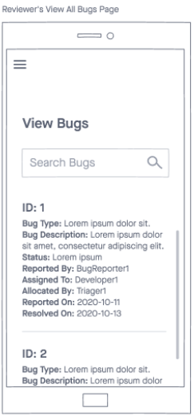

### **Screenshot of interface**

#### Bug Reporter

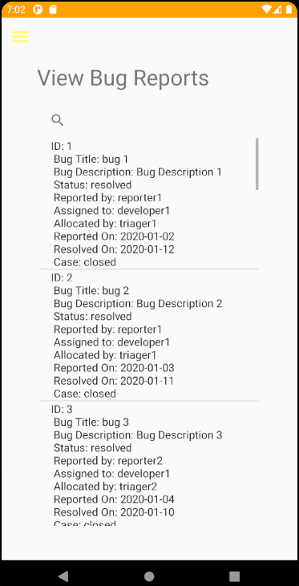

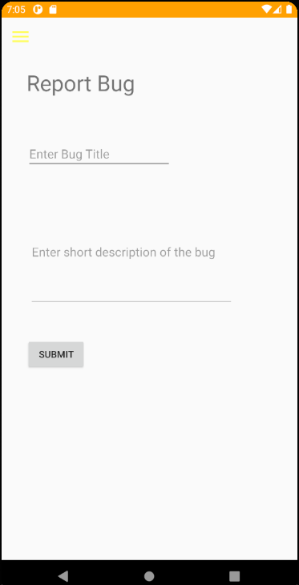

#### Triager

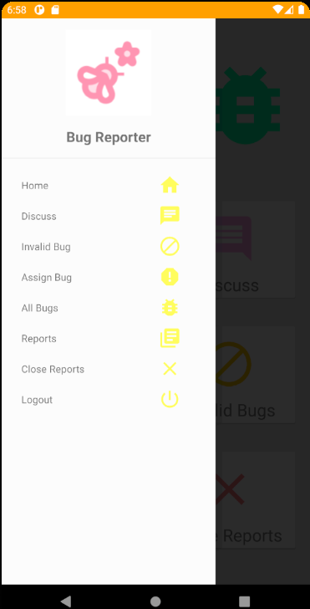

#### Developer



##### 

##### 

#### Reviewer



#### 

### **Screenshot of taiga**

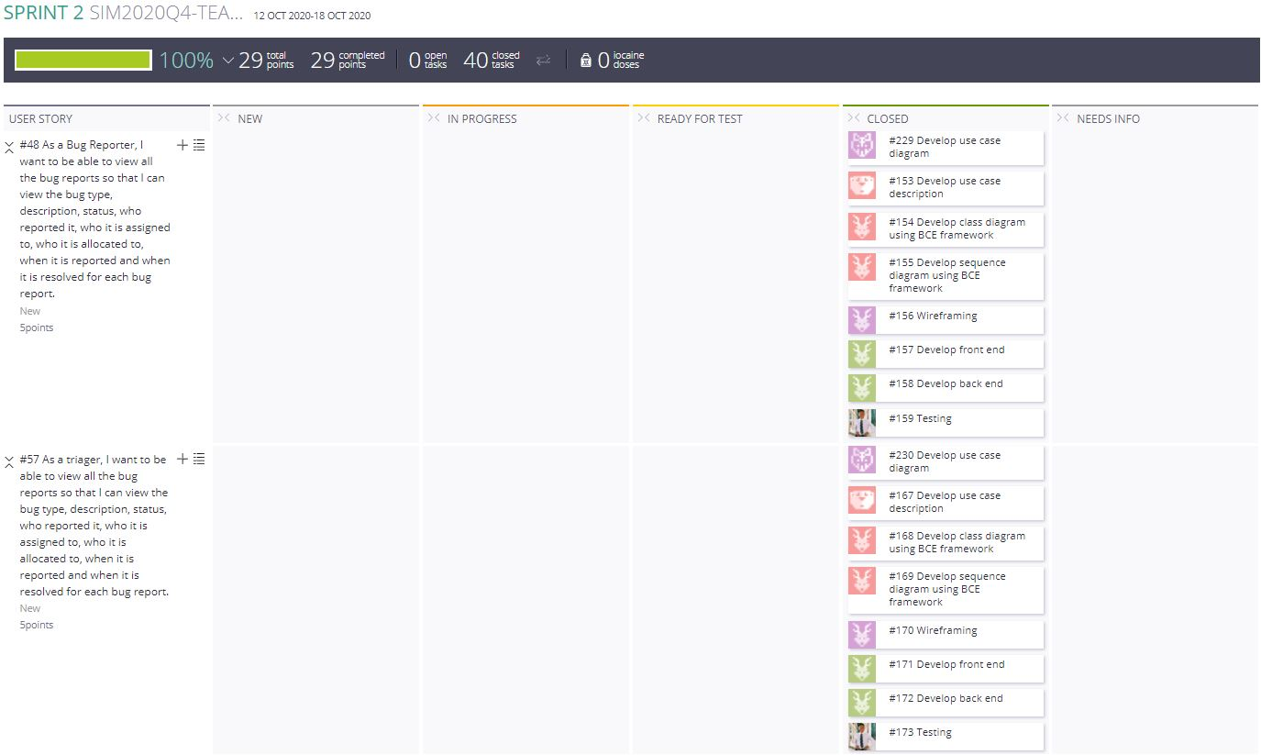

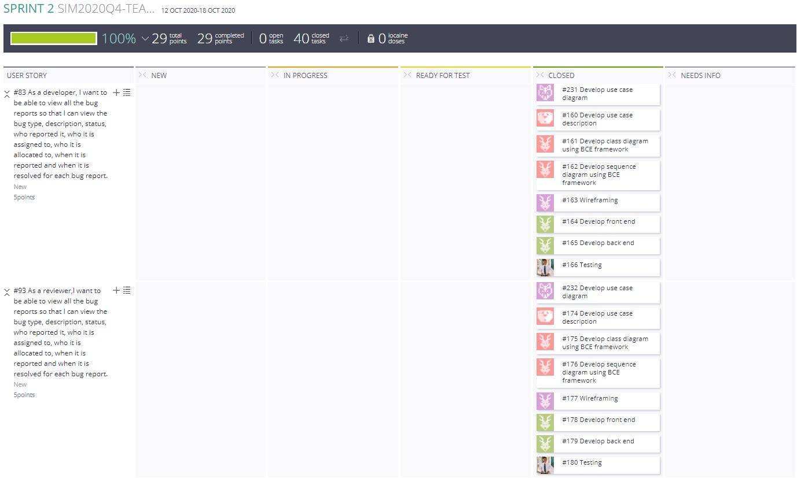

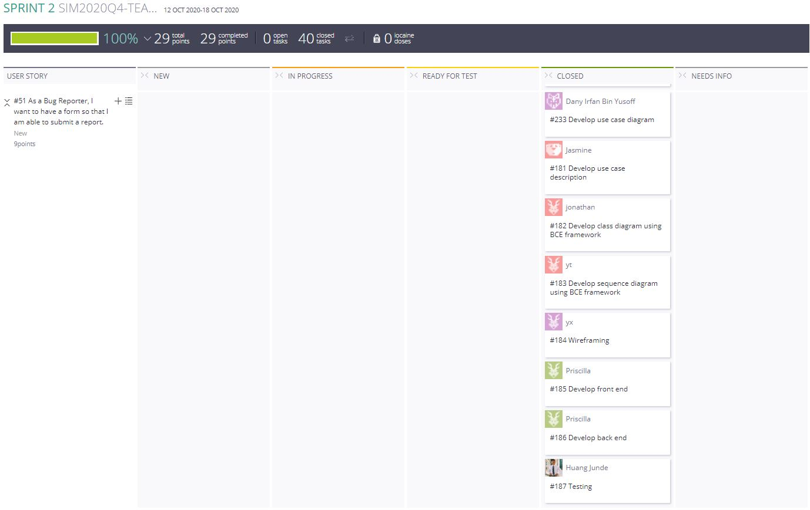

#### 

### **Test cases**

#### Bug Reporter

##### 

##### 

##### 

##### 

##### 

##### 

##### 

##### 

##### 

##### 

##### 

#### 

#### Triager

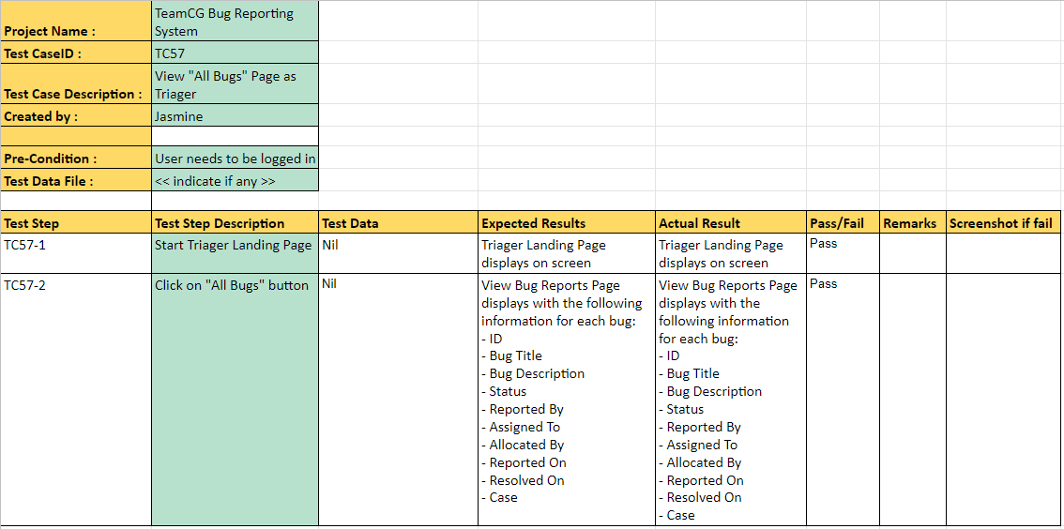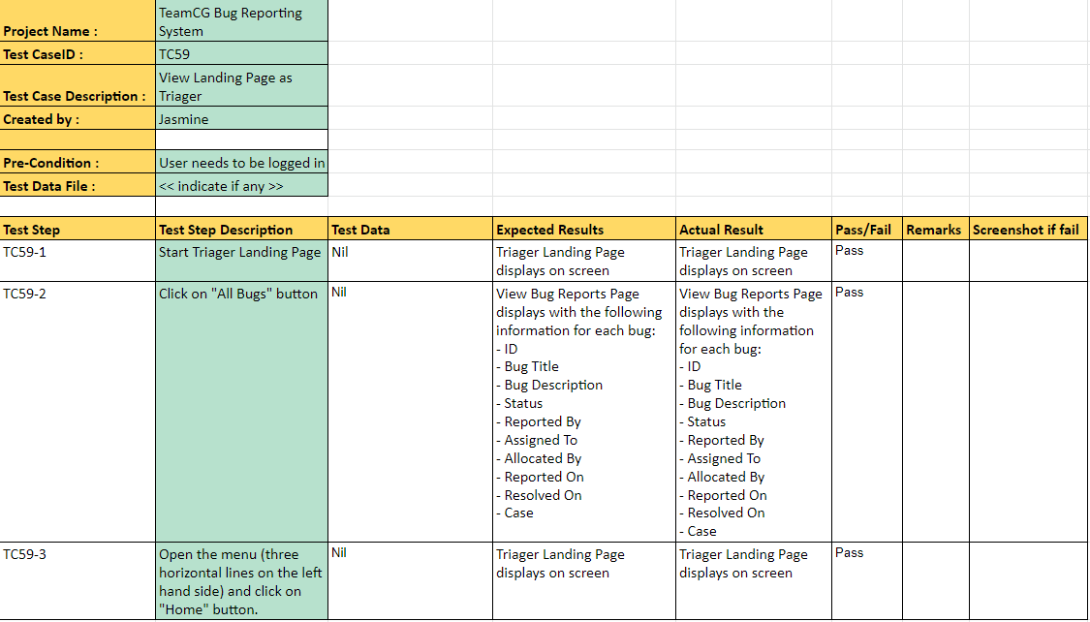

#### Developer

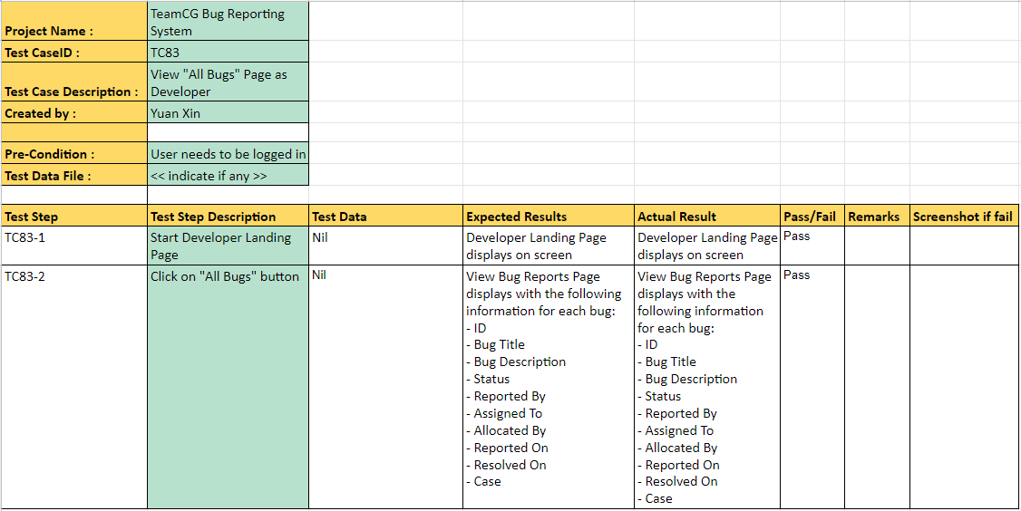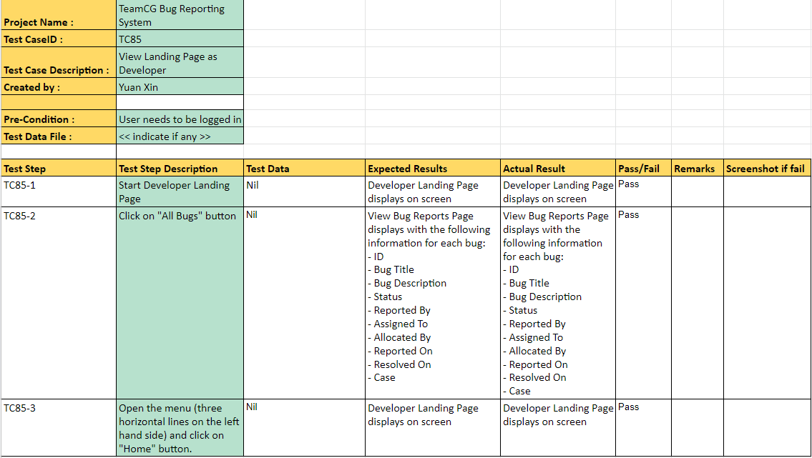

#### Reviewer

### 

## **c. Sprint 3**

### **Screenshot of interface**

#### Bug Reporter

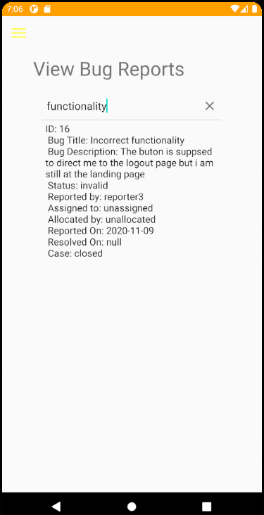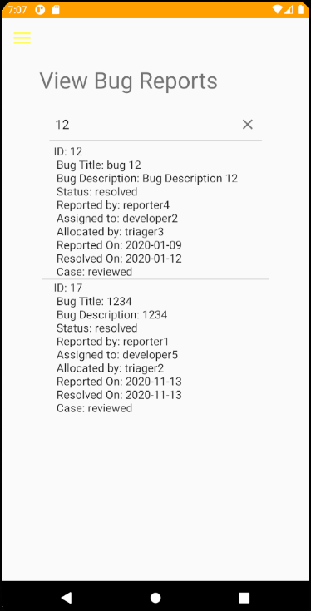

##### 

#### Triager



#### Developer



#### Reviewer



### **Screenshot of taiga**

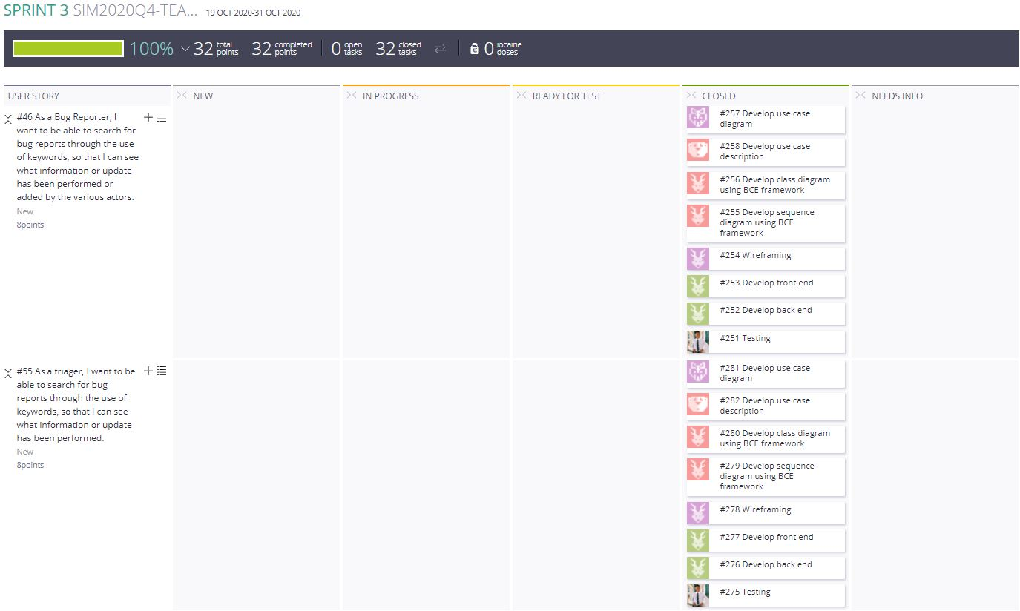

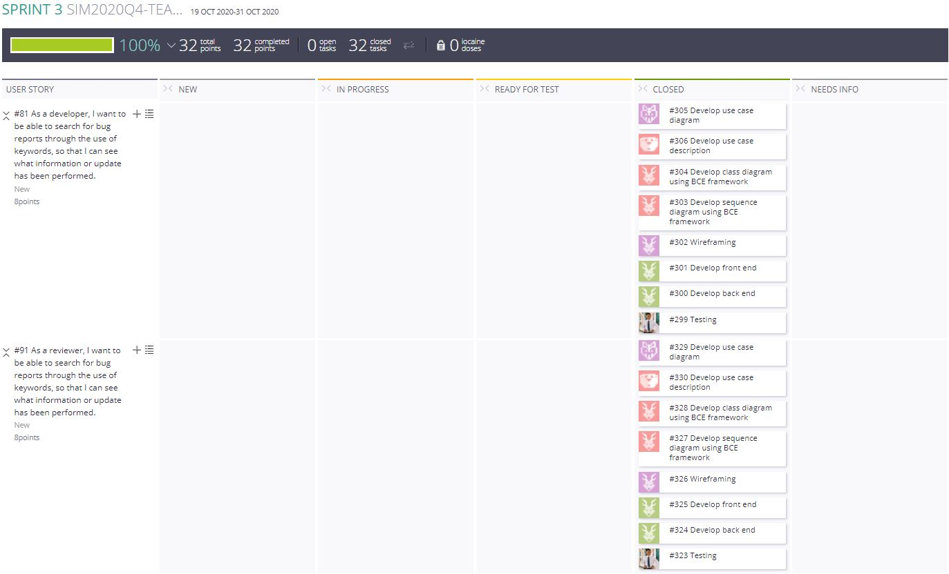

### **Test cases**

#### Bug Reporter

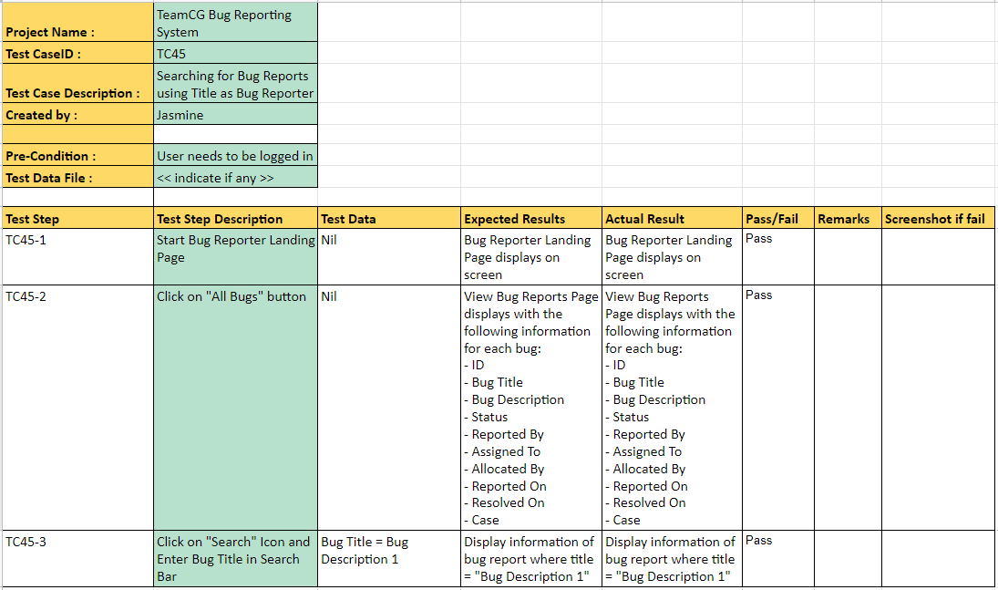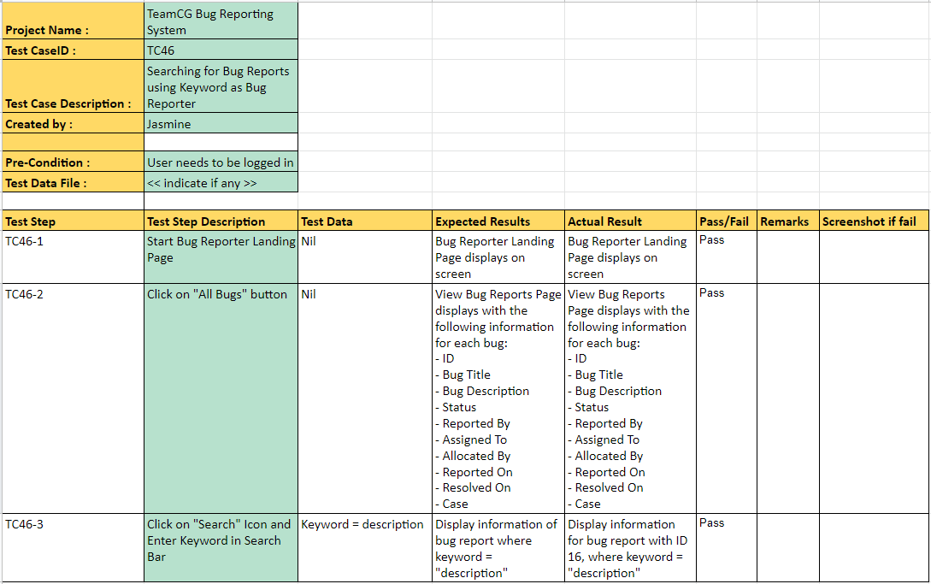

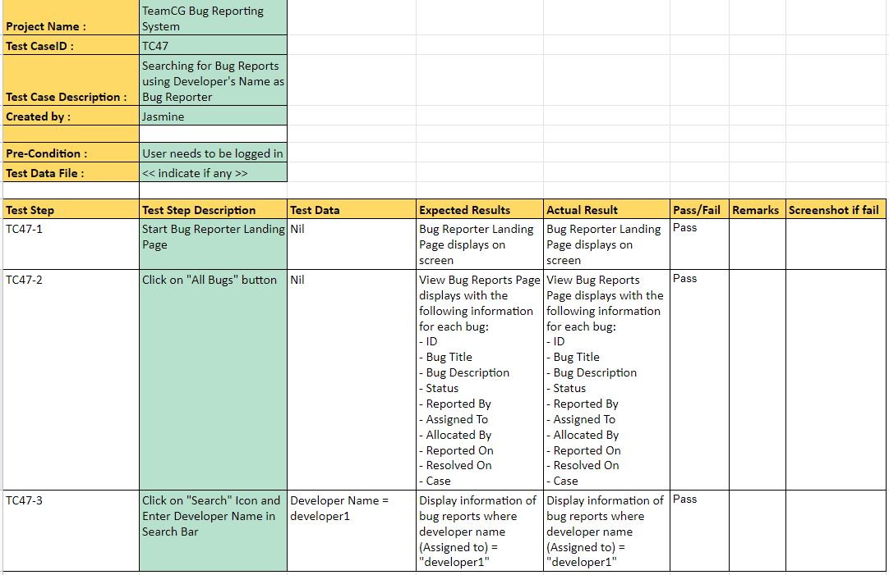

#### Triager

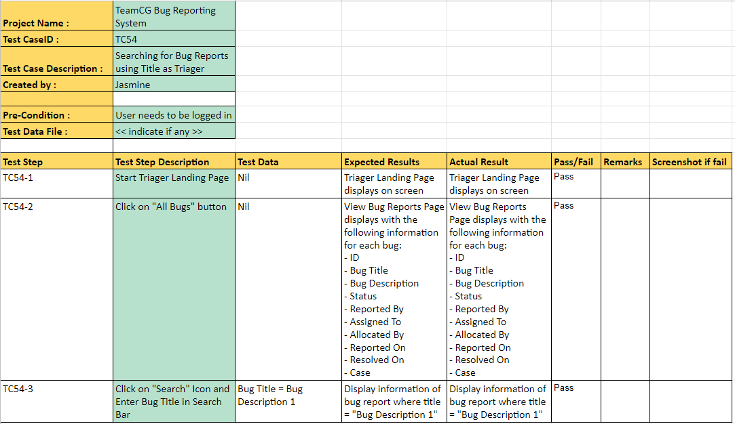

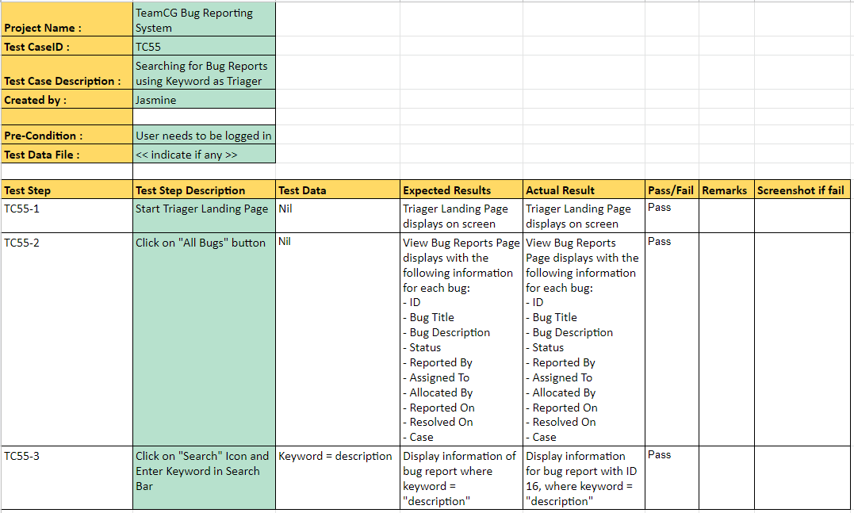

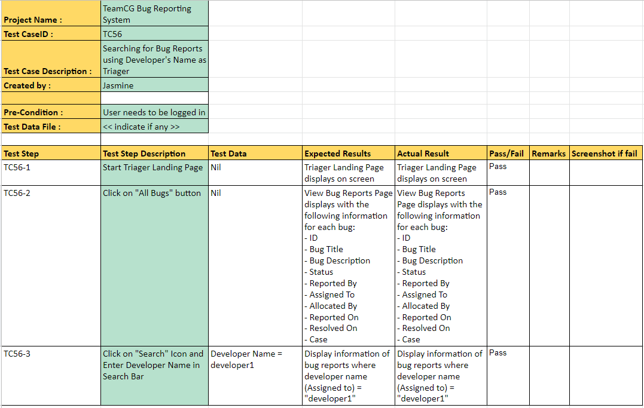

#### Developer

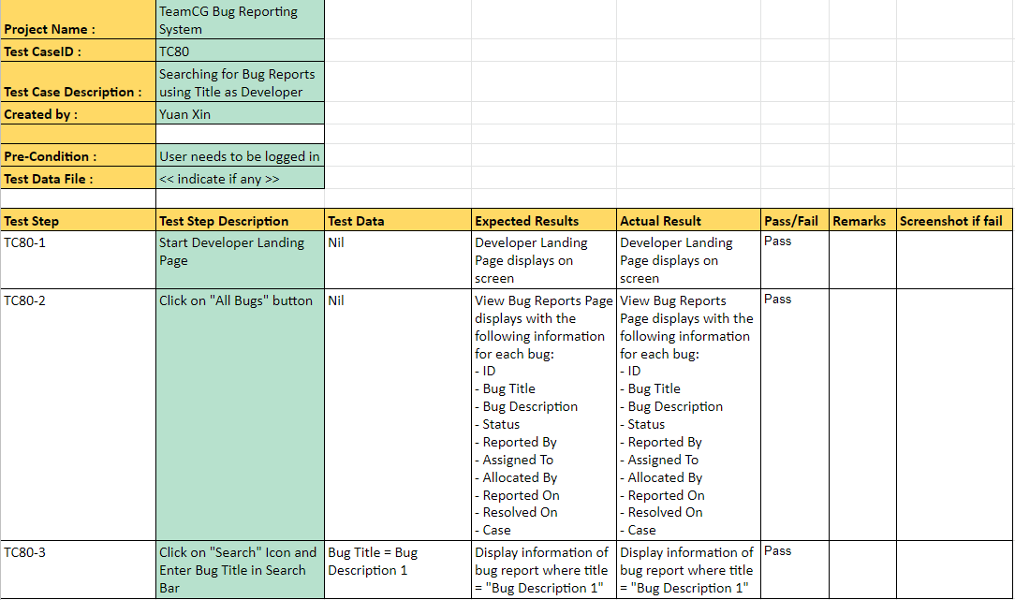

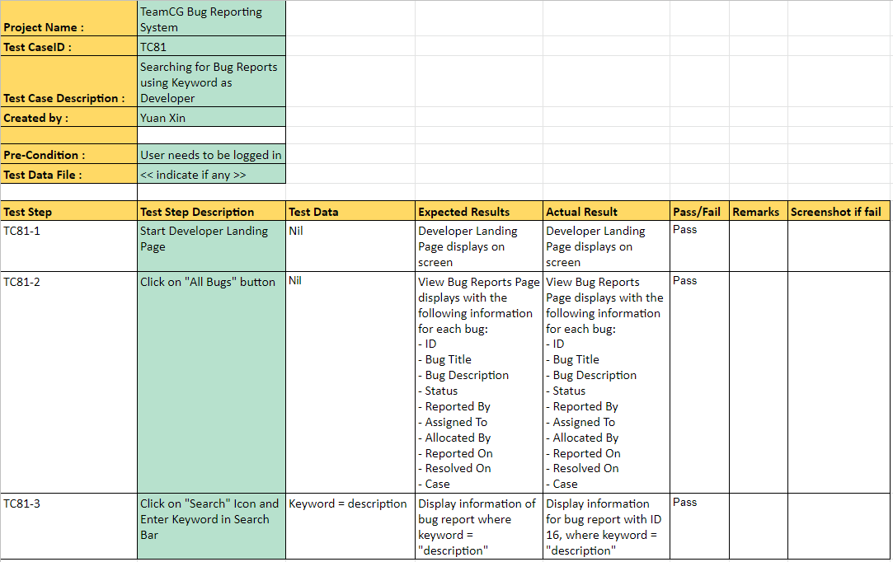

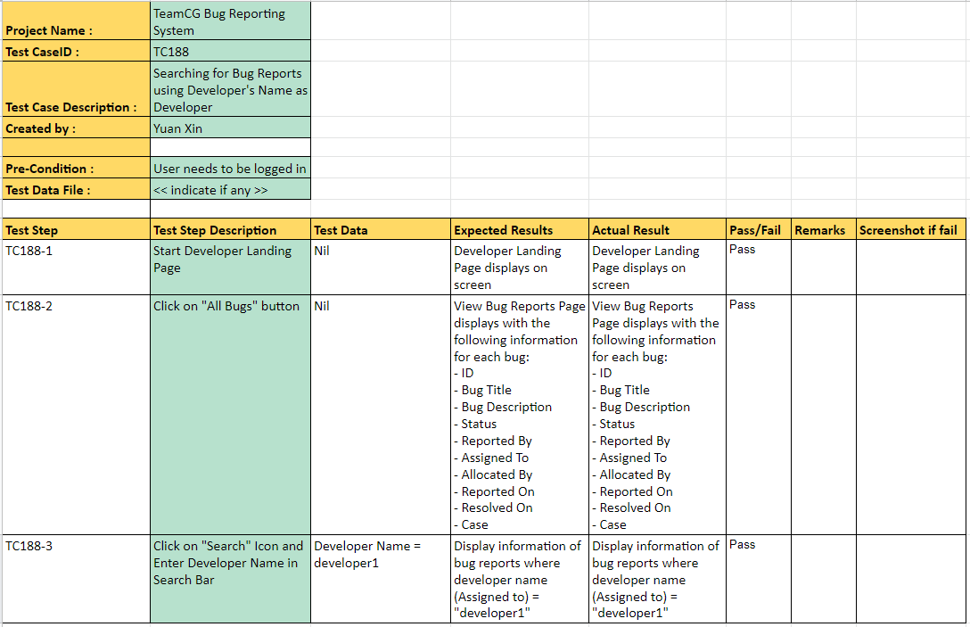

#### Reviewer

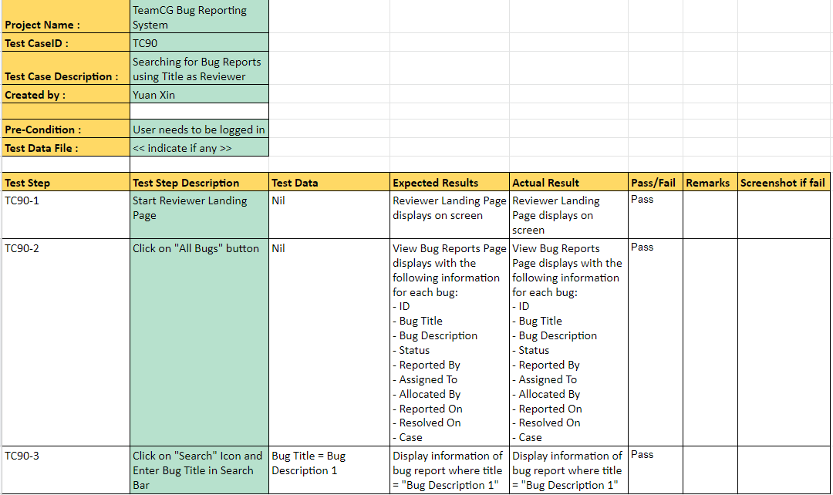

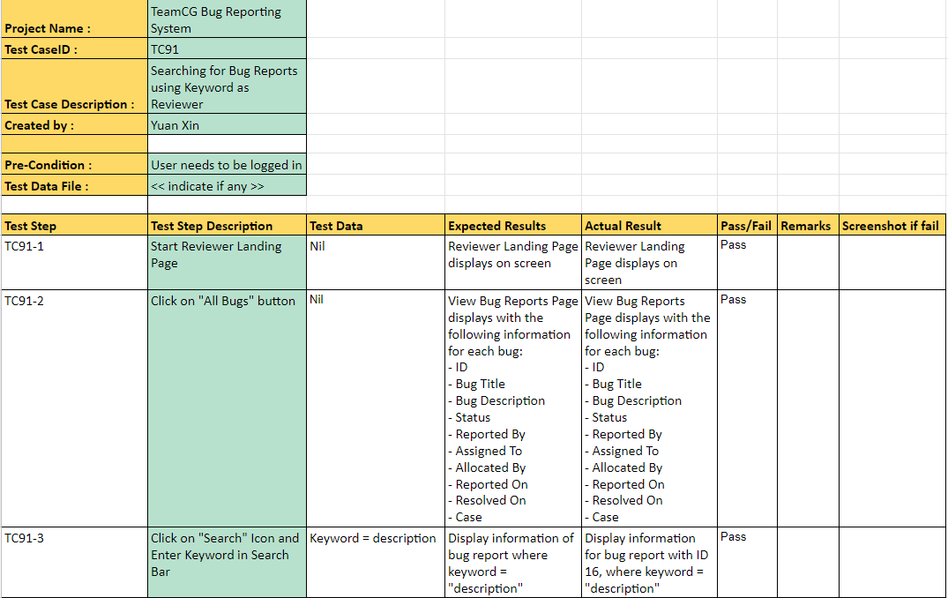

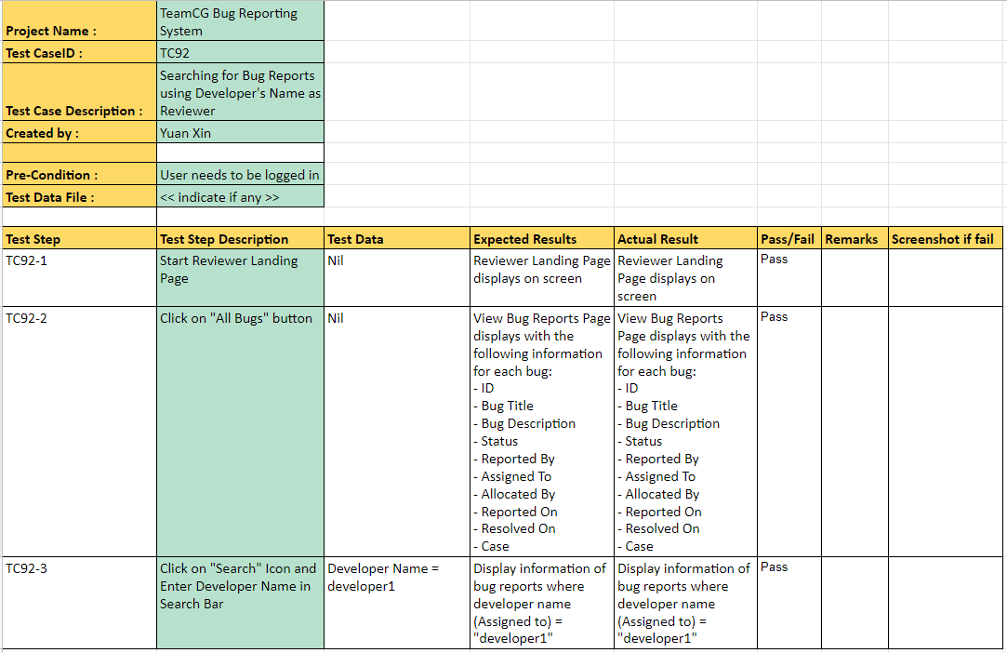

### 

## **d. Sprint 4**

### **Wireframe**

#### Triager

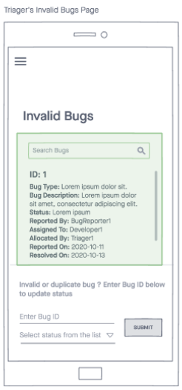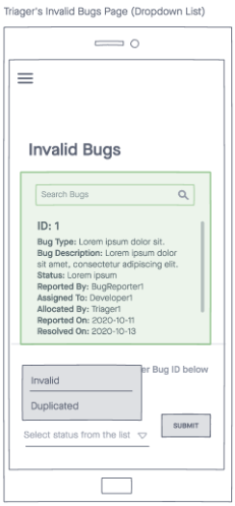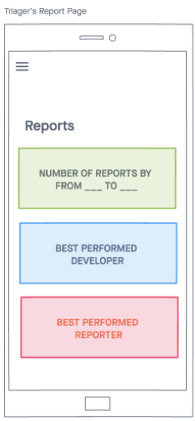

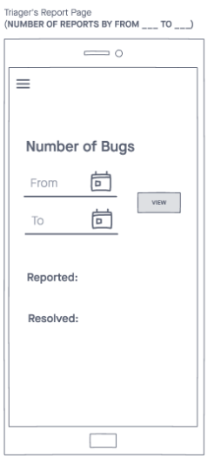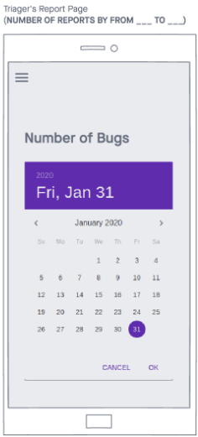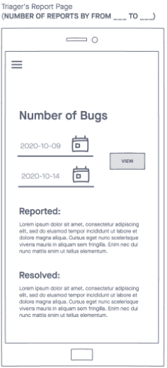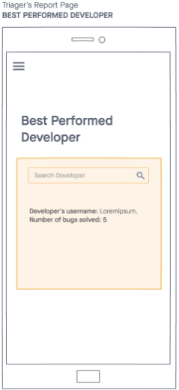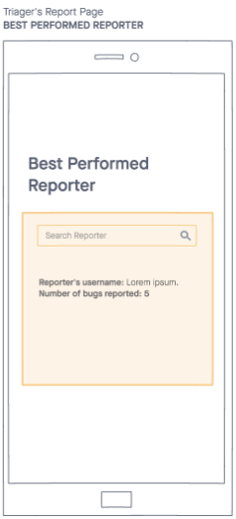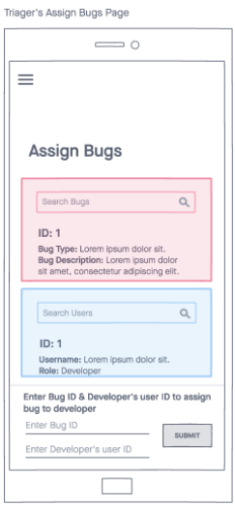

#### Developer

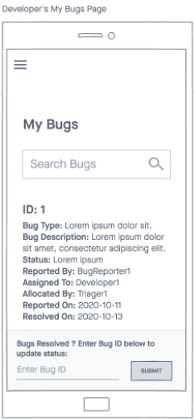

#### Reviewer

#### 

### **Screenshot of interface**

#### Triager

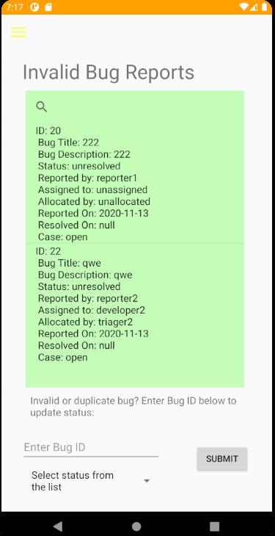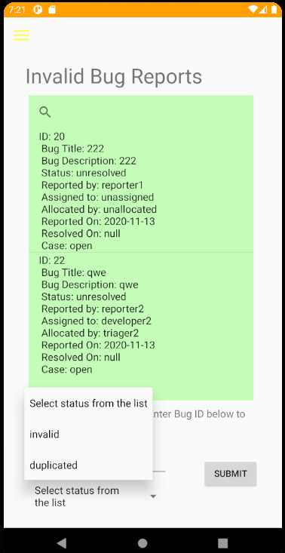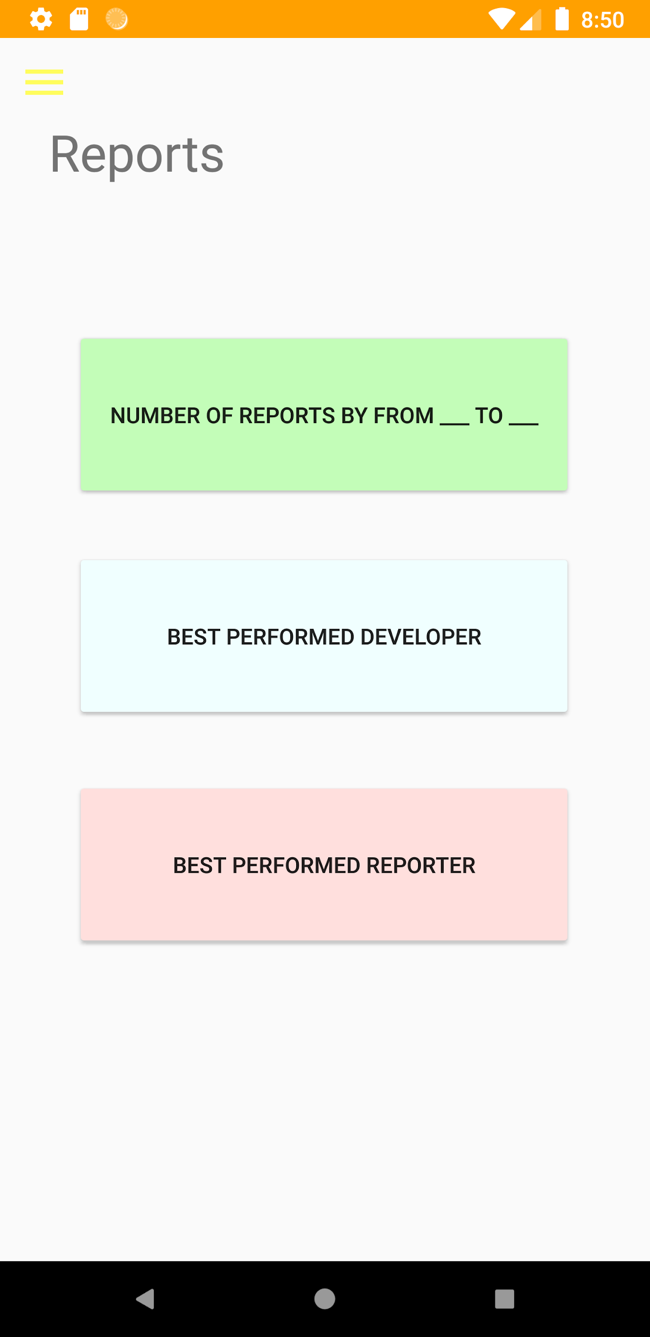

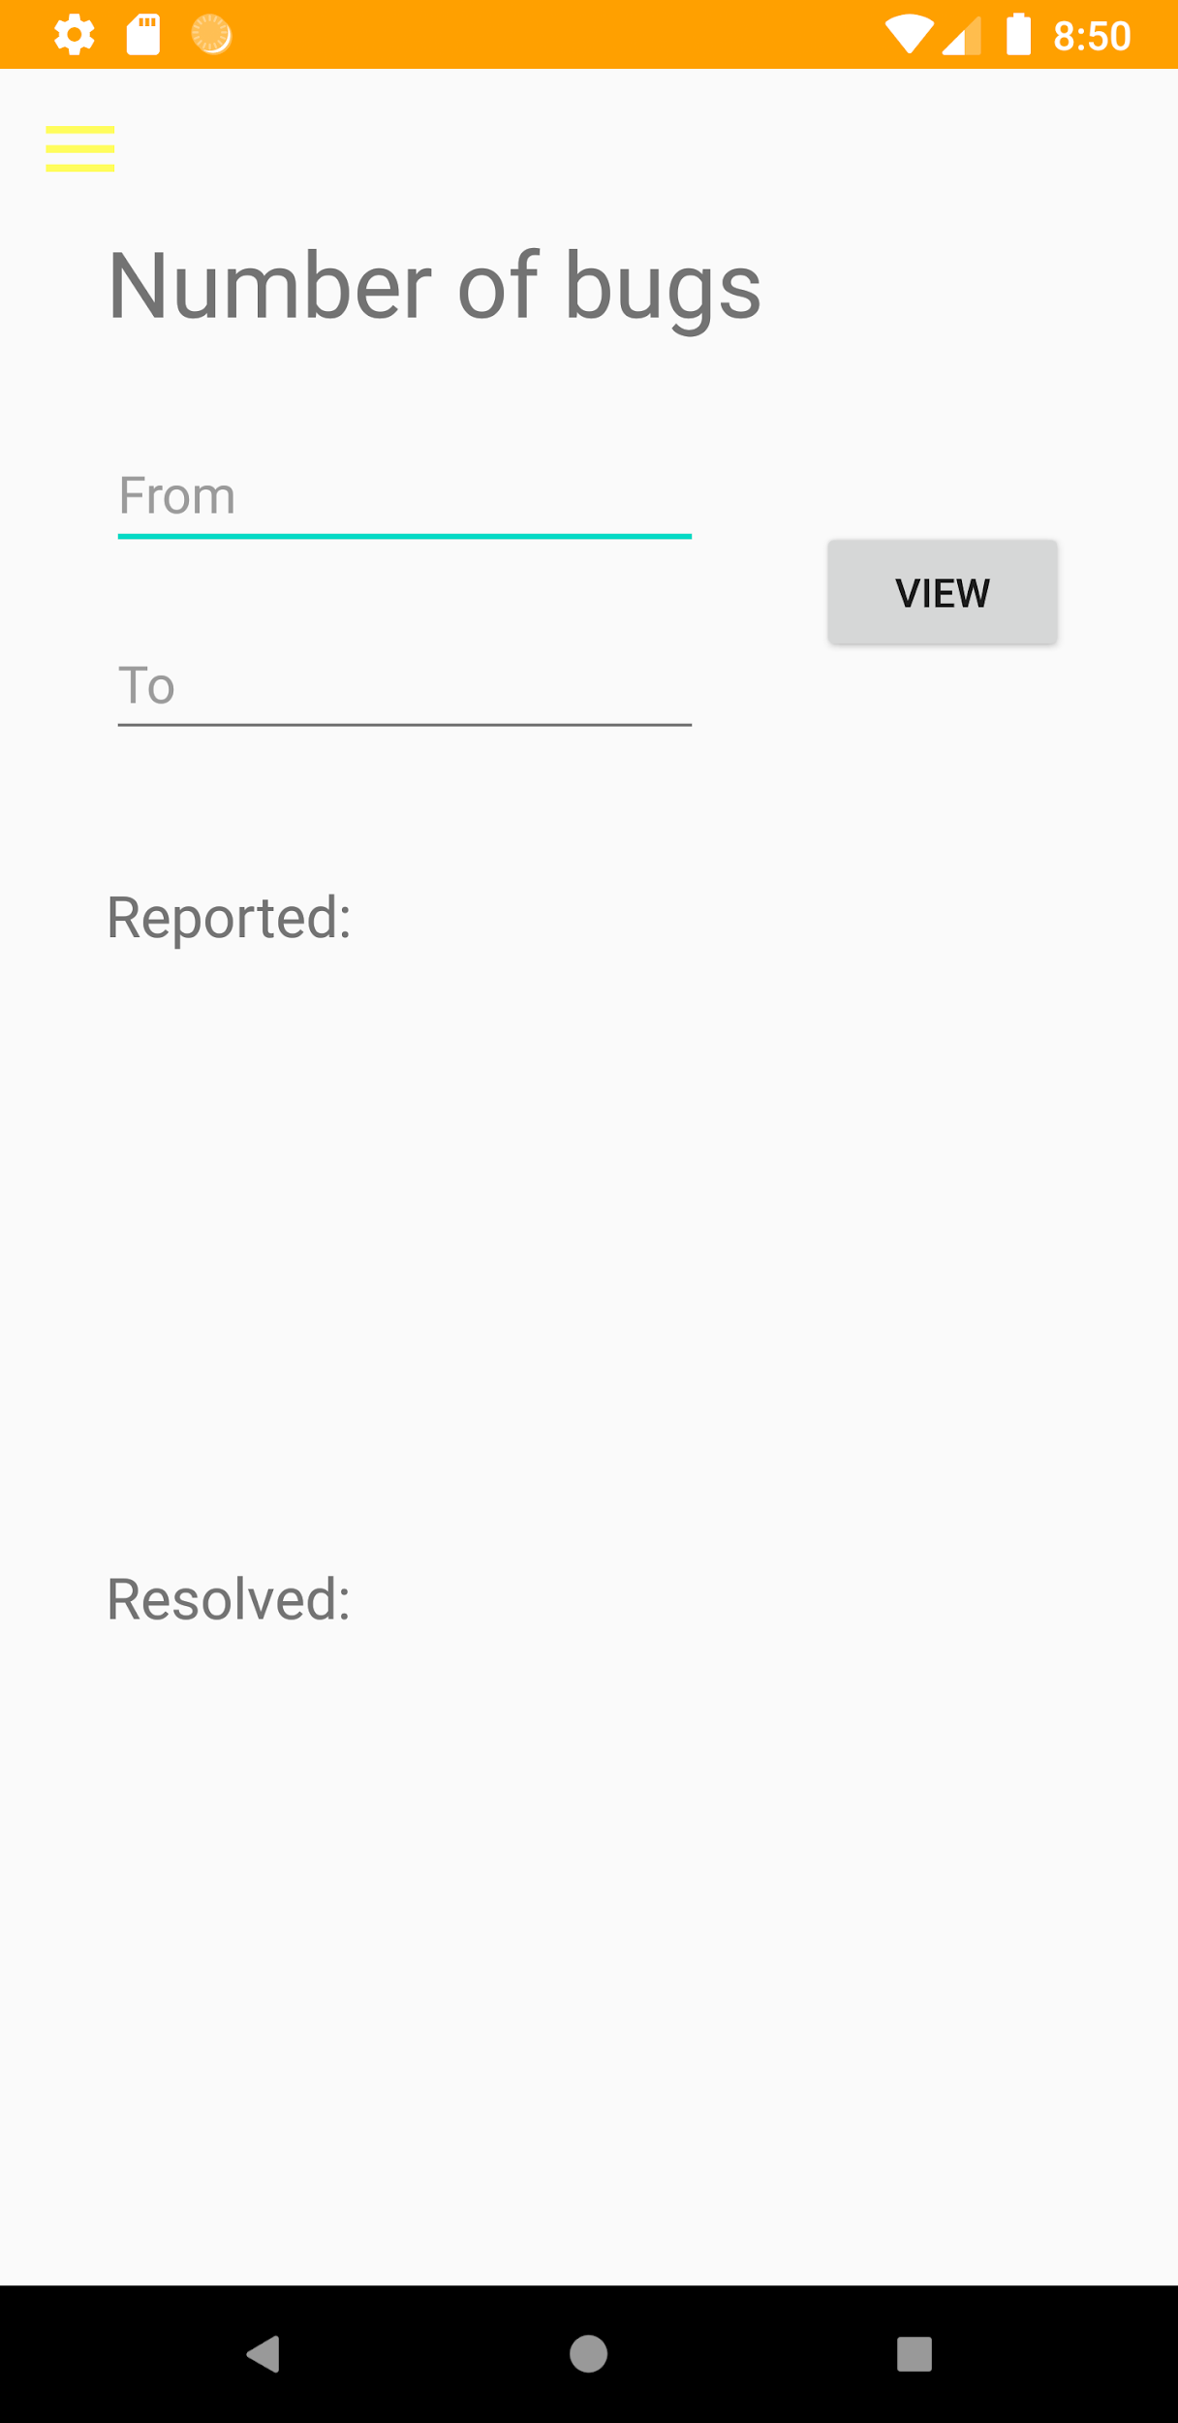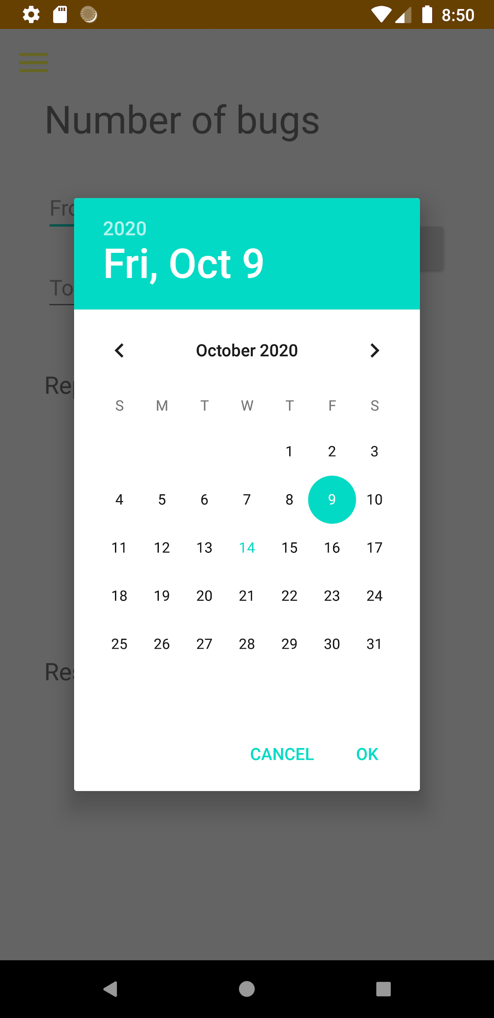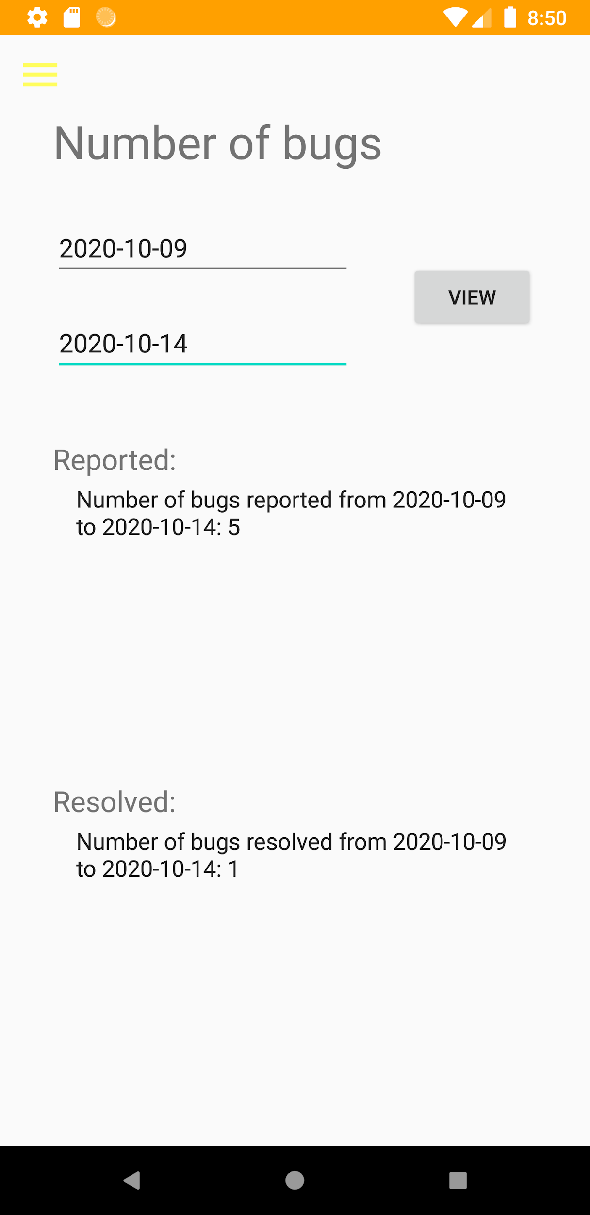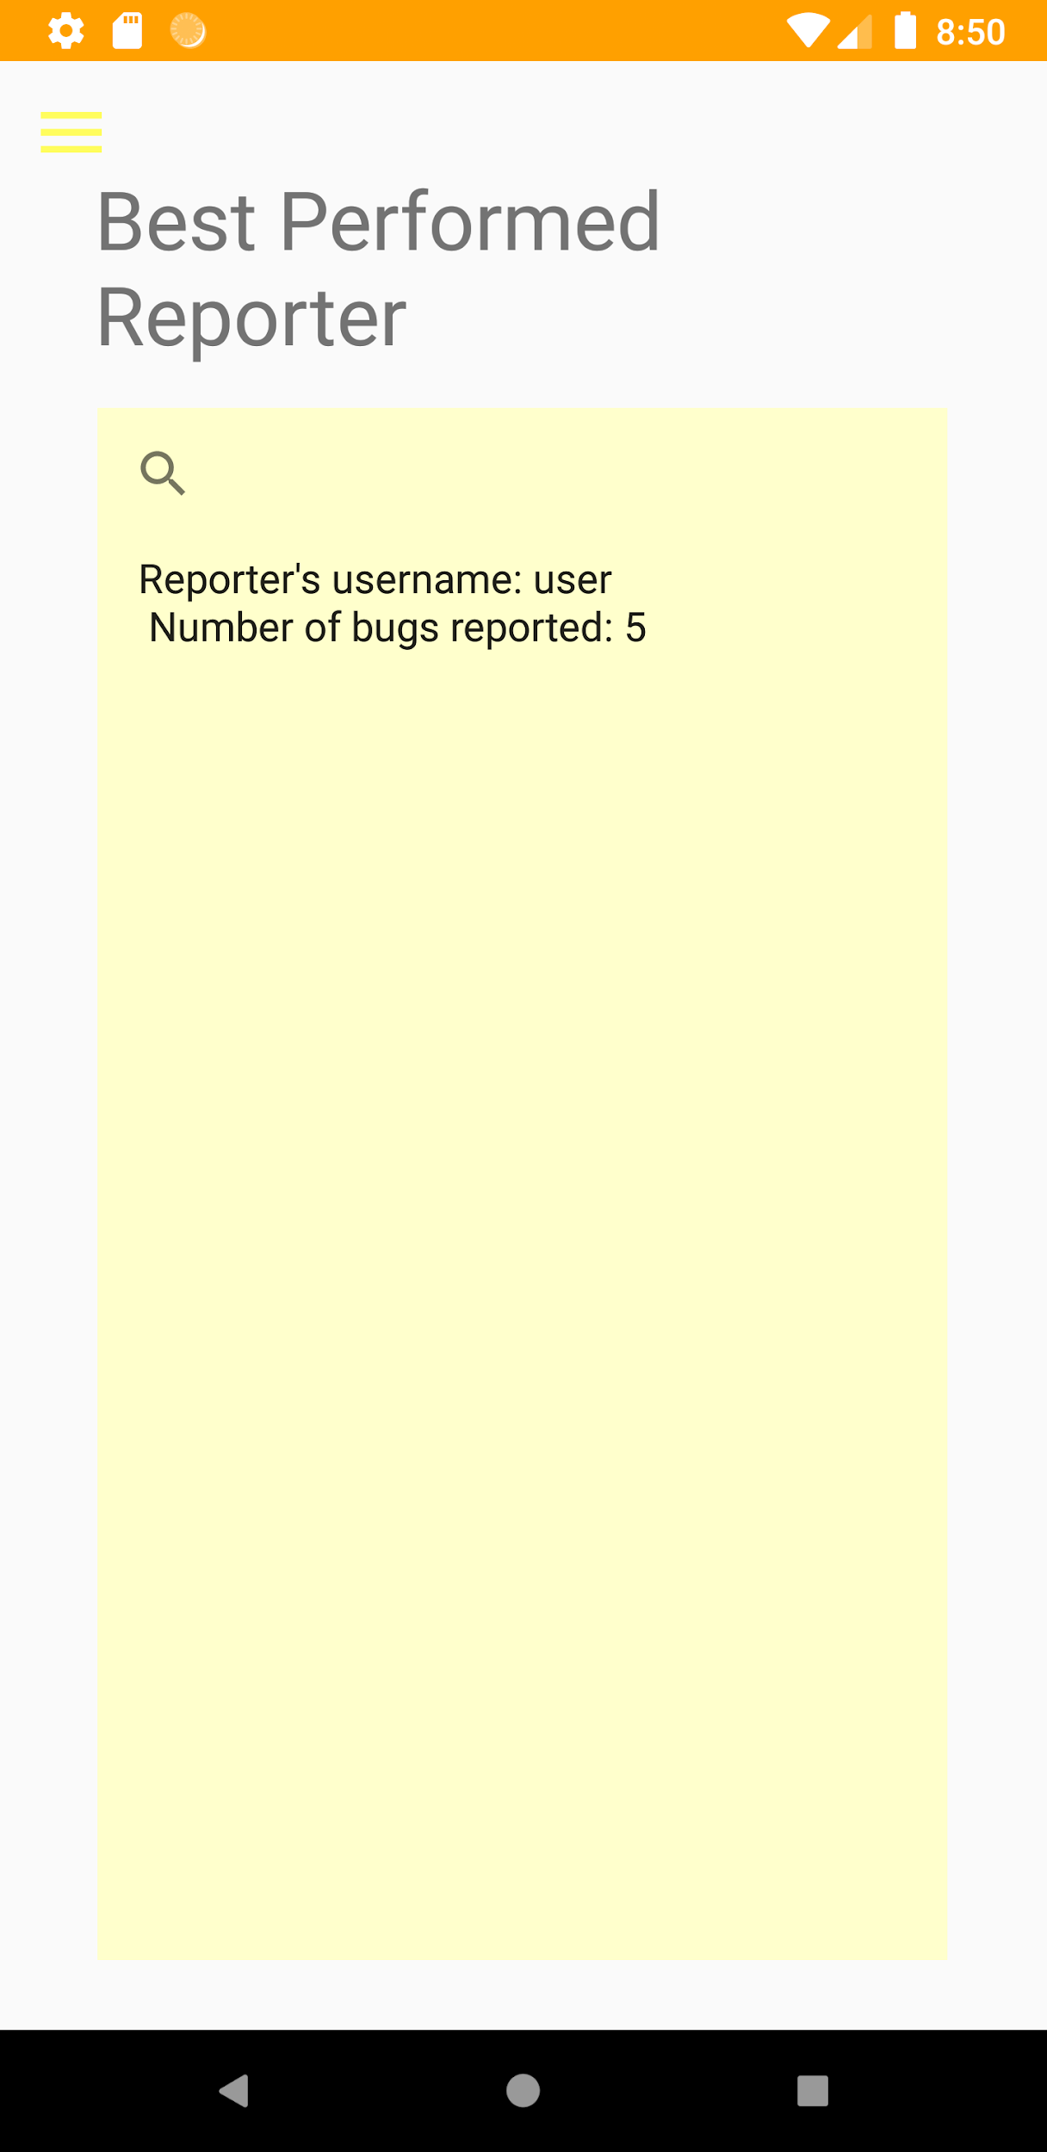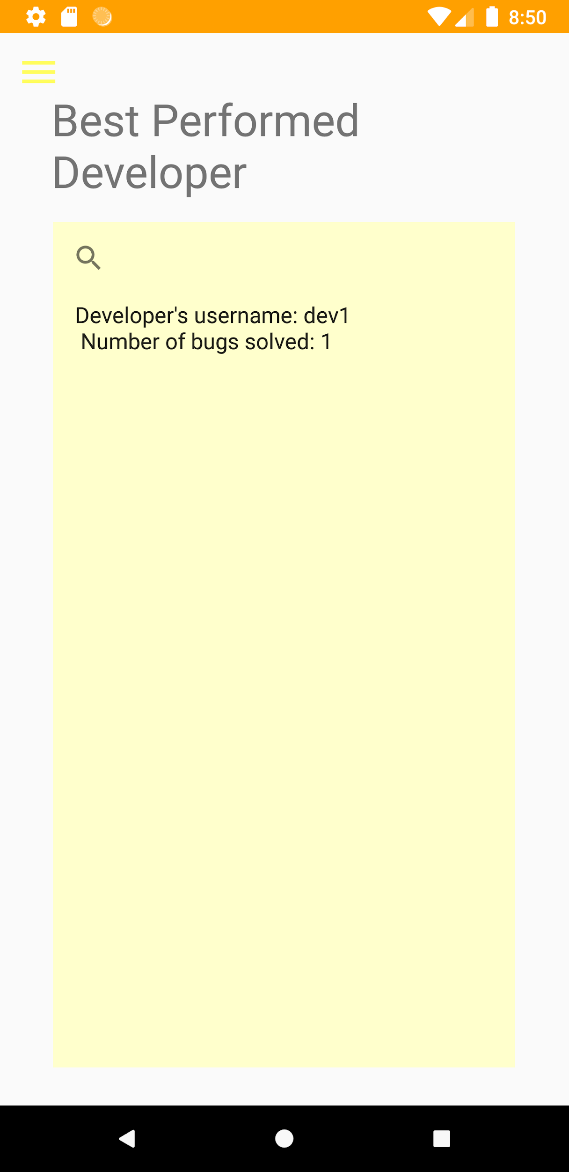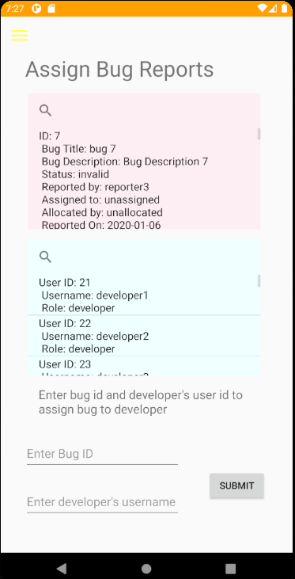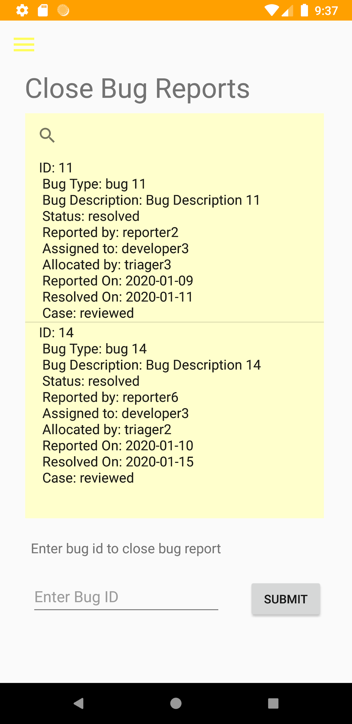

#### Developer

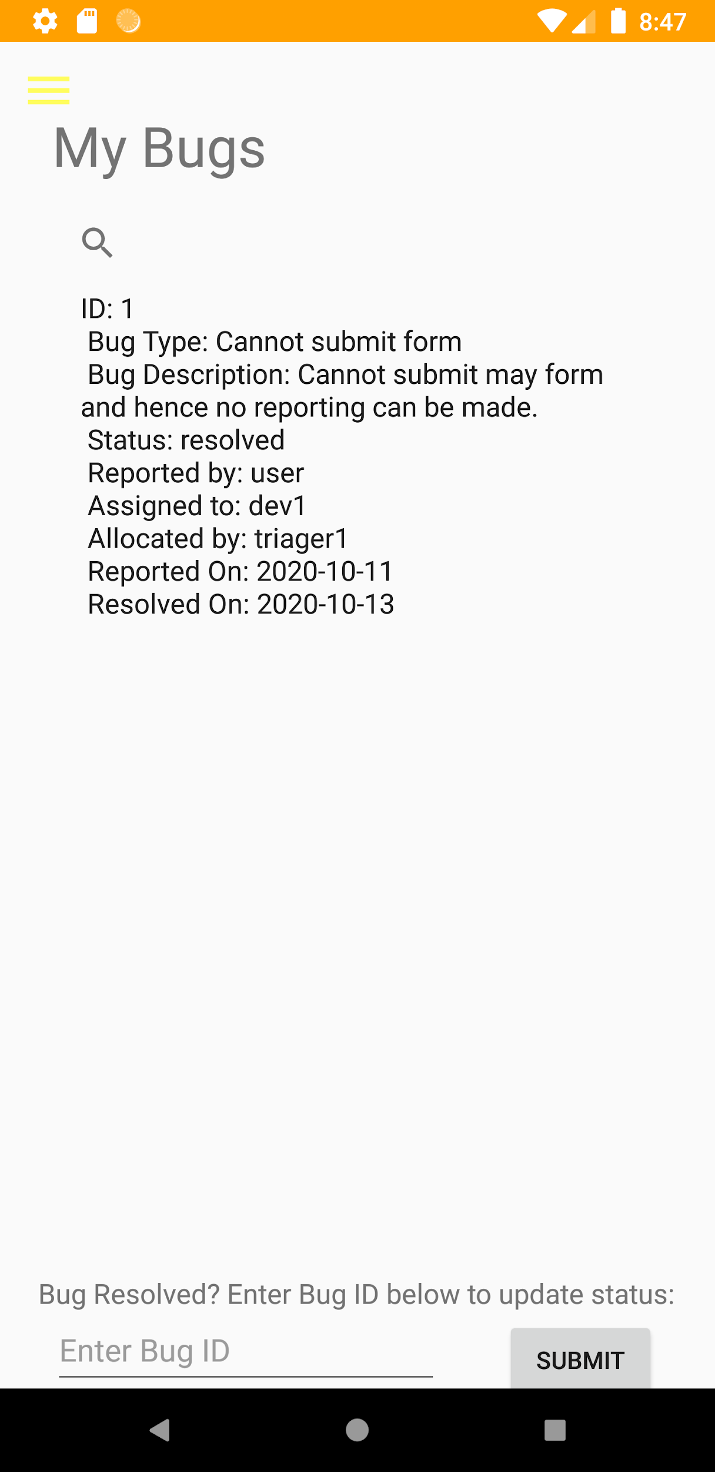

#### Reviewer

##### 

### **Screenshot of taiga**

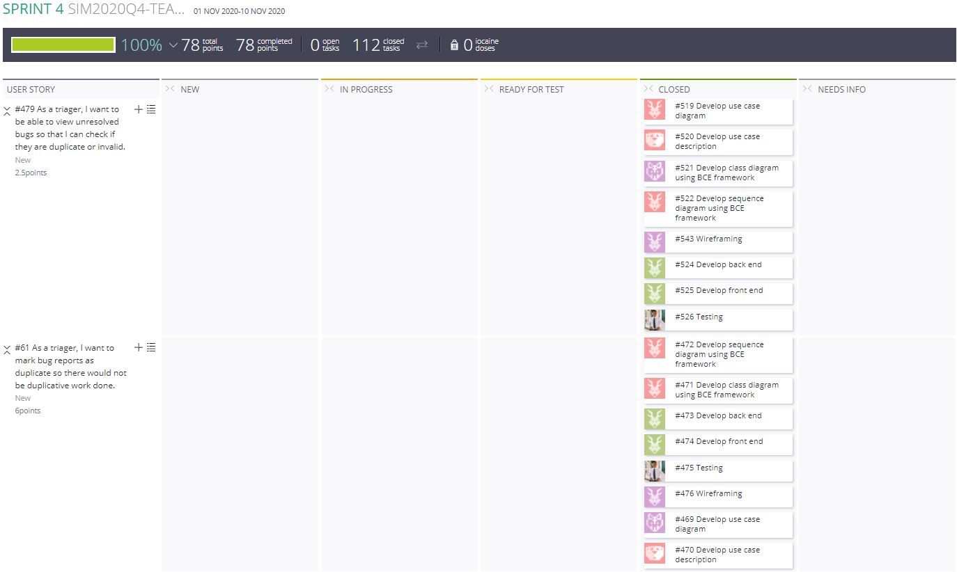

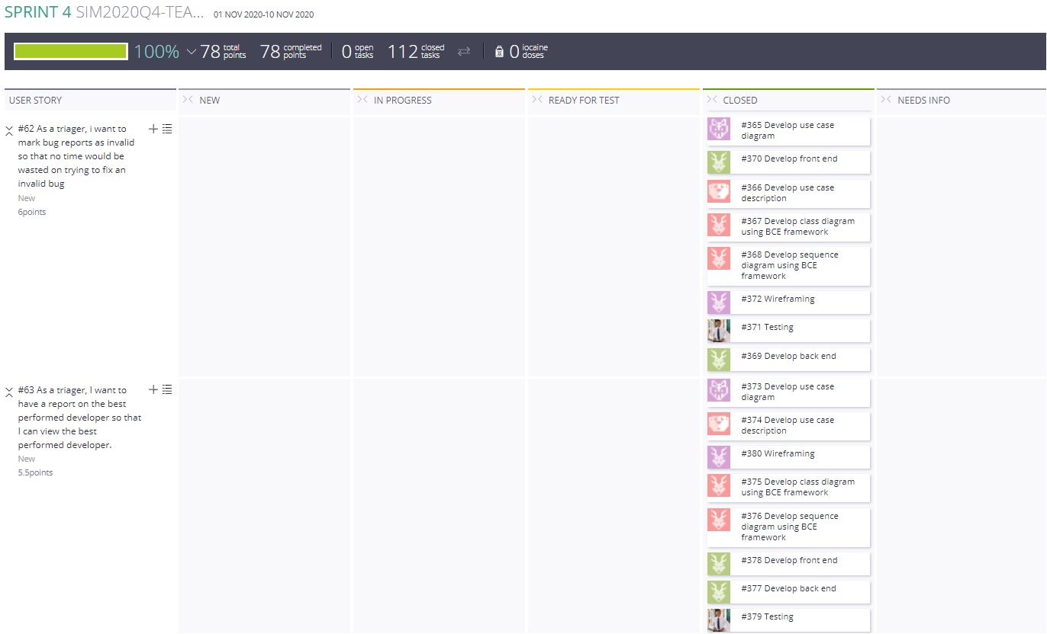

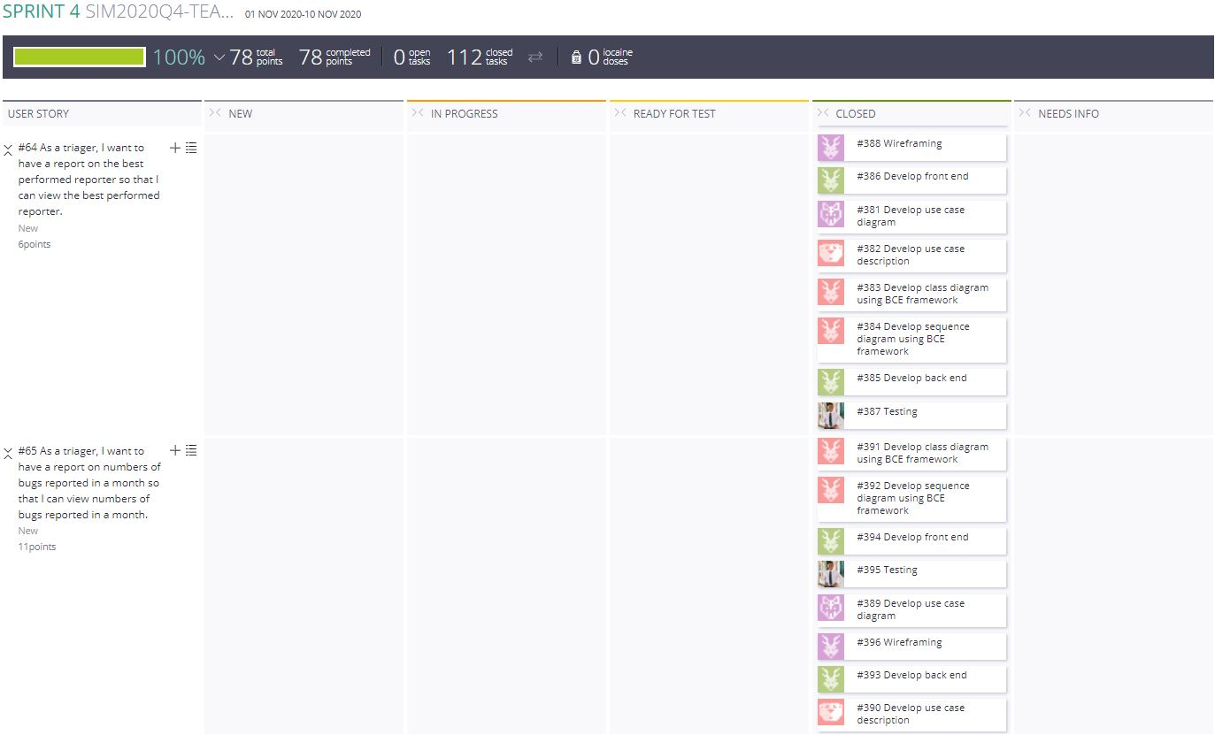

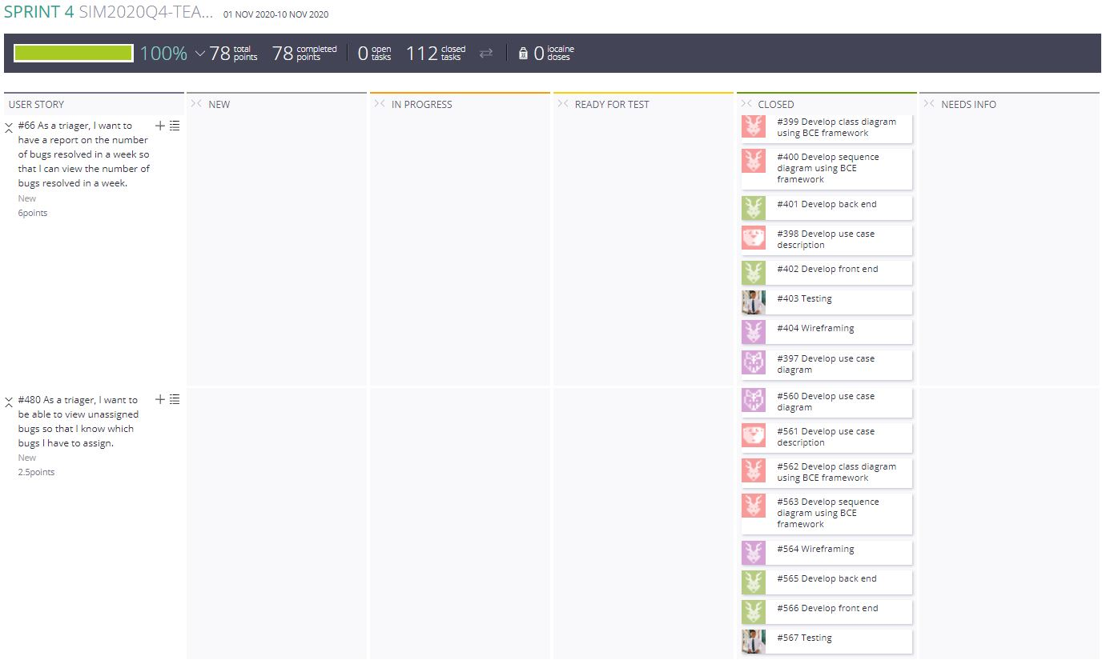

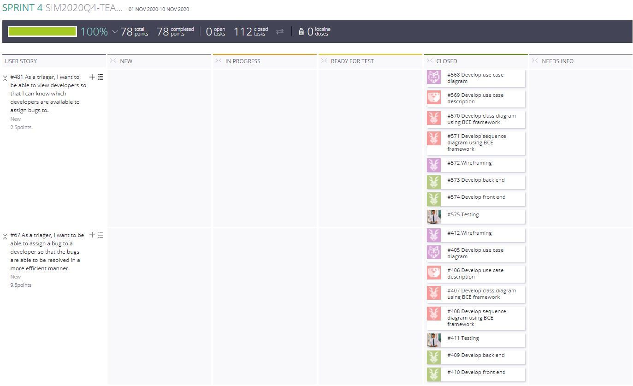

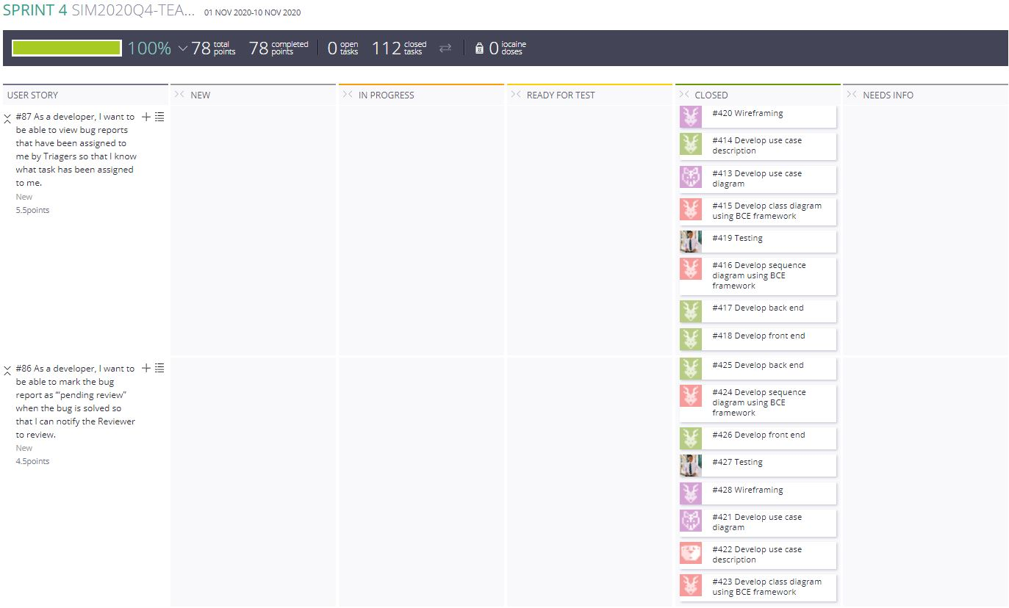

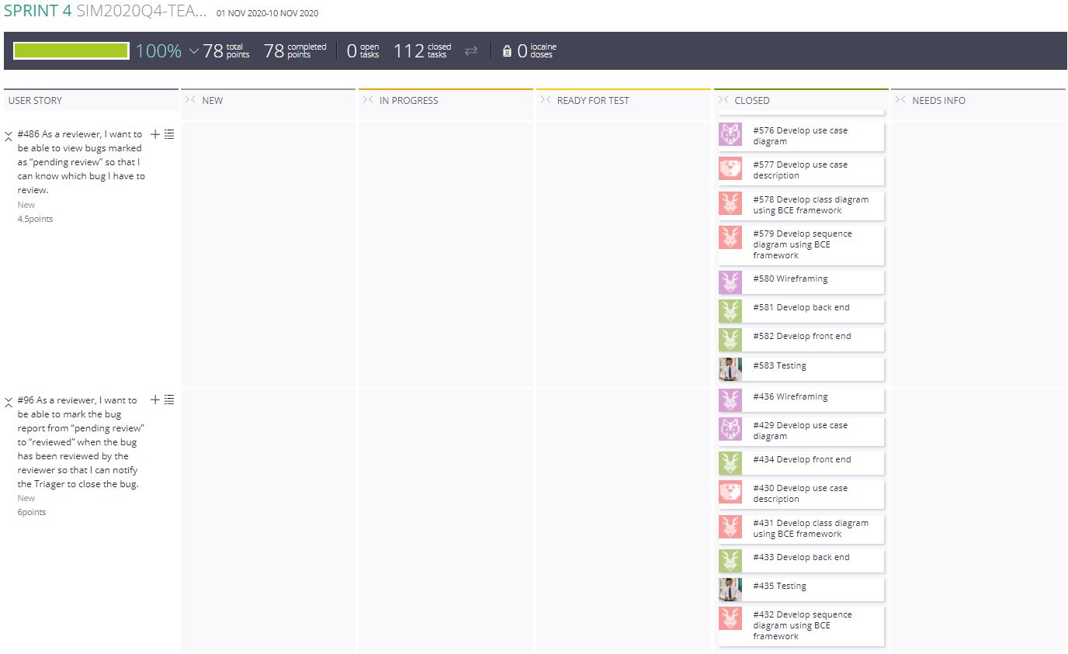

#### 

### **Test cases**

#### Triager

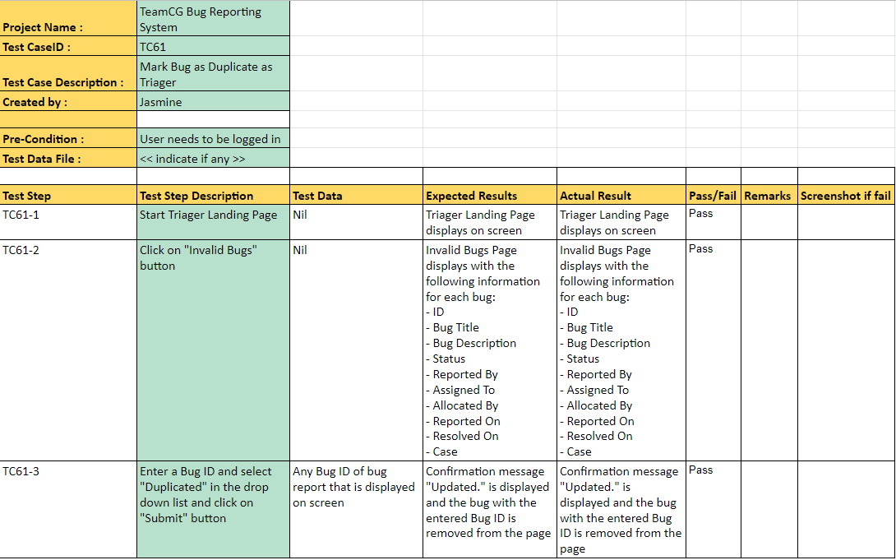

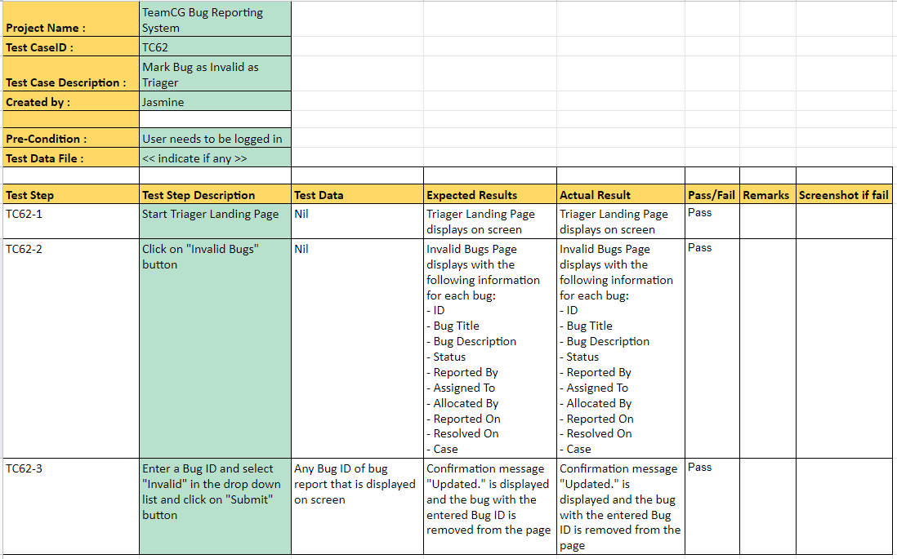

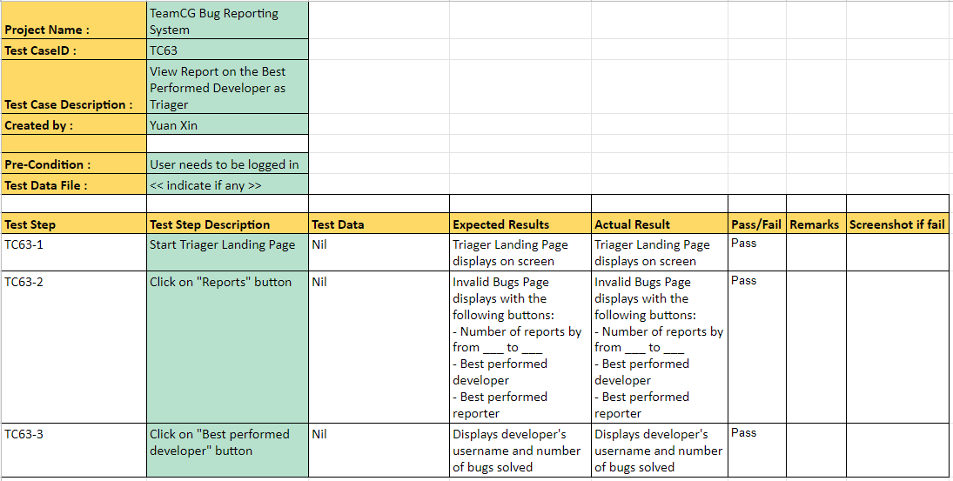

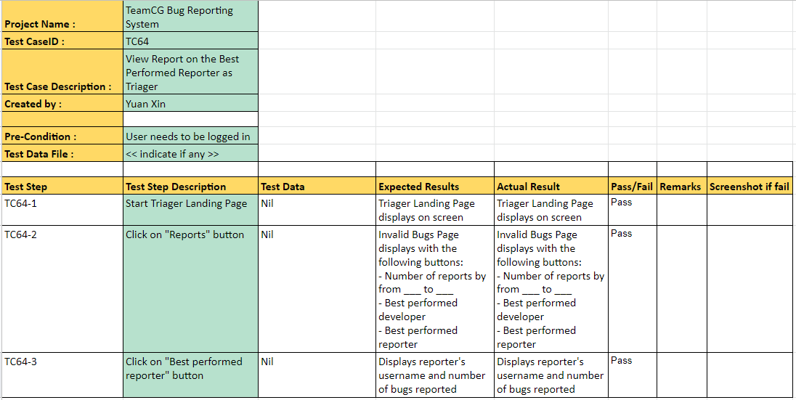

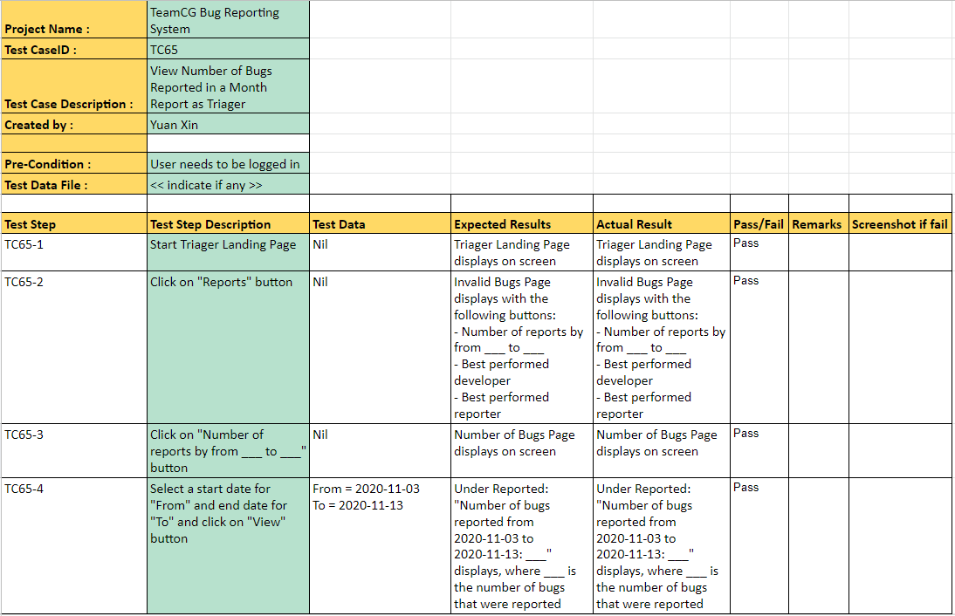

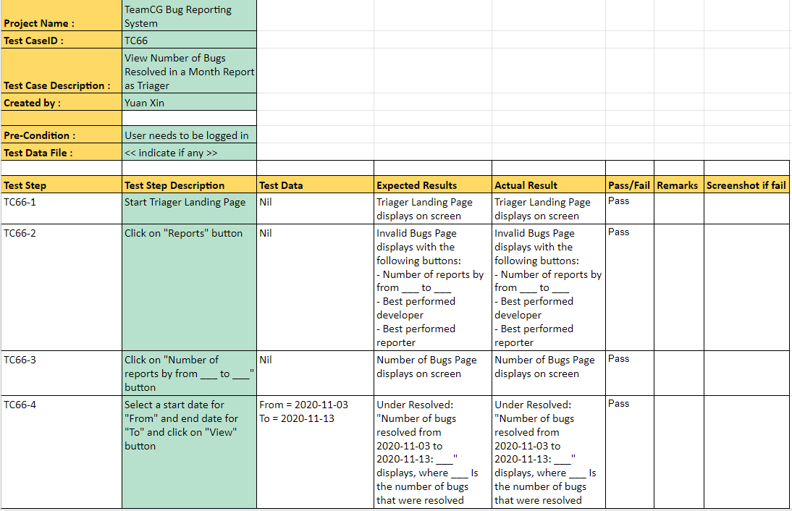

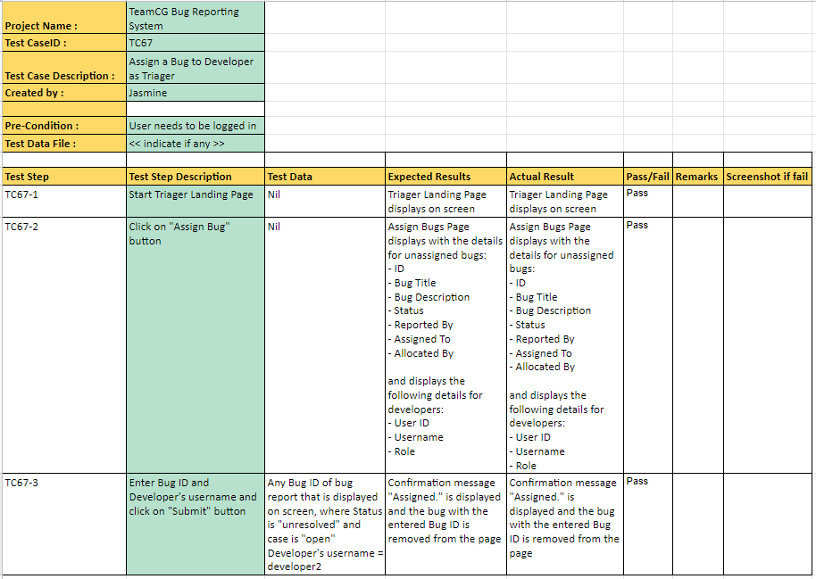

#### Developer

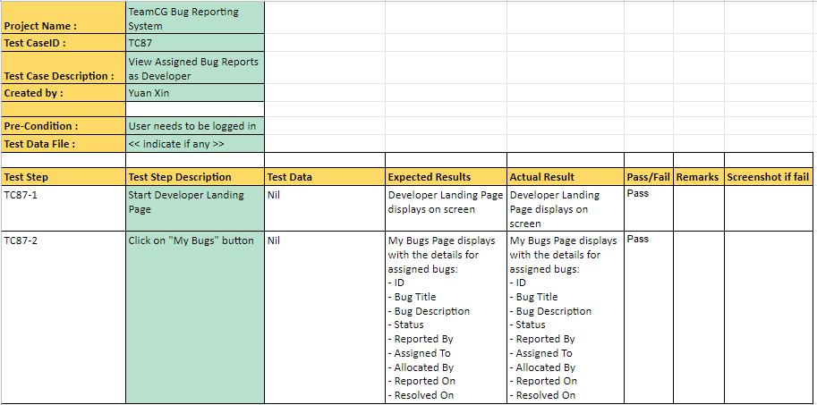

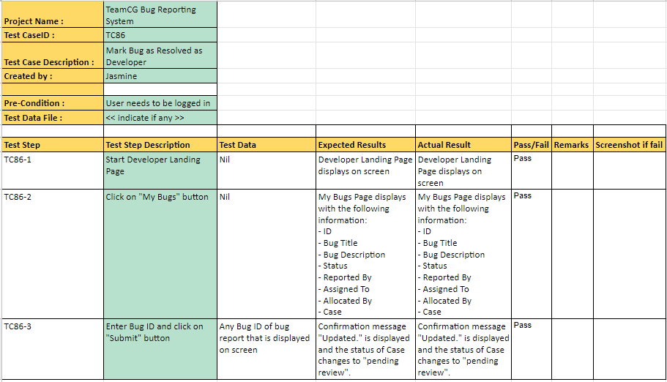

#### Reviewer

##### 

## **e. Sprint 5**

### **Wireframe**

#### Bug Reporter

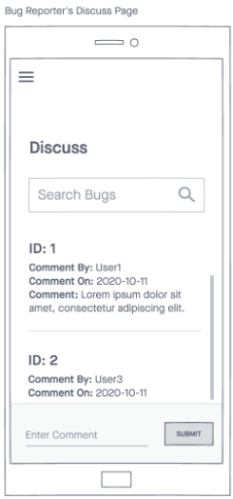

#### Triager

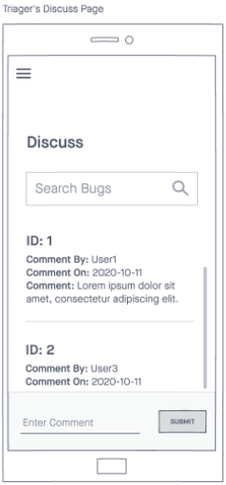

#### Developer

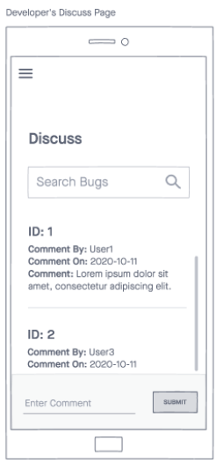

#### Reviewer

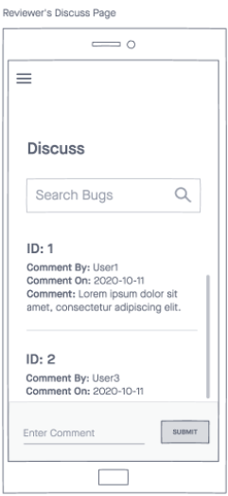

#### 

#### 

#### 

### **Screenshot of interface**

#### Bug Reporter

##### 

##### 

##### 

##### 

##### 

##### 

##### 

##### 

##### 

#### Triager

##### 

##### 

##### 

##### 

##### 

##### 

##### 

##### 

##### 

##### 

#### Developer

##### 

##### 

##### 

##### 

##### 

##### 

##### 

##### 

##### 

##### 

#### Reviewer

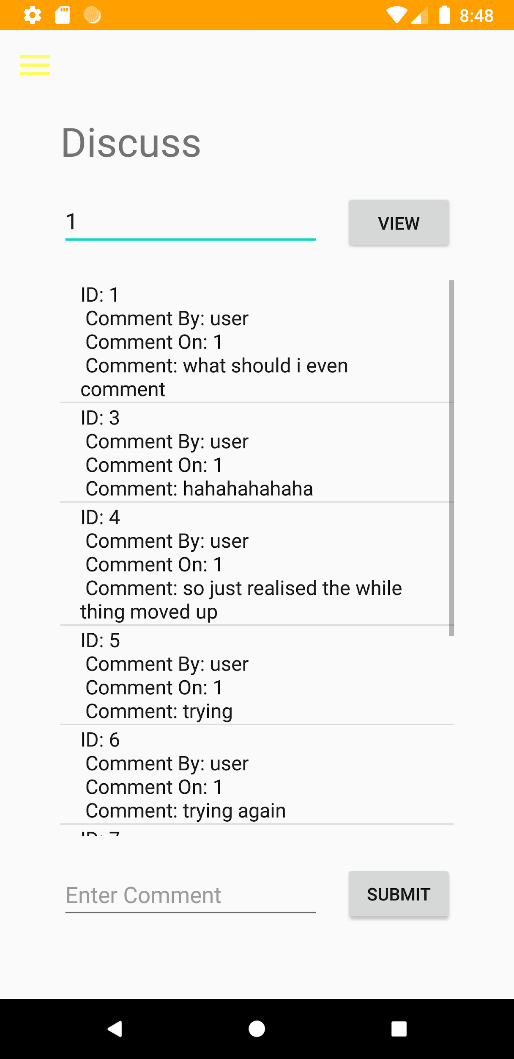

### **Screenshot of taiga**

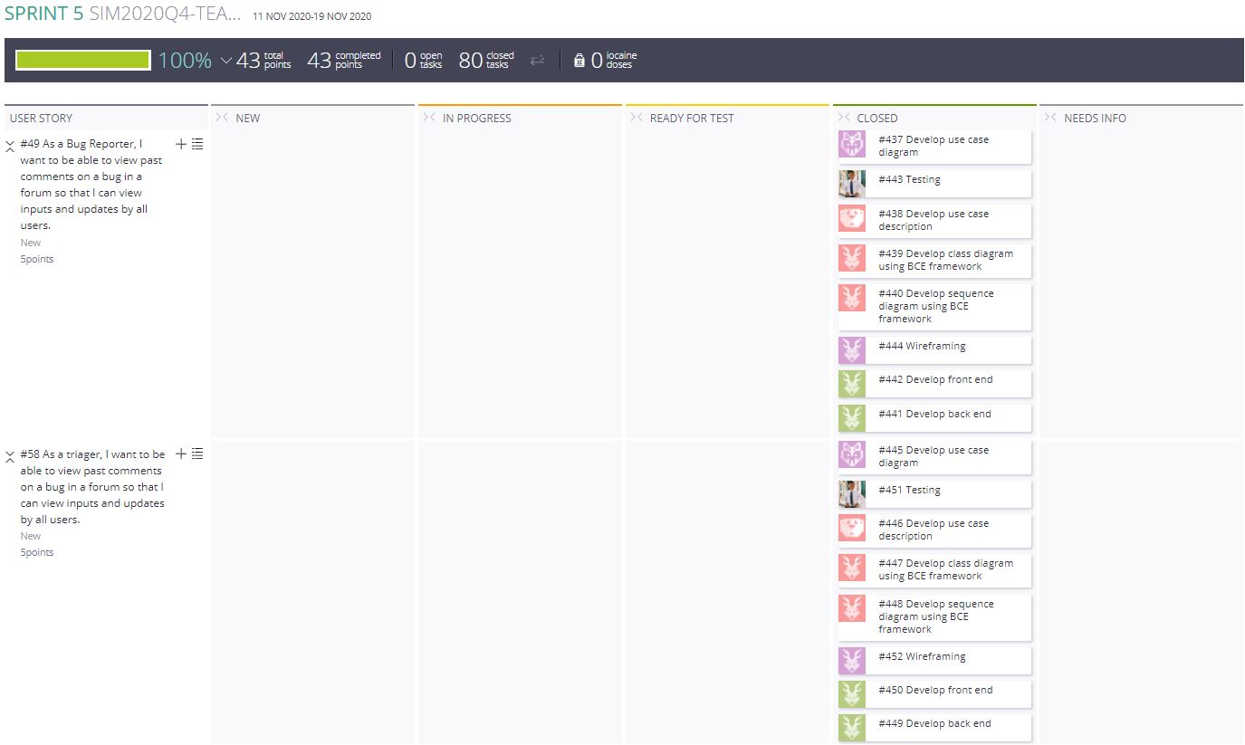

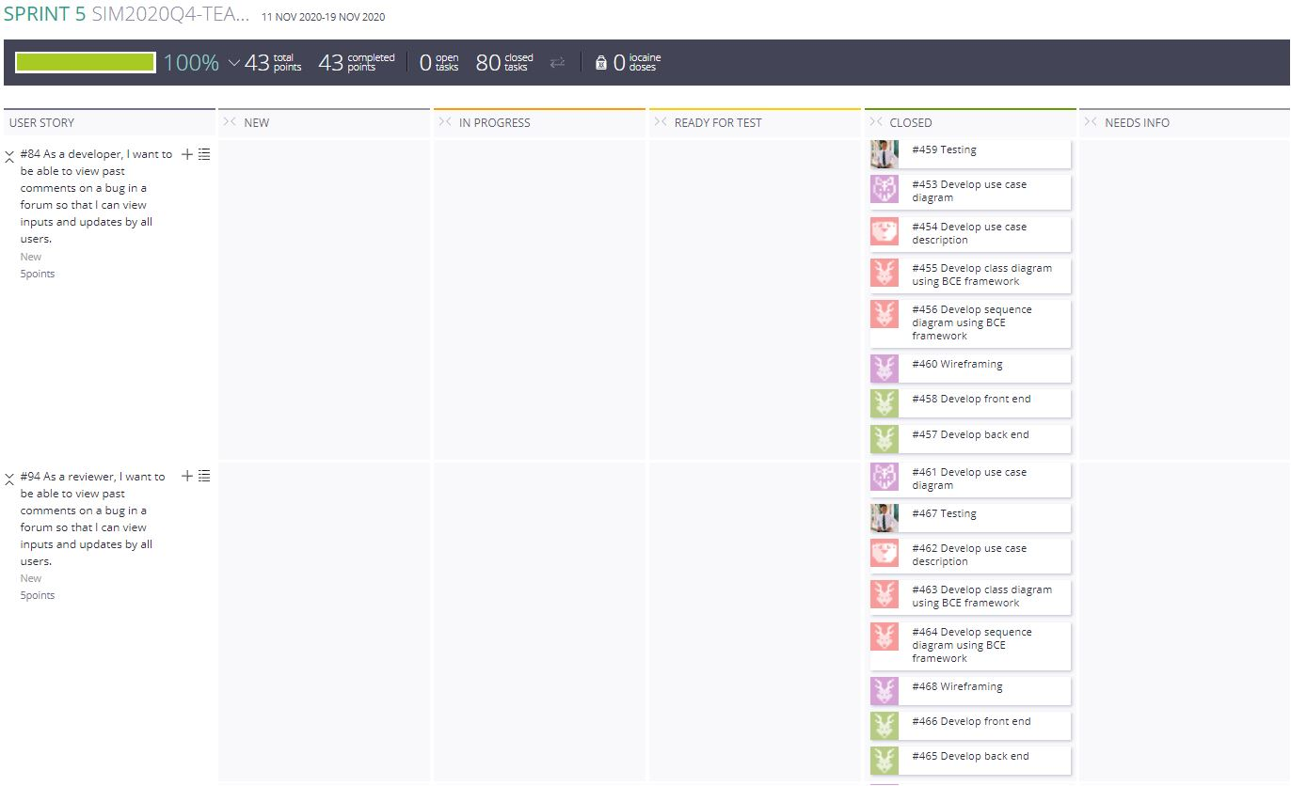

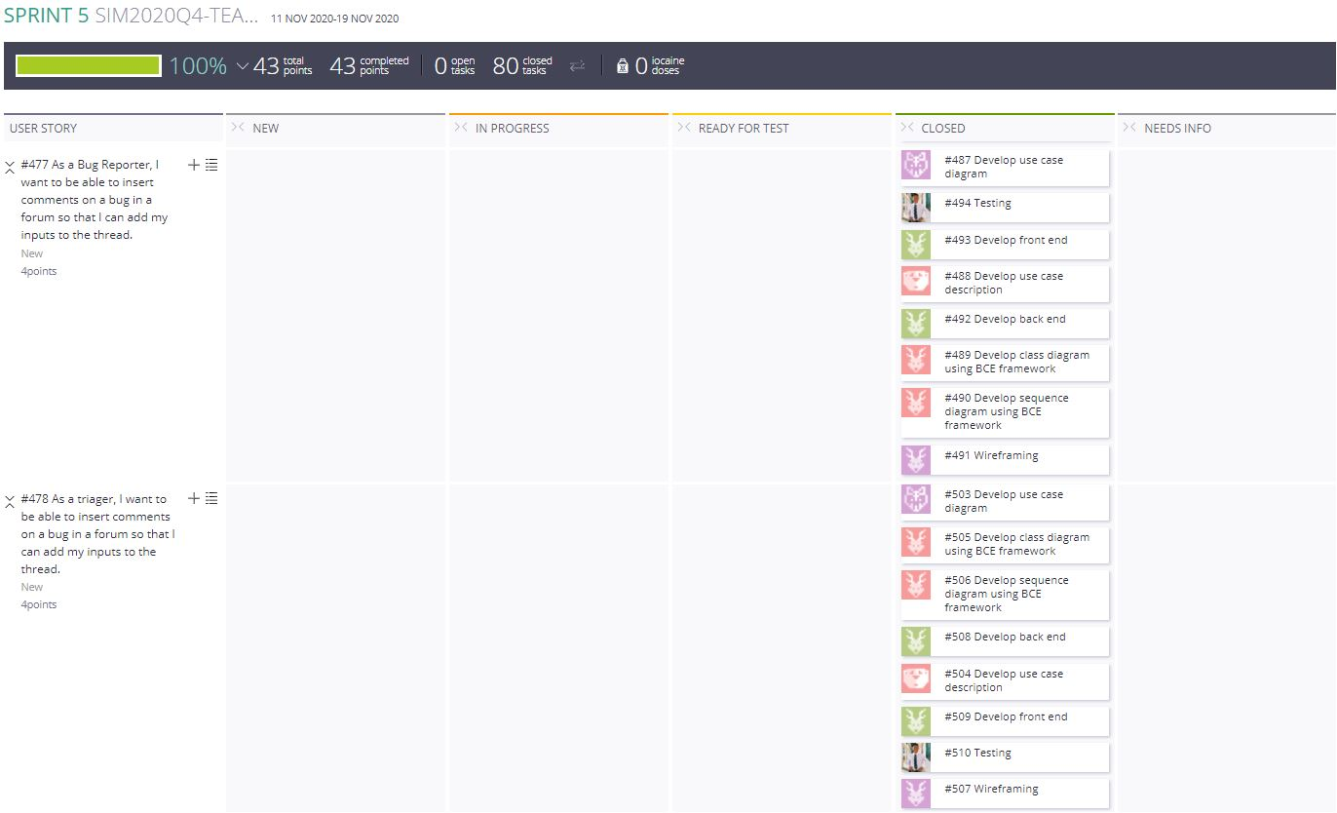

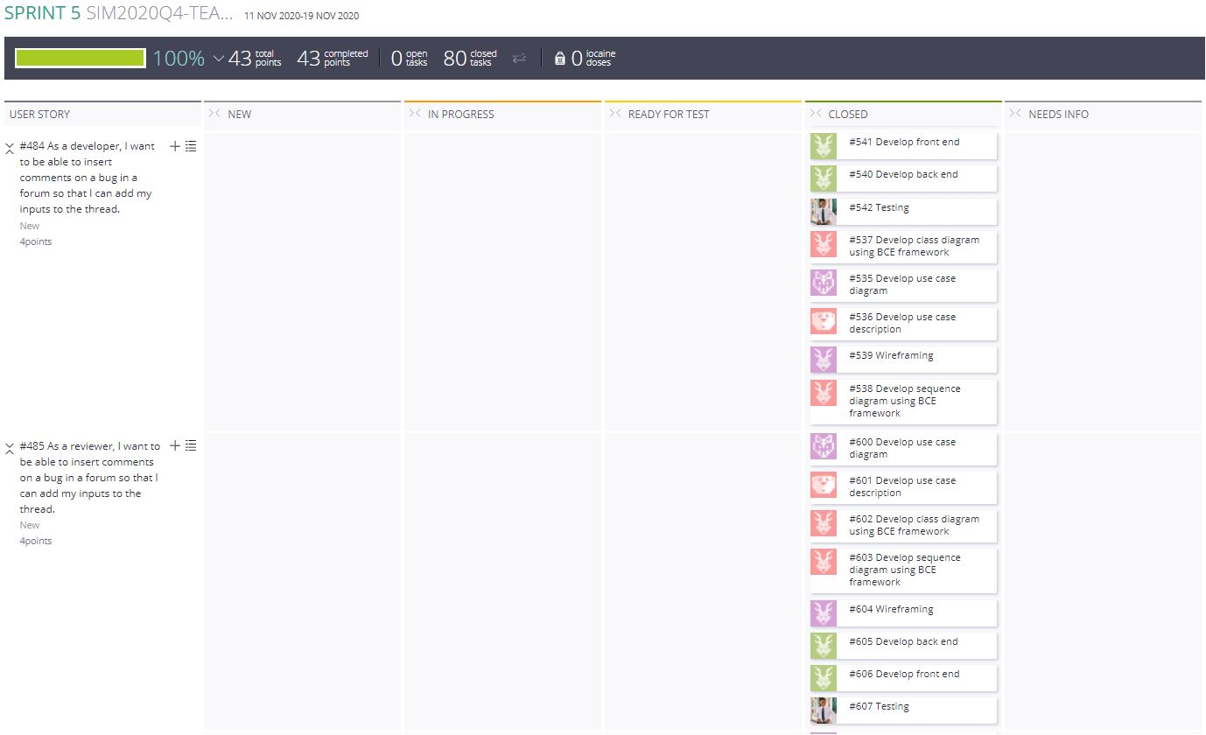

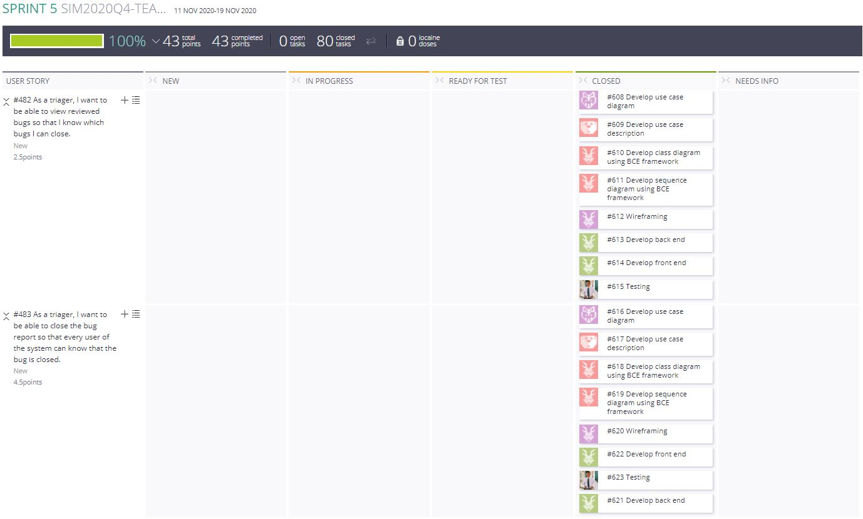

### **Test cases**

#### Bug Reporter

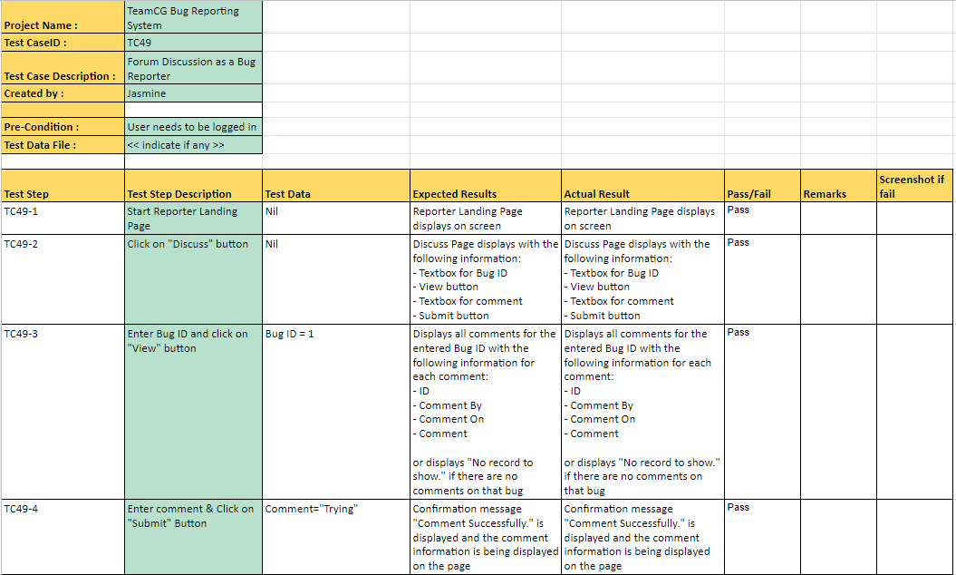

#### Triager

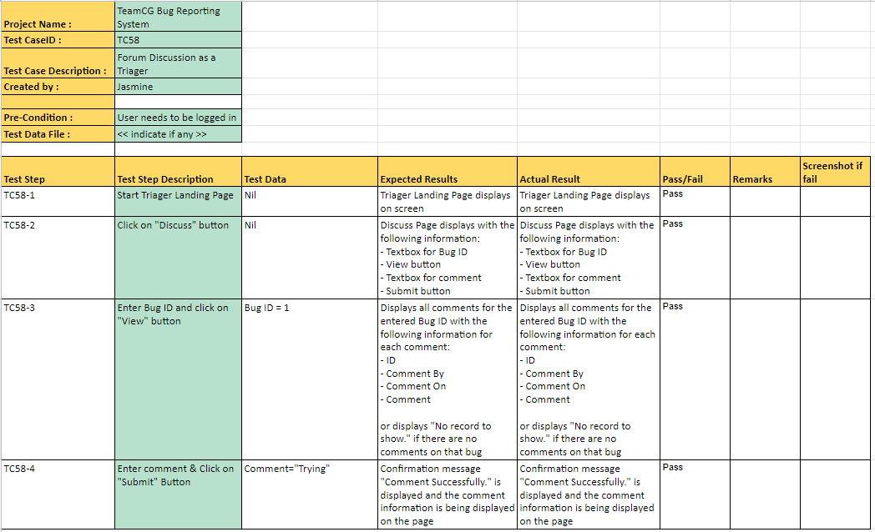

#### Developer

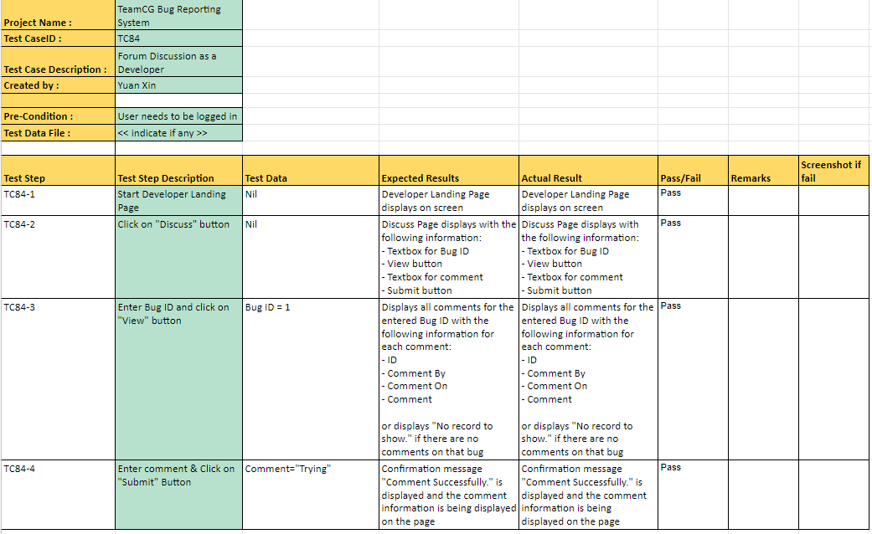

#### Reviewer

##### 

# 

# **9. CI/CD screenshots for one feature/functionality**

The images show the source code files that were uploaded into gitlab. Uploading all the files will allow gitlab to check the builds of the files properly. 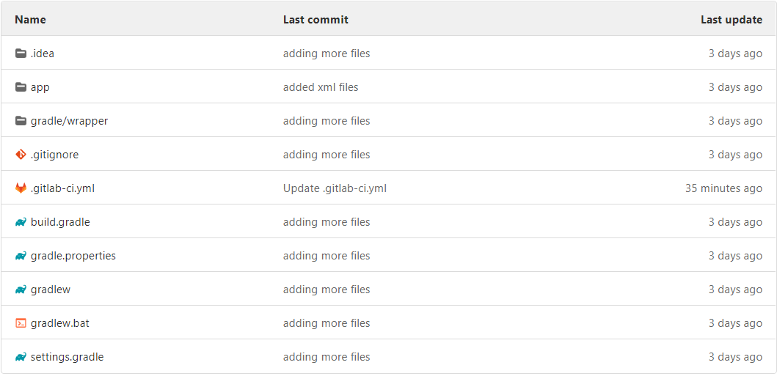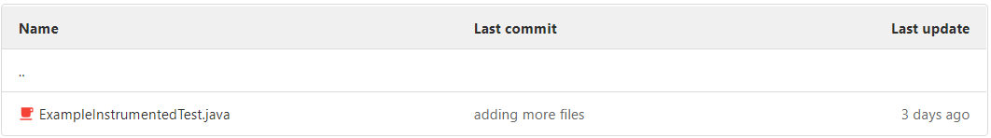

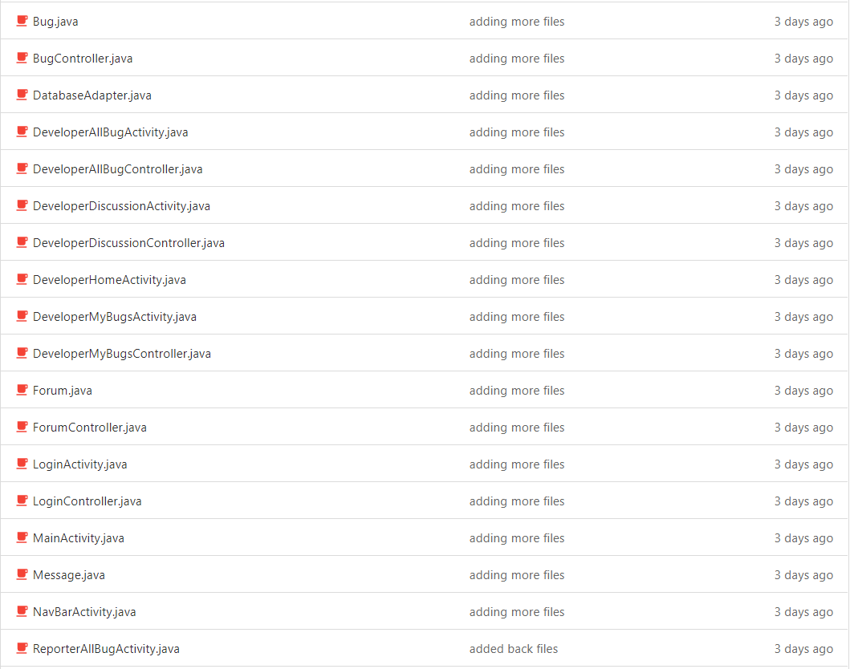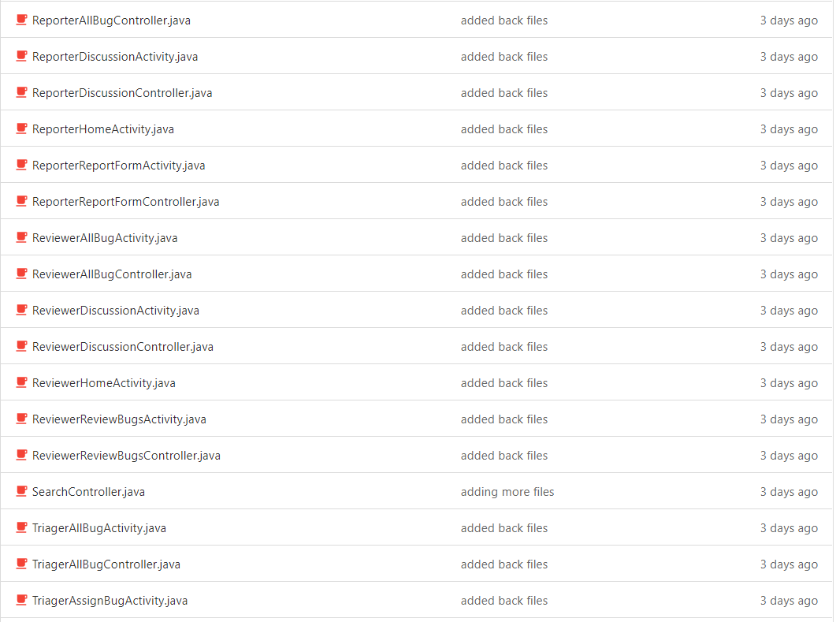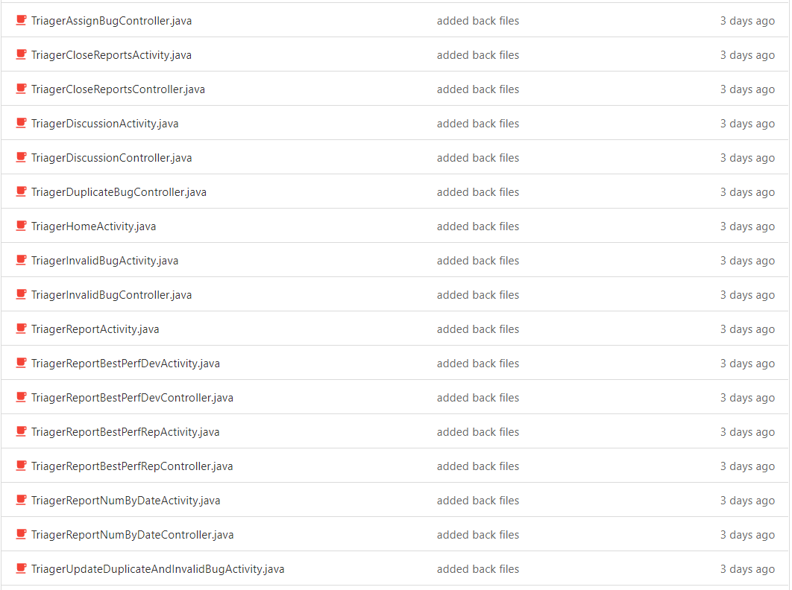

The following images show the .yml file that was used for the gitlab integration. The phases that were included are lintDebug, assembleDebug and debugTests. lintDebug is where gitlab analyzes the code for potential errors. assembleDebug is where the project is made and debugTests is where all the tests run. If any of the tests fail, it will interrupt the pipeline and fail it.

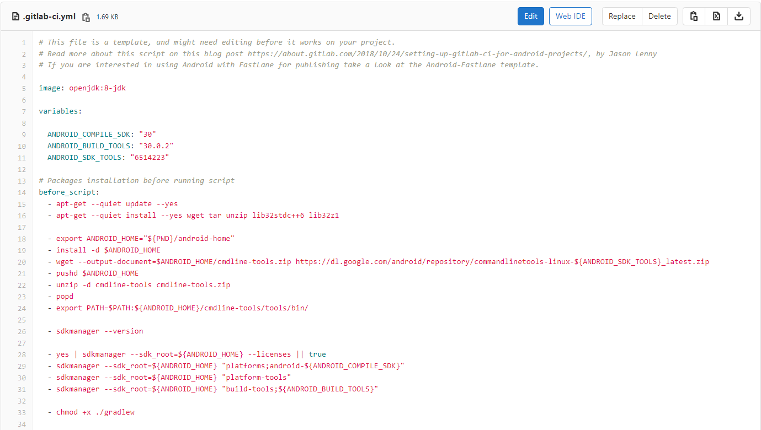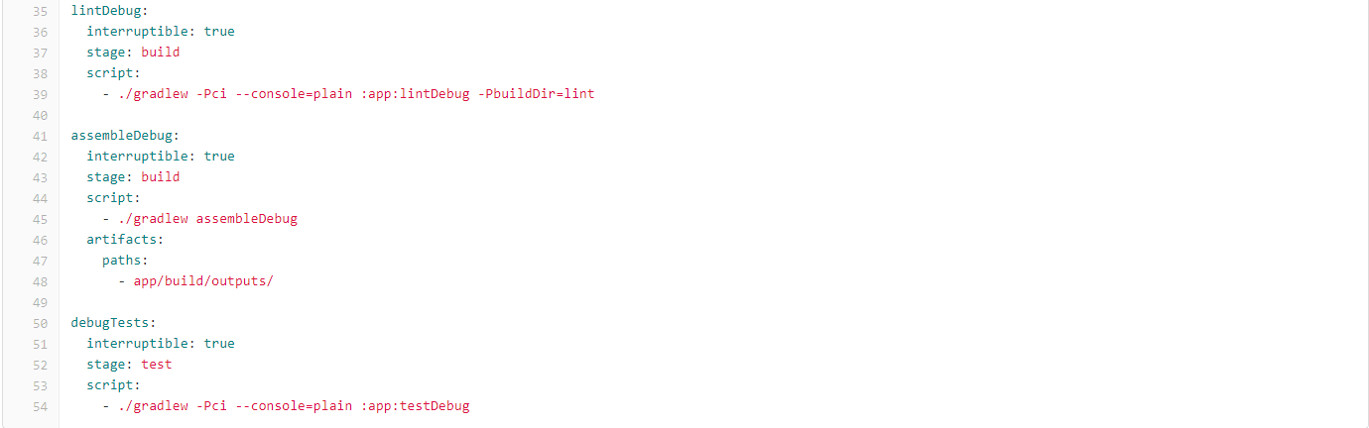

Pipeline

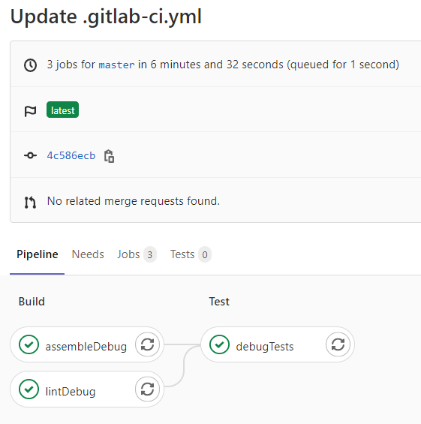

assembleDebug:

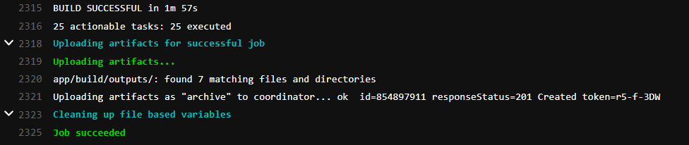

lintDebug:



debugTests:

# 

# **10. Ethical considerations**

## **Accountability**

The team is to take full responsibility for the successful implementation and execution of their respective tasks. Members will be held accountable for the success and failures of the tasks that are assigned to them. Creating a culture of accountability is essential to foster better work relationships, improves job happiness, and eliminates surprises. More importantly, it will build a sense of ownership in the project. Sense of ownership allows members to build an emotional attachment and responsibility towards the end product. Without it, it is very easy for members to develop an “It's not my job” kind of attitude. Thus, affecting the project quality.

## **Colleagues**

The team shall be fair to and supportive of one another. If there are disputes, they are to be resolved as a team in a mature manner, with the intention to create the best product. The team will not take credit from other team members, and will fully credit the work of others. The work that was done by others is also reviewed in an objective, candid and properly-documented way.

## **Dependability**

The team will make a collective decision to maintain and/or keep major functions within the program. The team will also make sure that the system is reliable and available, where the system will behave as expected and that the system and services are mostly available with little or no downtime.

## **Integrity**

The team has ensured that the work that they put out is something that is done by them and only them. The team will also take responsibility for the work that is being done by detecting, correcting and reporting any discovery be it error or room for improvement associated with the software development project.

## **Judgment**

Team members shall maintain integrity and independence in their professional judgment. If uncertain, a collective decision can be made. The team makes sure that everyone has approved the work that was done before moving on to the next phase of the project. The team has to maintain professional objectivity when working on the project so as to be impartial and fair to the project itself.

## **Management**

The team shall ensure that the products and related modifications meet the highest professional standards possible by using the best practises at all times. The team also has to ensure that the materials that are done are able to provide better quality in terms of reducing the risk exposure and enhance the quality of the final deliverables.

## **Self**

Throughout the duration of this project, the team has made self-improvements through the knowledge of software development processes. The team has also promoted work ethics during the whole duration of the software development project.

# 

# **11. Feature of software application that can be developed using data-driven software development**



**Model Requirement**

The feature that will greatly benefit from Data Driven Development is the Bug Report feature as most data from the bug report can be broken down and used by authorised stakeholders for research analysis.

The Data Driven Development could promote efficient analysis and retrieval of common search queries and keywords used by users across specified periods of time, which could also identify the most common issues faced by users. It will also allow the developer to look at the issue that is most commonly faced by users and from there the developer can better identify the present and future issue.

User stories that will be using these features:

1. As a Bug Reporter, I want to be able to search for bug reports through the use of keywords, so that I can see what information or update has been performed or added by the various actors.
2. As a triager, I want to be able to search for bug reports through the use of keywords, so that I can see what information or update has been performed.
3. As a developer, I want to be able to search for bug reports through the use of keywords, so that I can see what information or update has been performed.
4. As a reviewer, I want to be able to search for bug reports through the use of keywords, so that I can see what information or update has been performed.

## 

## **Data Collection**

The Data Driven Development would use the existing database to retrieve data from historical bug reports such as keywords and use it to perform analysis. New data would also be used to generate more accurate observations and to update the existing database, contributing to a wider spectrum of analysis of data from the Bug Report that was submitted.

## **Data Cleaning**

Data used for Data Driven Development will be periodically stored and then replaced by new data to observe and enhance the accuracy of trends over time.

Inaccurate data like invalid or duplicate bug reports will be removed from the database to ensure that the data is correct and consistent throughout. Inaccurate data in a bug reporter program can corrupt the collected data and cause inaccurate analysis and affect the data driven development accuracy.

Missing data (like the developer’s name) of a bug report will also be filled in to enhance the accuracy of the output of the system (like best performed developer report).

## **Feature Engineering**

The purpose of Feature engineering is to properly prepare input dataset to ensure compatibility with the machine learning algorithm requirements and to improve the performance of machine learning models.

A technique that can be used for the Data Driven Development is Imputation. This technique helps to resolve issues regarding missing values without severely affecting the performance of machine learning models. Imputation can be performed numerically. In numerical context, imputation preserves the data size and is thus a preferred option instead of dropping data. This could be applied to our bug reporting system when we replace missing values with 0 for columns such as “number of bug reports last month”.

## **Model Training**

The implemented strategy will consist of learning algorithms such as Random Forest to perform the model training process and also a test set so as to ensure that the data driven development is performing optimally and objectively that it meets the requirement that was required from the bug report.

## **Model Evaluation**

The developer is able to view the bug, solution and result. So that the developer can literate data again and see what other areas can be paid attention to, or if they should focus on other issues. It is also used to evaluate if the data driven development meets the needs of the objective.

## **Model Deployment**

The model will be deployed by using a set of android studio code though android studio into the application system

## **Model Monitoring**

To monitor the Data Driven Development that was implemented and to survey bugs and errors to improve performance. With this, the developer can fine tune the data driven development function so as to better respond and solve future issues by identifying more accurately the issue faced by the user and to get better data from the Bug Report database.

# 

# **12. Meeting minutes**

## **Meeting Minutes 1**

Meeting Date: 30 Sept 2020

| **Attendance** | | |
| --- | --- | --- |
| **Name** | **Student Number** | **Present / Not Present** |
| Huang Junde | 6347046 | Present |
| Dany | 7083105 | Present |
| Priscilla Kai Ting Loo | 6278632 | Present |
| Eng Yong Tee | 6347186 | Present |
| Hai Tian Jonathan Khoo | 5922033 | Present |
| Yap Yuan Xin | 6278905 | Present |
| Hwang Qi Hsin, Jasmine | 6276672 | Present |

**Agenda:**

1. The team is progressing on the list of User Stories
2. The team is progressing on the use of taiga for the project management

**Progress Report**

| **Work Completed in this meeting** | * Developed user stories |
| --- | --- |
| **Work to be completed in next meeting** | * Develop UML diagrams (use case diagram, use case description) |
| **What went well and why?** | * We are able to list out all the user stories in a small amount of time and have our stories checked. * This is because we have a lot of discussions and little to no conflicts. |
| **What is not going well and why?** | * We had several duplicates and redundant user stories listed down because we were not clear of what exactly we needed to have. |
| **Suggestions/Issues** | * We have already clarified with Mr Terence on what is needed to be changed |

**Discussion Summaries:**

Team has gone through the details that need to be inside the user stories and also have consulted with Mr Terence on the user stories and updated the user stories to be in line with the project requirement and have begun to import the user stories into taiga sprint.

## **Meeting Minutes 2**

Meeting Date: 7 Oct 2020

| **Attendance** | | |
| --- | --- | --- |
| **Name** | **Student Number** | **Present / Not Present** |
| Huang Junde | 6347046 | Present |
| Dany | 7083105 | Present |
| Priscilla Kai Ting Loo | 6278632 | Present |
| Eng Yong Tee | 6347186 | Present |
| Hai Tian Jonathan Khoo | 5922033 | Present |
| Yap Yuan Xin | 6278905 | Present |
| Hwang Qi Hsin, Jasmine | 6276672 | Present |

**Agenda:**

1. The team is progressing on the updates made to the user stories
2. The team is progressing on the updates made to the use case description
3. The team is progressing on the diagrams (i.e. class, BCE and sequence)
4. The team is to clarify on requirements for the front end development

**Progress Report**

| **Work Completed in this meeting** | * Finalizing our user stories * Develop class diagram for login * Develop sequence diagram for login |
| --- | --- |
| **Work to be completed in next meeting** | * Finish class diagram for all other use cases * Finish sequence diagram for all other use cases * Wireframing and coding for sprint 1 |
| **What went well and why?** | * There was more discussion and interaction this week, with little to no conflict * Everyone was contributing useful inputs |
| **What is not going well and why?** | * We needed some time in trying to understand the concepts of the sequence and BCE diagrams, so that took up quite some time |
| **Suggestions/Issues** | * We have already clarified with Mr Terence on what is needed to be changed and have clarified all our doubts |

**Discussion Summaries:**

The team has consulted with Terrance and made changes to the user stories , use case description and started on the development of the class and sequence diagram. While in the process of discussion of required deliverables that need to be done by the next meeting has also been brought up and begun working on the materials .

## **Meeting Minutes 3**

Meeting Date: 16 Oct 2020

| **Attendance** | | |
| --- | --- | --- |
| **Name** | **Student Number** | **Present / Not Present** |
| Huang Junde | 6347046 | Present |
| Dany | 7083105 | Present |
| Priscilla Kai Ting Loo | 6278632 | Present |
| Eng Yong Tee | 6347186 | Present |
| Hai Tian Jonathan Khoo | 5922033 | Present |
| Yap Yuan Xin | 6278905 | Present |
| Hwang Qi Hsin, Jasmine | 6276672 | Present |

**Agenda:**

1. The team is progressing on the diagrams (i.e. class, BCE and sequence)
2. The team is ensuring that everything that happened during sprint 1 is consistent

**Progress Report**

| **Work Completed in this meeting** | * Checking for consistency across all documents * Adding points to some user stories |
| --- | --- |
| **Work to be completed in next meeting** | * Update Taiga record * Amend BCE and Sequence diagrams * Testing |
| **What went well and why?** | * All team members were contributing valuable inputs and had meaningful discussions |
| **What is not going well and why?** | * Due to the need of conforming to the BCE framework changes were made to both the BCE and sequence diagram |
| **Suggestions/Issues** | * The issues faced by the team was the unfamiliarity of the BCE framework which meant the team had an open discussion regarding the BCE framework. |

**Discussion Summaries:**

The team had discussed several issues faced over the past weeks and got a better clarity on our current progress. We had straightened out the project requirements and better allocated tasks to respective team members according to our individual strengths.

## **Meeting Minutes 4**

Meeting Date: 25 Oct 2020

| **Attendance** | | |
| --- | --- | --- |
| **Name** | **Student Number** | **Present / Not Present** |
| Huang Junde | 6347046 | Present |
| Dany | 7083105 | Present |
| Priscilla Kai Ting Loo | 6278632 | Present |
| Yong Tee | 6347186 | Present |
| Jonathan khoo | 5922033 | Present |
| Yap Yuan Xin | 6278905 | Present |
| Hwang Qi Hsin, Jasmine | 6276672 | Present |

**Agenda:**

1. The team is making revision to the BCE class and sequence diagram
2. The team is reviewing current code and making the necessary changes to better adhere to BCE framework

**Progress Report**

| **Work Completed in this meeting** | * Updated Taiga record * Review and make adjustment to BCE class and Sequence Diagrams |
| --- | --- |
| **Work to be completed in next meeting** | * Amend BCE class and Sequence diagrams |
| **What went well and why?** | * All team members were contributing valuable inputs and had meaningful discussions |
| **What is not going well and why?** | * Due to the BCE framework requirement the team has to make adjustments to the programming aspect both on the front end and back end of the code to align with the BCE framework requirement. |
| **Suggestions/Issues** | * Suggestion was made to carry out more review on both the front end and back end of the code so as to conduct checking that the code fulfills the BCE framework requirement. * More discussion will be needed in order to achieve a common understanding as well as to achieve better synergy. |

**Discussion Summaries:**

The team had discussed several issues faced over the past weeks and got a better clarity on our current progress. We had straightened out the project requirements and better allocated tasks to respective team members according to our individual strengths. During this session, several changes were made to the code so as to better adhere to the BCE framework.

## **Meeting Minutes 5**

**Meeting Date: 28 Oct 2020**

| **Attendance** | | |
| --- | --- | --- |
| **Name** | **Student Number** | **Present / Not Present** |
| Huang Junde | 6347046 | Present |
| Dany | 7083105 | Present |
| Priscilla Kai Ting Loo | 6278632 | Present |
| Yong Tee | 6347186 | Present |
| Jonathan khoo | 5922033 | Present |
| Yap Yuan Xin | 6278905 | Present |
| Hwang Qi Hsin, Jasmine | 6276672 | Present |

**Agenda:**

1. The team is to finalise on the project Gantt Chart
2. The team is reviewing current code and making the necessary changes to better adhere to BCE framework
3. The team has decided on test driven development (TDD) of Sprint 1 for the testing portion of the project

**Progress Report**

| **Work Completed in this meeting** | * Complete Gantt Chart * Review and make adjustment to Backend Codes * Review and make adjustment to BCE class and Sequence Diagrams |
| --- | --- |
| **Work to be completed in next meeting** | * Amend BCE class and Sequence diagrams * Gantt chart * Reviewing source code |
| **What went well and why?** | * All team members were contributing valuable inputs and had meaningful discussions * It was not too difficult setting-up JUnit for our project which is done in java, despite using Android Studio |
| **What is not going well and why?** | * Major changes to the codes needs to be done to fit the BCE framework * Setting up of JUnit was an issue at first because none of us were familiar with the process |
| **Suggestions/Issues** | * Search up on how to set up the JUnit for Android Studio * There were some unfamiliarity challenges drawing our gantt chart on MS Visio compared to MS Project due to the lack of MS Project software license |

**Discussion Summaries:**

The team had discussed several issues faced over the past weeks and got a better clarity on our current progress. We had straightened out the project requirements and better allocated tasks to respective team members according to our individual strengths. Changes are also made to the code so as to better adhere to the BCE framework. The team has also completed the gantt chart for the project, and has decided to do the test driven development (TDD) for Sprint 1.

## **Meeting Minutes 6**

**Meeting Date: 16 November 2020**

| **Attendance** | | |
| --- | --- | --- |
| **Name** | **Student Number** | **Present / Not Present** |
| Huang Junde | 6347046 | Present |
| Dany | 7083105 | Present |
| Priscilla Kai Ting Loo | 6278632 | Present |
| Yong Tee | 6347186 | Present |
| Jonathan khoo | 5922033 | Present |
| Yap Yuan Xin | 6278905 | Present |
| Hwang Qi Hsin, Jasmine | 6276672 | Present |

**Agenda:**

1. The team finalising the report and video for the presentation
2. The team has begin the final proofreading and fine tuning of all the deliverables

**Progress Report**

| **Work Completed in this meeting** | * Completed Final Report * Completed Demonstration video of the Bug Reporting App |
| --- | --- |
| **Work to be completed in next meeting** | * Not available |
| **What went well and why?** | * All team members were contributing valuable inputs and had meaningful discussions * The final report is being finalised and proofread to ensure all relevant material are included * The team has shown teamwork throughout the entire duration of the project |
| **What is not going well and why?** | * Slight difficulty in the comprehension of some of the requirement * The team had issues in figuring out the Ethical Considerations and discussion pertaining to the Bug Reporting App that is being developed |
| **Suggestions/Issues** | * The team has come to together and clear the doubts on some of the requirement stated * More detailed example and explanation on Ethical Considerations and discussion on lecture slides |

**Discussion Summaries:**

The team has begun finalising the final report and proofreading all the documentation that are required for the project. Video demonstration for the final presentation has also been completed. Issues are faced by the team when completing the Ethical Considerations and discussion portion of the project as it was something new that the team had not done before in previous projects but it was resolved in no time with everyone brainstorming and pitching ideas and solutions.